My parents life at 15

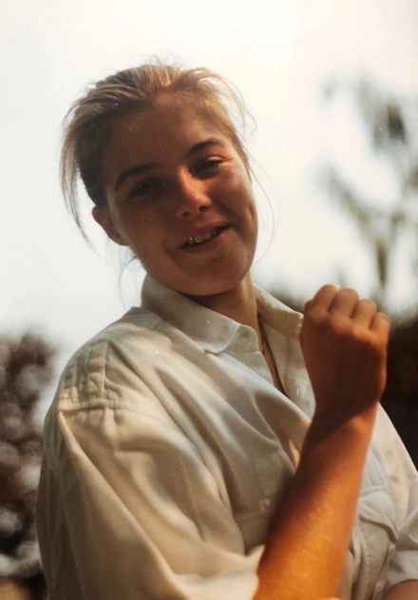
My mothers name is Alexandra. In 1988 she was 15 years old, today she is 47 years old. She has always been a funny and spontaneous person who loves to discover new things in the nature.

In her free time she loved to play tennis what she is still doing. She had many friends and had a lot fun spending time with them. She often went to the cinema or listened to 80s pop. Sometimes she also went to a lake with her friends and enjoyed a relaxing day.
She lived with her parents and her brother in a village near Hamburg. It was really small and surrounded by a lot of farms. But it had a tennis court which was really nice for my mother because tennis was her favourite hobby and she only had to walk two minutes to the court.
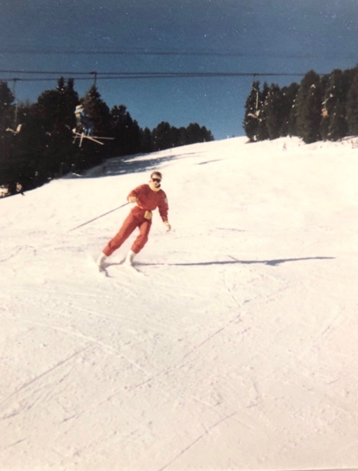
Her parents were very friendly and her whole family liked to play tennis together. They also often did trips like skiing or hiking. They always laughed together and joked around a lot. Unfortunately her father died really early because of cancer.
My mother joined the 9th grade at the high school next to her town, the EvB. She went to school when she was 6 years old. At first she attended the primary school in Großhansdorf. She had to go fifteen minutes by bike to the EvB, which was not very long compared to her friends.
At school she had 12 different subjects, her favourite subjects were Maths and PE. At her school you could study 3 different languages: English, Latin and French. My mother learned all of them but she really struggled with English which she started in the 5th grade. Her first lesson normally started at 7:40 a.m. and school usually ened at 1:45 p.m. They did not have hard punishments at school but they sometimes had detention. All in all she had a really cool and funny school time.

