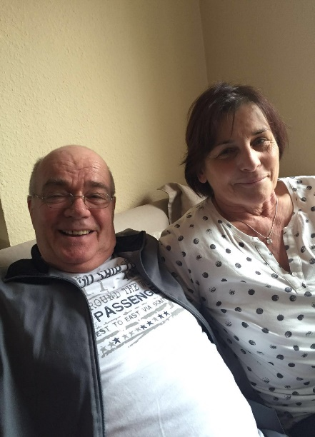
LIFE OF 14 OF MY GRANDFATHER

Between my grandpa and me there are a lot of differences but also things that are siminilar…
My grandpa´s name is Wolfgang, he was born on June 22,1944 that was in the time oft the war . Together with his mother, his brother and his father , he lived in the GDR. But he can´t remember the war time because he was too young.Today he is very happy that he did not have to experience another war. For this he is very grateful. My grandpa is a very open and cordial person. Although he himself is already old , he visits his mother (my great- grand mother) , who soon turn 102 , 4 times every day and keeps her company. That´s what characterizes my grandpa. He is there for us and even if it is the last thing he does, he always tries to help where he can, but that also makes him quite difficult sometimes.
My grandpa started school at the age of seven and was there until he was 15. At school he could not choose between several foreign languages like me or my mother , but his only foreign language was Russian. At the age of 15 , my grandpa started working. When he was 15 he began his apprenticeship as a skilled worker for welding technology , which he did 3 years until he was 18. But when he was 14, years old , like me now , he also had 14 subjects in school , even if they were called differently from what we do today… In his free time he liked to listen to pop music by bands like the beatles for example … (They are still one of my favorite bands today…) He also liked to do things with his brother , his friends and neighbors such as driving scooters , playing soccer and more. His hobbies were swimming and gymnastics. What surprised me was that he went to the cinema once or twice a week.
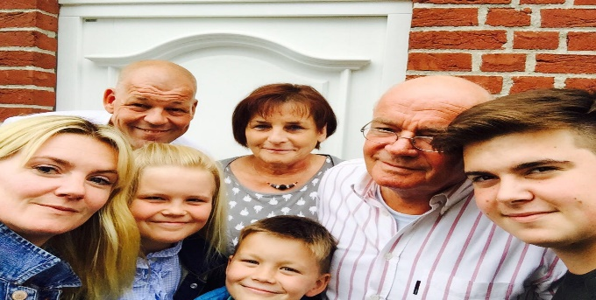
Today his brother ( 3 years older than him ) is unfortunately no longer alive. I think that´s why it is so important to him to visit his mother as often as possible and to spend time with his family.

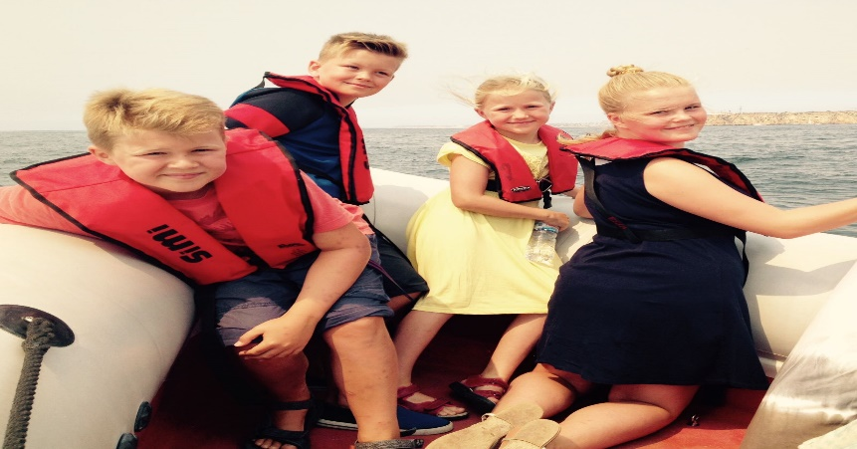
My grandfather is not only a very important family member for me , he is also the hero of all other grandchildren and children and is always there for us in any situation.
WE LOVE HIM AND HE LOVS US !!! That´s how family work! 