Life at 14
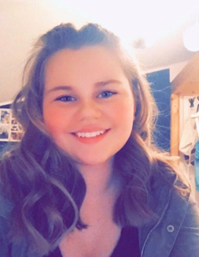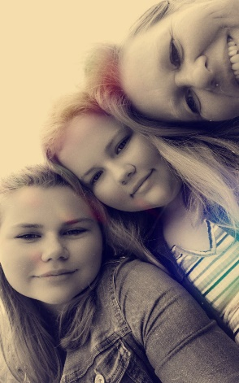

My name is Amelie and I am 14 years old. I was born on the 30th march in Bad Oldesloe.
I am a reliable and a very happy person who always laughs but when someone annoys me I can get bitchy and angry.
In my free time I like to meet friends, bake, cook or play the clarinet in a orchestra, with which I have 2 concerts every year. I also have a dance class with my friends every Thursday, and I enjoy listening to pop and rap music.In the evenings I mostly watch series on Netflix.
I live in a small town in Germany named Trittau (which is near Hamburg). I live in a big house with a garden with my parents Sabine and Götz, my 2 out of 3 siblings Pierre and Nathalie and my sister's mice, Dobby and Molly. In the house I have to tidy up my room, have to clean the dishwasher out and in and suck. My 3. sibling named Rene lives in Bavaria in my grandma`s house. My grandparents live in the same town as me so that I can see them every day.
When I was 6 years old I started school. I was in my primary school for 4 years. When I was 10 I came to the EvB. There I met a lot of great new friends who make my everyday school life a lot easier. In our school there is a ban that we are not allowed to use our mobile phones, now I am in the 9th grade. At school, we have a computer room, break halls, a forum and many class rooms. Our lessons begin mostly at 7:40 a.m. .and end at 13:45 p.m. We have 90 minutes lessons and 14 subjects. In our school you can choose between 3 foreign languages: Latin, French and Spanish. I have been learning English since the 3rd grade. My second foreign language is Latin. I go to school by bus. Sometimes I help out in primary school, when I have days off, because later I want became a teacher.

