My grandmother’s life at 15

My grandmother’s name is Rita. She was born on 1st of January and now she is 66 years old. She is a really open-minded, kind and reliable person, who cares a lot about how the others are feeling.
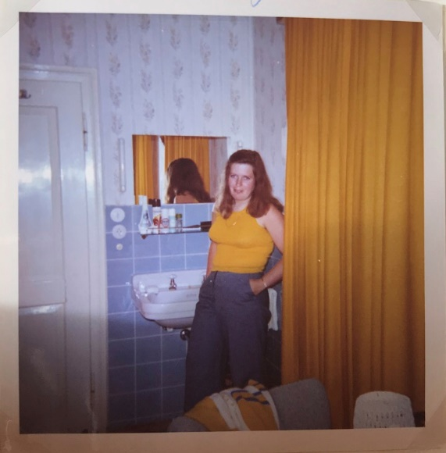
When she was 15 years old she lived with her parents and her two siblings in a village near Hamburg. She did a lot at home for example cleaning the house, cooking and baking for her family or doing some garden work. In her free time, when she didn’t have to help at home with the housework, she was a lot outside and met her friends. They went into the city or played badminton. They also took part in a dancing course and sometimes went to the cinema, but just about 1-2 times a month. My grandmother also enjoyed listening to the topical charts at that time, which was much rock music. She listened to songs from ‘‘The Beatles“ or ‘‘The Rolling Stones“ for example.
She started school when she was six years old and attended a school near her village where she was until the 6th grade. After that she went to middle school but just until the 10th grade. She always had to go to school on foot or by bike. At her school they just had English lessons for about 3 years and no other foreign languages like today. They did not have a libary to study at and punishments were a hit with a switch on the fingers, detention or they had to go to see the principal for example. Her favourite subject was Maths and all in all they had about 13 different subjects.

