Personal Profile of my grandfather

My grandfather’s name is Jürgen and he was born on 23rd May 1941 and died on 24th September 2011.
He has always been a funny and friendly person who laughed a lot.

When he was 15, he sometimes met his friends in his free time but most of the time was he at home and spent time with his family or had work to do.
He listened to classic music back then and went to the cinema twice a year.
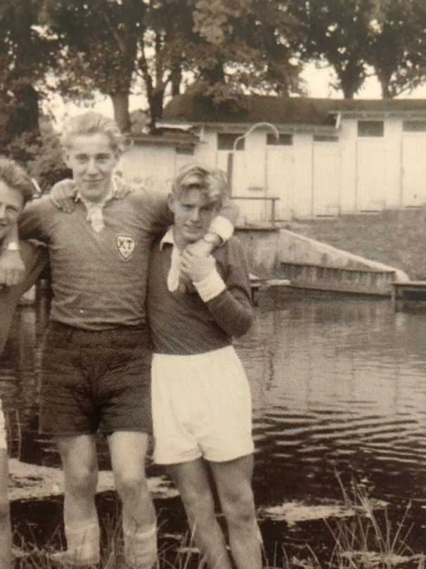
He lived together with his two brothers and his mother in a small village near Hamburg. His father died before he was born in the war. He had to help a lot and did chores like cleaning the house, doing the laundry or sweeping the courtyard. He and his brothers didn’t get pocket money like we do now.

My grandfather started school when he was six and started working when he was 15. He went to school by bus or on foot. In school they had about 8 subjects and started learning English in the 5th grade. They hadn’t got the opportunity to study another foreign language at school.
When they did prohibited things at school, they were hit with a stick.

