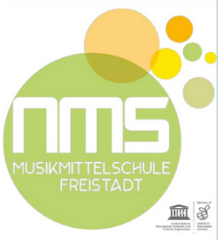
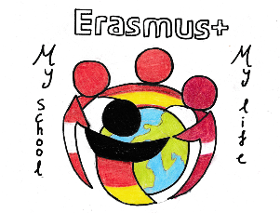
MY SCHOOL, MY LIFE
STUDENTS’ SATISFACTION QUESTIONNAIRE MEETING IN AUSTRIA
To which extent were your expectations of the 1st project meeting met? (6 = excellent)

Did your attitude and perception concerning the country you had visited change thanks to this mobility?

What impressed you most in Austria?

Do you consider yourself European?

Do you like to communicate in English?

Are you / will you be in touch with anyone from our Erasmus+ group?

How good would you rate Erasmus+ meetings in partner countries comparing with school trips?

What project activity was the most interesting in your opinion? Why?

What was your most important Erasmus+ experience?

What country are you from?

Finish the following sentences:
a/ This meeting has been for me

b/ The things that I appreciated are

c/ I learned that

d/ The best thing of the meeting was

e/ I would like to change

f/ Now I feel

Describe our meeting we have hold in 3 words (nouns or adjectives)
What I would like to tell organizers is

