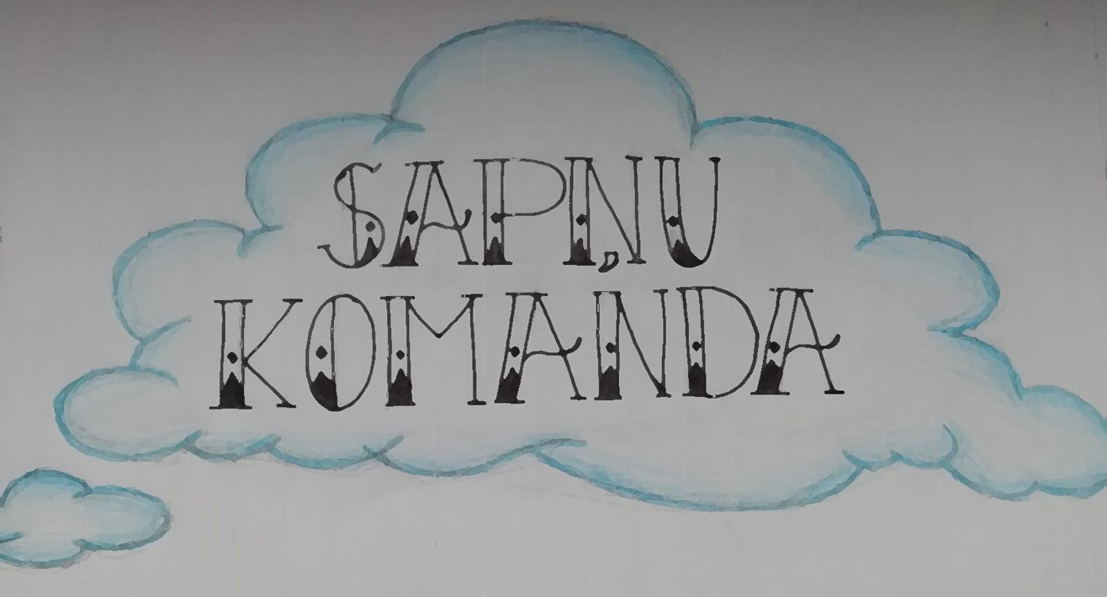

contact:
Leona Paegles iela 1
LV – 4101 Cēsis
Tel: +44 19902648

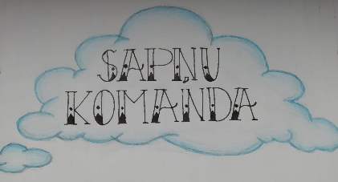
Aims

To create a resting place in Cesis State Gymanisum where students can relax and/or study.
Our company Sapņu komanda will create benches and waste bins for Cesis State Gymanisum.
It will be an outside chill and study area for the students, that they can relax, do their homework or just meet friends in front of school.

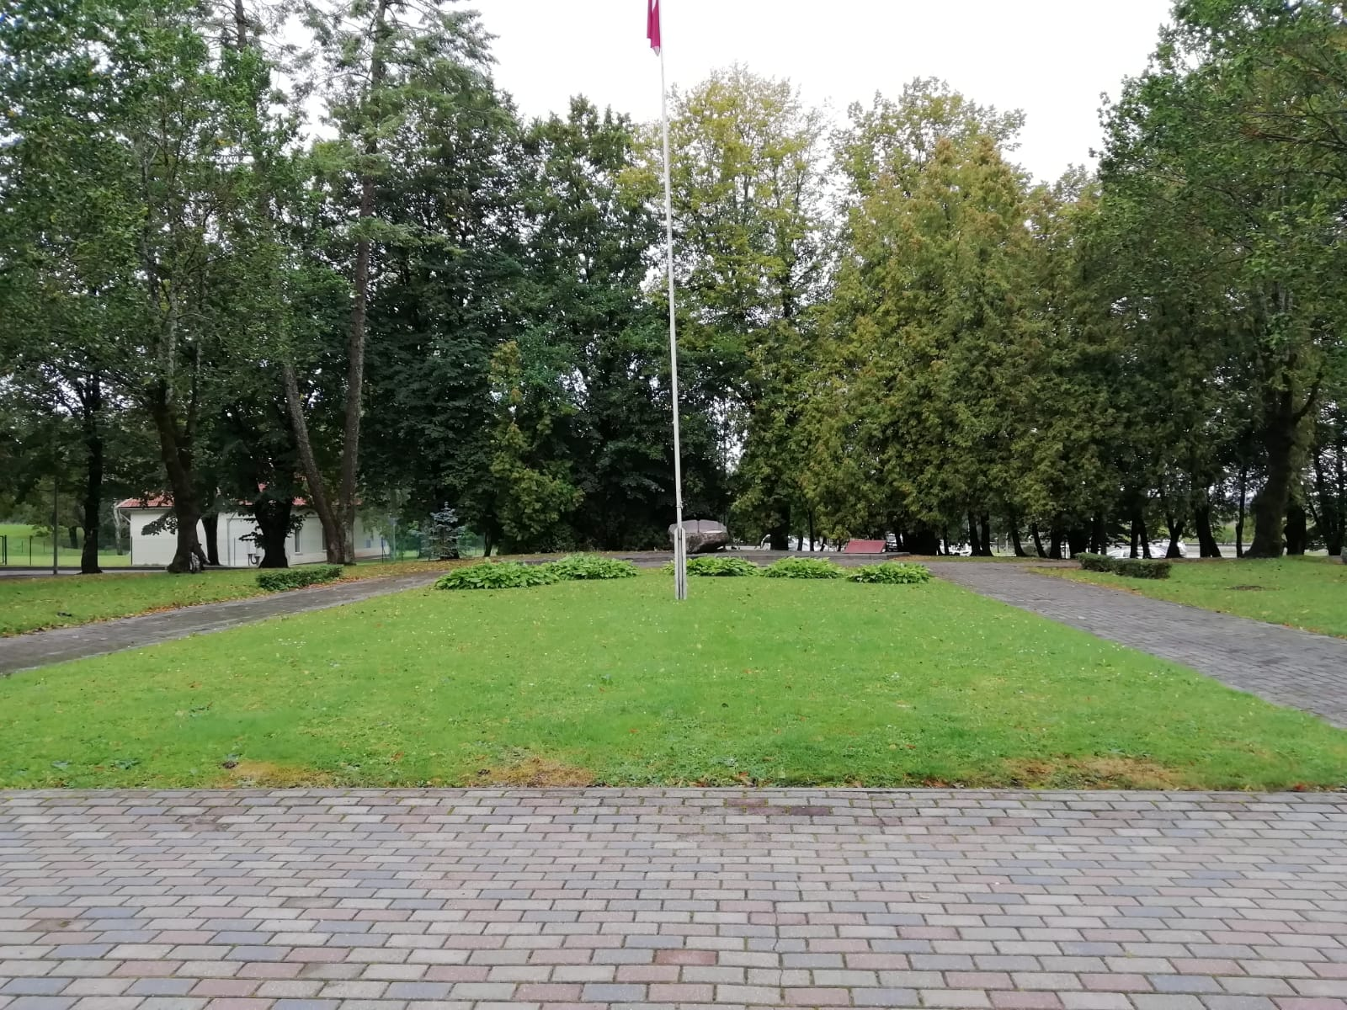

We support the school because we want to go outside more and enjoy the nature. Moreover, we think, that the rubbish bins can help the students to keep the area in front of school clean.

Description of products

We produce several kinds of woodwork for your schoolyard and school building, such as:
- Bird boxes
- BENCHES
- BIRD BOXES
- decorative elements

We can offer different designs for our products
Benches
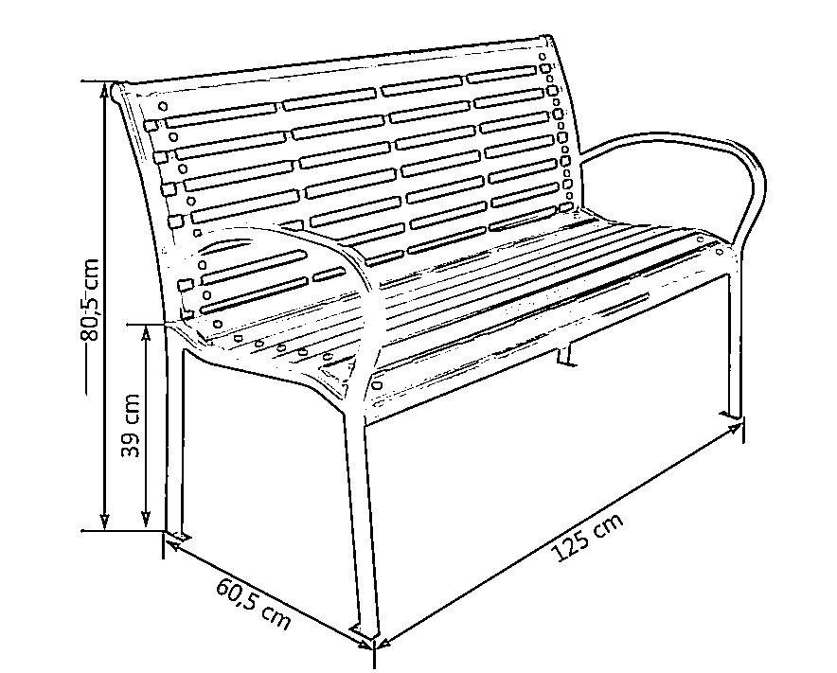

Bird boxes
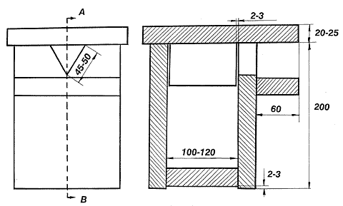
For nesting titmouse, sparrow, black snipe

MATERIALS AND COSTS
1. | 4 Metal benches | 395.20 €
2. | (1 x 35kg) cement bag | 9.80 €
3. | Pavement | 64 €
4. | Wood board for the benches and bird box | 50 €
5. | Nails, screws  (bird boxes, benches) | 22 €
6. | Plants and soil | 90 €
7. | Decorative elements | 40 €
8. | Trash cans | 100 €
 | Total costs | 771 €

Owners
President: Marta Latvia
Anete Latvia
Vice president: Theresa Austria
Agnes Austria
Secretary/reporter: Liene Latvia
Estere Latvia
Writer: Emma Germany
Organizer: Lena Austria
Verena Austria
Sophie Austria
Monika Austria
Jana Austria
Oriol Spain
Eric Austria
Anna Spain
Calculation: Eduard Spain
Matthias Austria
Emma Germany
IT president: Marian Spain
Time manager: Pauline Germany

