contact:
Nordstraße 4
D – 06632 Freyburg/Unstrut
Tel: 0049 3446428215

Aims – what we want to change
The main reason for this wall and making it colourful, is the fact that this school is very pale and colourless. To make children happy and to make the environment even move appealing and attractive we want to make this wall very bright and beautiful. Also, it is a way of getting all of the participants by colouring and drawing. Students can express themselves through it.

Description of the product
There will be a beautiful graffiti painting on the graffiti wall.
We have made the perfect design which includes cheerful and bright colours.
This wall will make the school environment more appealing and will have a positive impact on students as well as their work in school.

Final effects
- we would create a healthy, happy and over all cheerful environment for kids in school
- it will have a positive impact on students and their grades
- participants of this project will be able to test their hand in spray painting and wall painting, because in school it is not possible to paint pictures on such big formats.

examples of our work
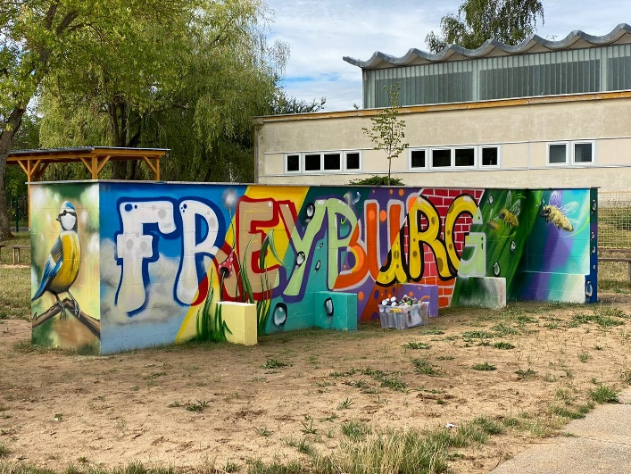

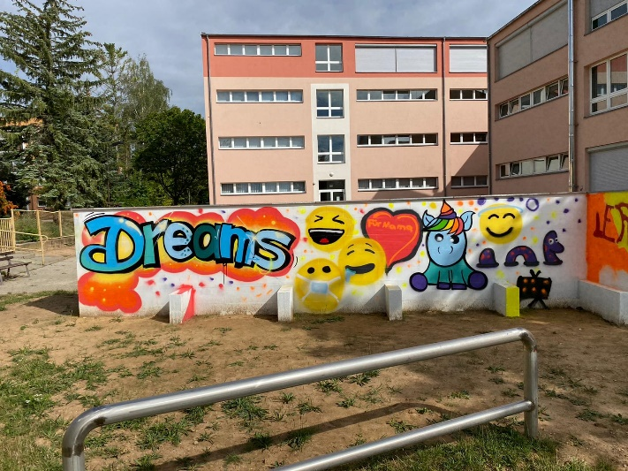

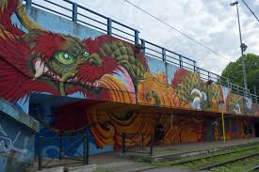

costs
installing the wall of concrete:
excavation work in your place | 1000,00 €
breeze blocks | á 5,00 €
concrete | 5,00 € per m³

spraying the wall:
mask | 34,00 €
spray can | 5,00 €
template | 14,00 €

Name of participants:
President Simon Riesen Germany
Vice president Alba Galcera Spain
Designer Marçal Arnal Spain
Maximilian Roy Germany
Secretary Nicole Stütz Austria
Oranizer Lena Leitner Austria
Florian Tschunko Austria
Worker Philipp Hoiböck Austria
Anda Upane Latvia
Viktorija Aleksejeva Latvia
Felix Resch Austria
Erik Naderer Austria
Finances Mileen Lehr Germany
Anna Tobia Spain
Press Emely Kugler Austria
Viktoria Mavraj Latvia

