SPI
School Playground Improvement

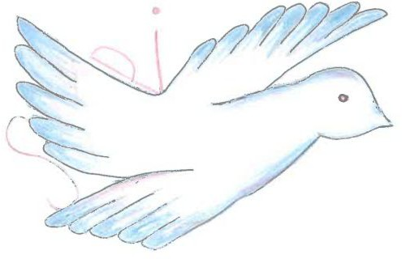

contact:

SPI

Calvari, 25

E - 43786 Batea

Tel: +34 977430016

AIMS - WHAT WE WANT TO CHANGE

The football field and the stairs were built many years ago so everything is old and broken. We want to repair, paint and decorate this stuff and have new things at the playground so all students of primary and middle school would want to come to school.
We would like to build a natural place where we could chill between lessons and not only a place with fields to play sports.
We would like a place for reading relaxed, a place where to chat with friends… We also want that kids can play freely, sit if they want in a nice place, run and walk.

OBJECTIVES
- to motivate that the children go out more in the breaks, so they can feel they are in their own environment
- to make the school more colourful, a beautiful place, a relaxing place according to environment
- to make the place cleaner, that everybody can recycle and put waste in the correct bin
- to learn the values of school and education at the same that we respect other free spaces

DESCRIPTION OF THE PRODUCT

In Spain - project, we are improving the playground area of the school in Batea.
We want to improve the garden to make it more beautiful, useful, entertaining…
At the moment, it is quite old and not very useful as it only has a football field and basketball court.

Before
GARDEN LADDERS
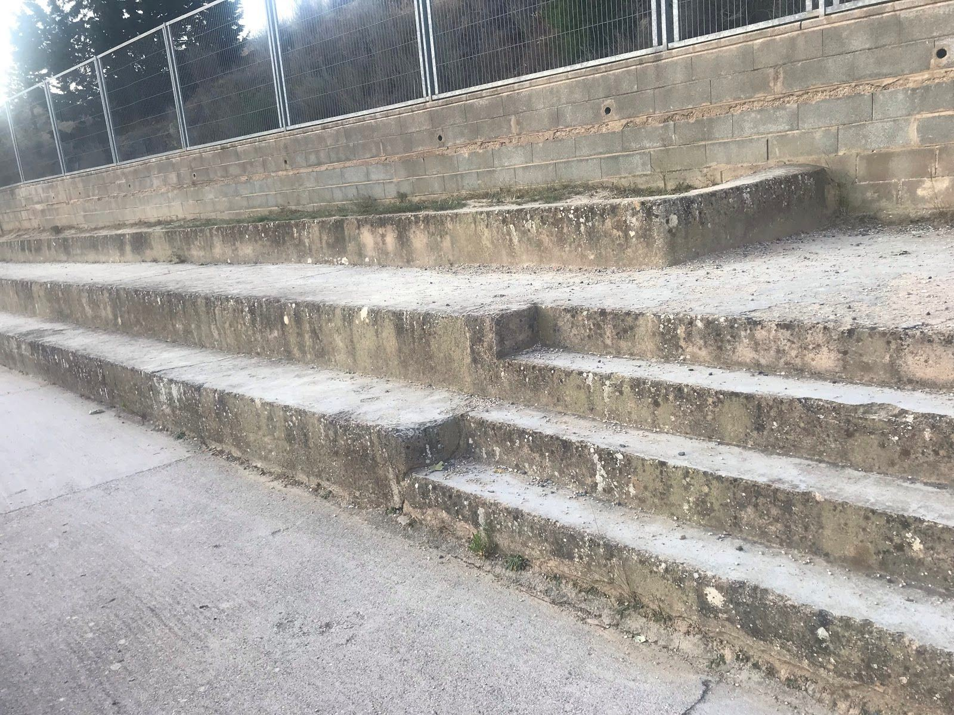

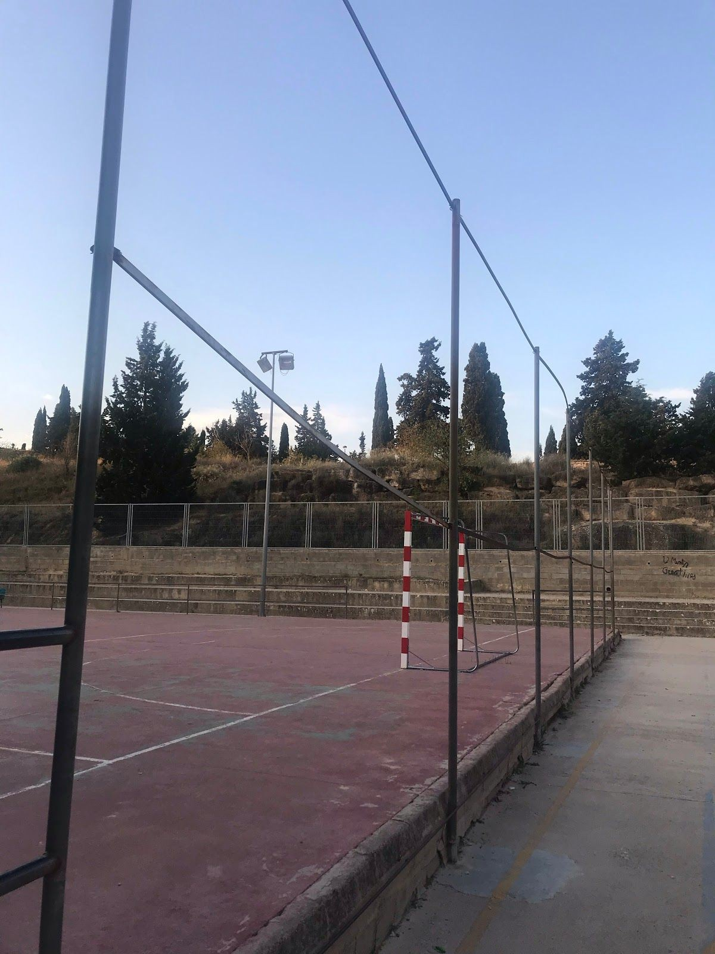
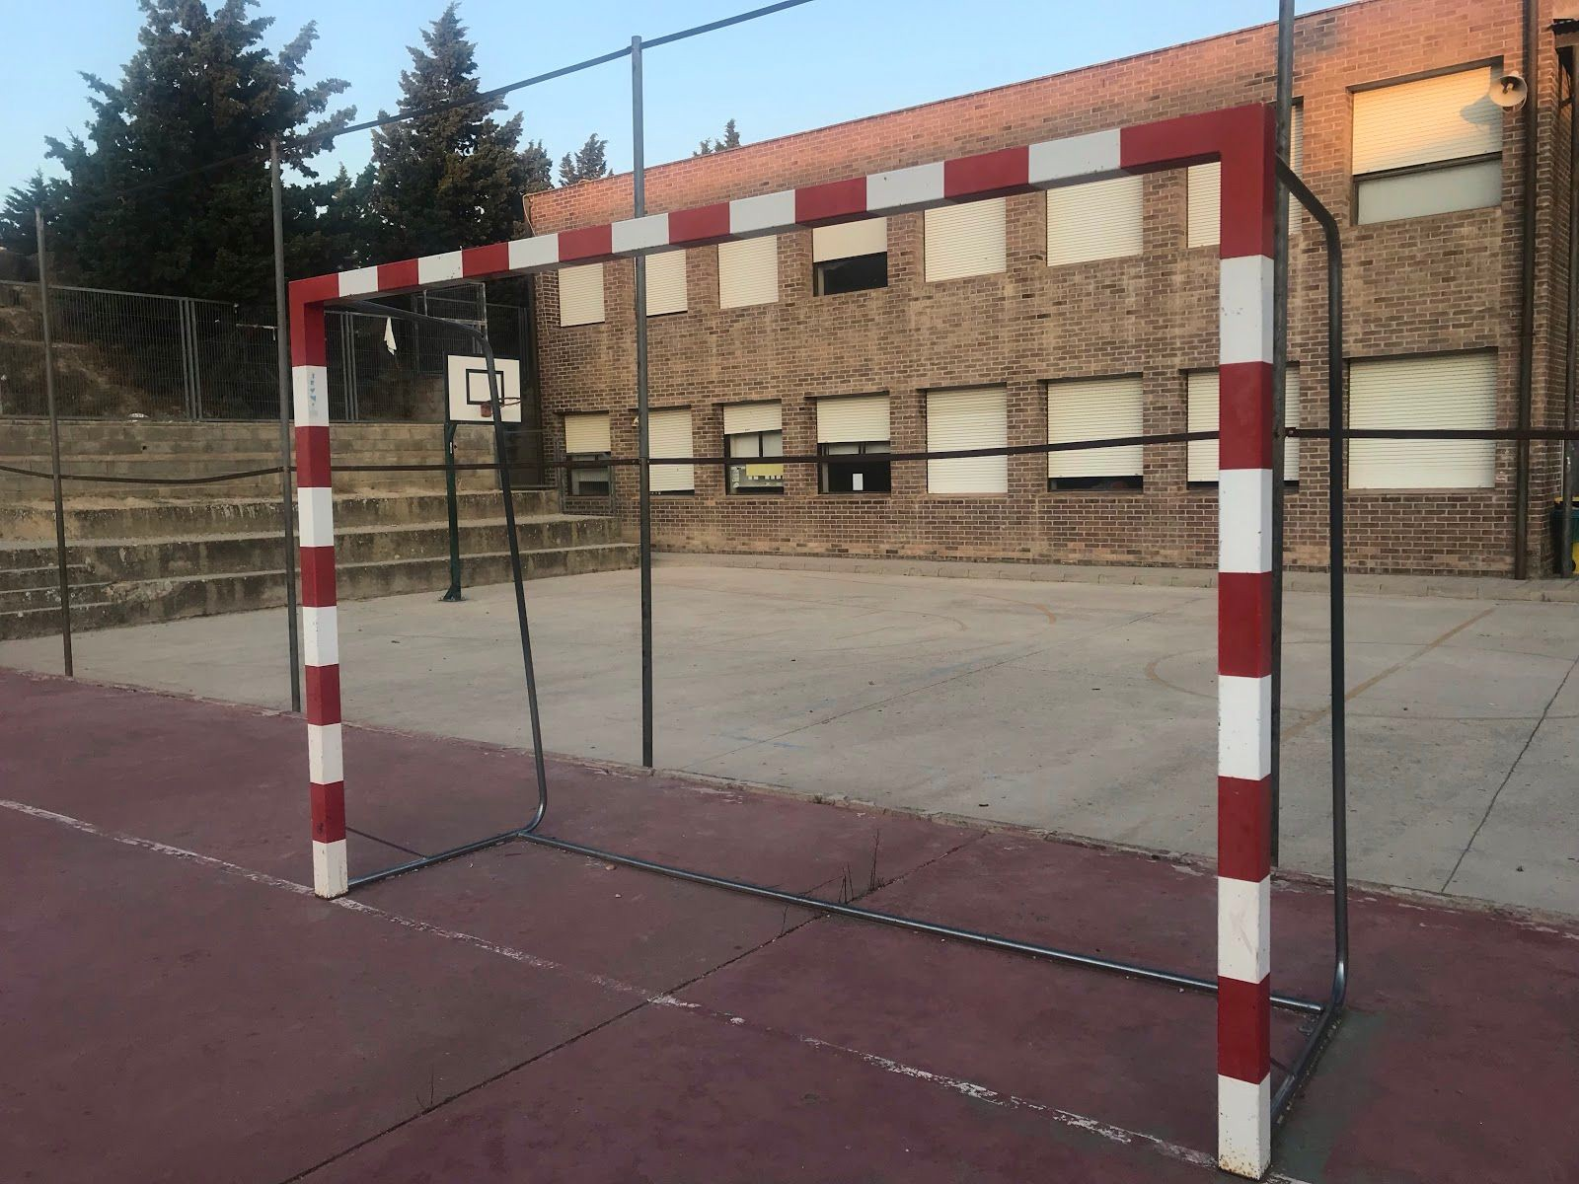
GOAL AND FOOTBALL CAMP NETS

After:

WOOD HOUSE for material
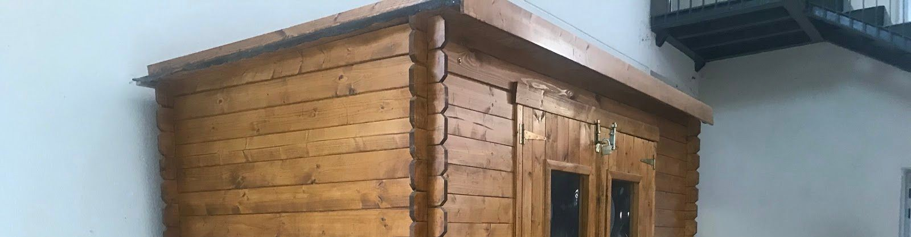

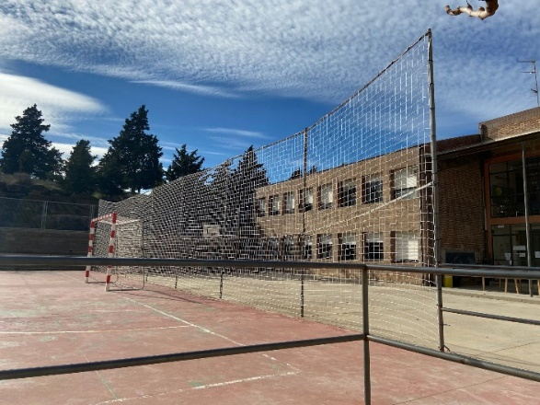
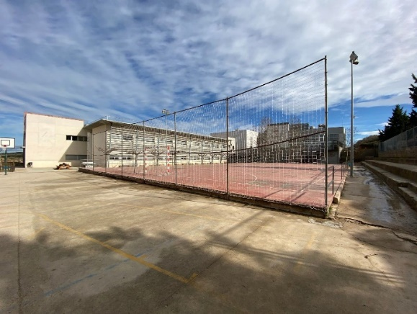

MATERIALS YOU NEED

- Raised bed for garden/vegetable garden:
wood, foil, stabler, bolts, soil and seeds
- Paint the stairs:
scrop the ross and clean the concrete stairs, colour
- Football field:
new color to the field, a net for the football and basketball field and a net around the football field
- Something to chill:
wood and cushions
- Trash cans/bins:
new bins for recycling.
- Tables for ping-pong:
new tables that are fixed in the playground.

DESIGNING

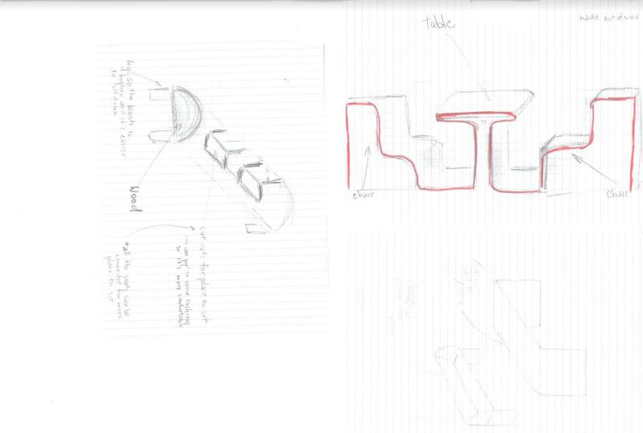

CALCULATION/COST

Wood - Foil - Stabler - Bolts - Soil - Seeds - Scop the ross -

Clean the concrete stairs
Paint
Net for the football field
Cushions
Trash cans/bins
Tables for ping-pong
Wood sofa
Gaga pit game
Paint the football field
Basketball court
Benches and tables

NAME OF PARTICIPANTS

President: Paula (Spain)
Secretary: Clemens, Betija, (Austria, Latvia)
Reporter: Lysann, Pauline, Cornelia (Germany, Austria)
Designer: Betija, Victorija, Dina (Latvia)
Vice-president: Guillem, Marti (Spain)
Innovator: Teresa, Tamara (Spain, Latvia)
Supervisors: Paula, Guillem, Jessy, Natalia, Ann-Katrin (Spain, Germany, Latvia)

