Music and Painting Company Ltd

Kontakt:
Music and Painting Ltd
Bahnhofstraße 18
A – 4240 Freistadt
Tel.: 07942 / 7 34 12
Direktion: 07942 / 7 34 12 – 11
Konferenzzimmer: 07942 / 7 34 12 – 12

Aims

With our products, we want to inspire people to be more creative in their free time.
We want to offer different types of our fantastic package, so that people are not limited in their creativity.
There will be great boxes on different topics and different styles of music. There will be boxes for nearly every taste from the fan of classical music to the hard-core heavy metal freak; there will also be opportunities to buy seasonal boxes, like during Christmas or Easter season. Each box will also offer the
appropriate premium colours, so that every box can help you to create a great masterpiece of art. We want to sell our products, to get money to support our school music events.
There will also be the great opportunity to get one of the very rare and limited Supporter Packages which include our great product, the Supporter Pack Certificate and a VIP ticket to one of our next school musicals for a minimal surcharge of 30 Euros
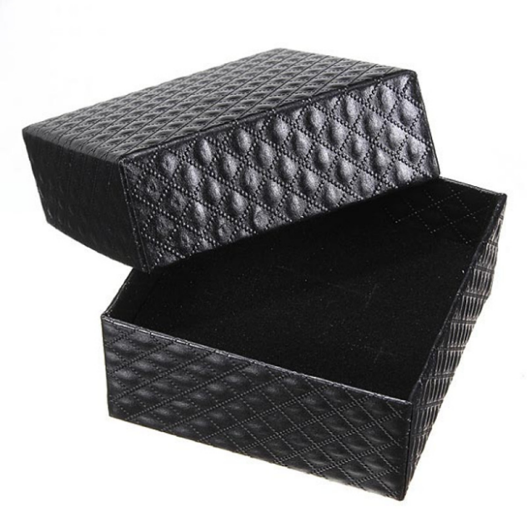
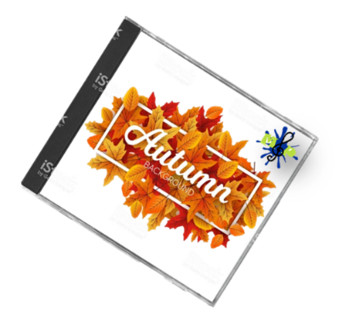

Description of the product

A package of our Music & Painting includes a high quality Compact Disk, a stretcher frame with a premium canvas, 24 different artist’s acrylic painting colours and 10 red sable brushes. Each package is a perfect composition, hand selected by a team of extraordinary artists and musicians.
Every box comes with an additional code with free downloadable bonus content.
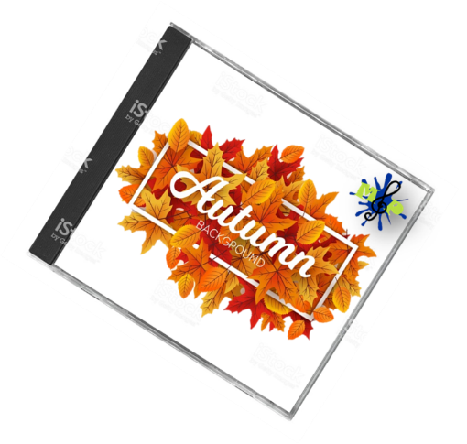
We produce several individualized editions of our package; at the moment our product catalogue consists of the following great editions:
- Spring Flowers Package
- Summer Vacation Package
- Autumn Colour Package
- Winter Wonderland Package
- Pop Music Package
- Heavy Metal Package
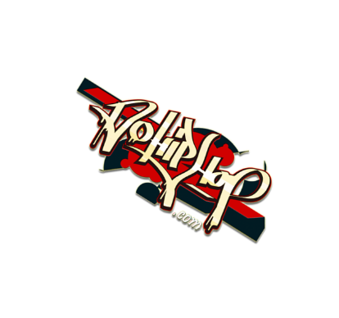
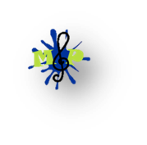
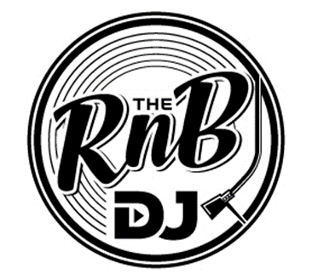
- Hip-Hop Package
- R’n’b Package
- Classical Music Package
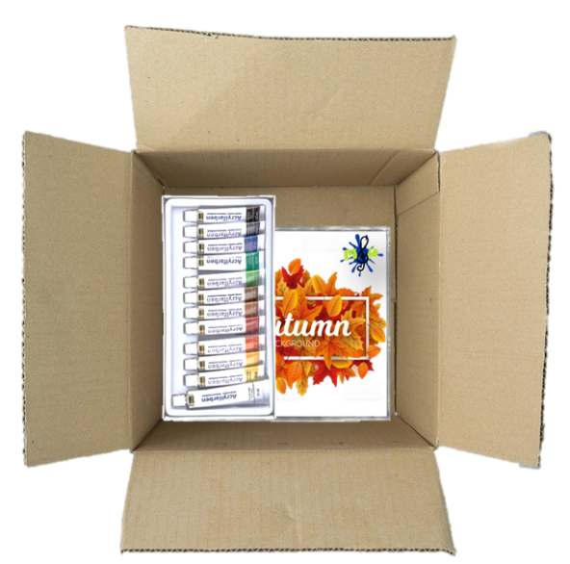

Building instructions/technical information sheet
You have bought one of our top quality stretcher frames with our premium canvas. The sizes may vary but all our frames work the same easy way. (pic 1)
Place all four parts of the frame in front of you. Attach them as you see in picture 2.
Place the canvas evenly on the frame and put the fabric edge in the frame.
Tighten the fabric and cling the canvas to the back of the frame.
Affix the four corners with the help of the 8 shims. Every corner is fixated with 2 shims.
Have a great time and let yourself be inspired by the great tracks on our Compact Disk.
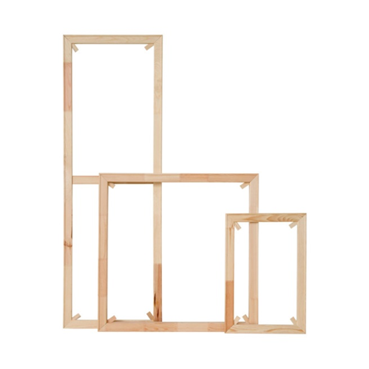
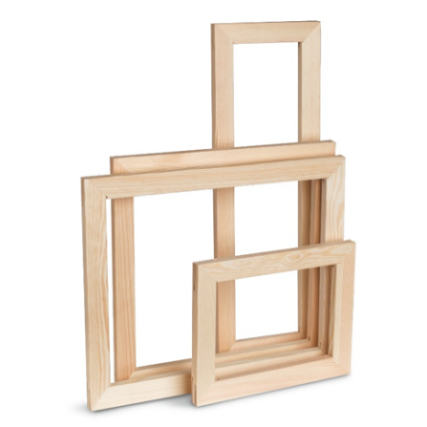
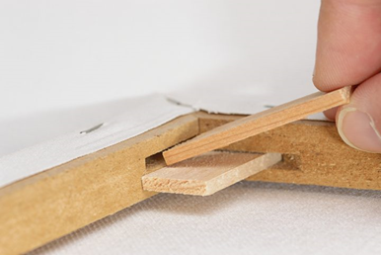

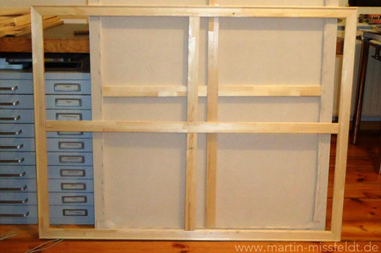
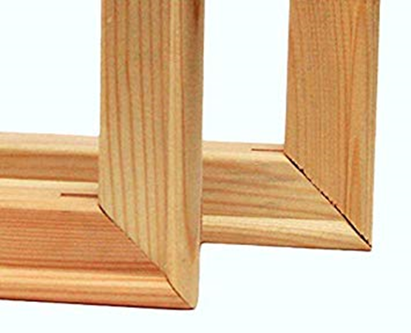
Designs

That’s how a painting could look like.

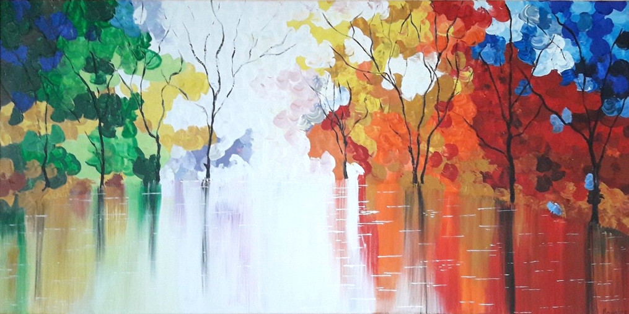
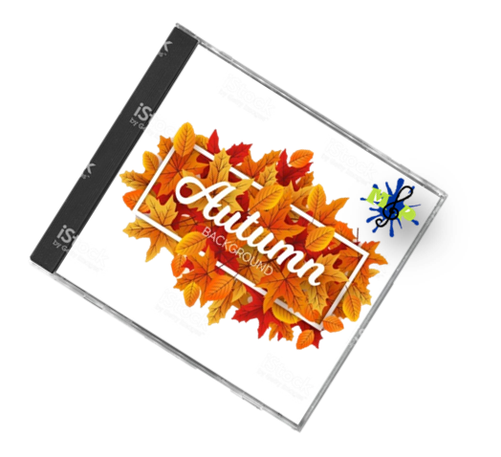

Costs-benefit-analysis

 |  | Pieces | Euro
 | Frames | 100 | 200
 | Blank CDs | 100 | 20
 | Find tracks | 10h | 200
 | GEMA costs |  | 1000
 | Boxes | 100 | 24
 | Colours + pencils | 100 | 1097
 | Packing | 5h | 100
 | Order management | 1h | 20
 | Shipments |  | 6
 |  |  | 2667 |  | 26,67
 | Taxes (0% profit) | 20% | 533,4
 |  | Total costs | 3200,4 | costs/PP | 32,004
 |  | Price | 5334 |  | 53,34
 | Taxes (200% price) | 20% | 1066,8 |  | 10,668
 |  |  | 6 400,80 € | final price | 64,01 €
Names of participants

Money man Leonie Holzer/ Paul Kreindl Austria
Designer Mona Merten/ Hannah Kelih Austria
Designer Alina Austria
Secretary Laura Sole Spain
Secretary Gabriela Staico Spain
Worker Fernando Lupu Spain
Organizer Laura Winkler Germany
Vice president Evelina Glaudina Latvia
President Stephanie Krause Germany
Worker Mar Dominguee Spain
Organizer Helena Horner/ Astrid Kreuer Austria
Organizer Sarah Fleischanderl/ Lisa Austria

