Project penguin watch

Authors | Jakub Šafařík, Martina Zýková
Version | V1 – 12/06/2019

Table of contents:
1 Lesson plan 4
1.1 Method 4
1.2 Introduction 4
1.3 Materials 4
1.4 Concept 4
1.5 Objectives 5
1.6 Subjects 5
1.7 Skills 5
2 What is the project about 6
2.1 Threats to Antarctic species 7
2.2 Why aerial photos? 7
2.3 How did we collect these photos? 8
3 Education 11
4 Outcome 12
4.1 Obscured / Blurred / Dark images 12
4.2 Objects in image margins 13
4.3 Close versus distant objects and zoom options 14
4.4 Penguin species, chick or adult? 18
4.5 Other objects, unlisted animals 20
4.6 Cameras & locations 21
4.7 Talk: discussions boards, hashtags, notifications 22
4.8 Technical problems, mistakes in the classification & other questions 24
5 References 26

The European Commission support for the production of this publication does not constitute an endorsement of the contents which reflects the views only of the authors, and the Commission cannot be held responsible for any use which may be made of the information contained therein.

Lesson plan

Method
Students participate in an interactive activity where they get familiar with a purpose of the Citizen Science project, they learn how to cooperate and help the project, discussing possible reasons to join such projects. They then participate on the project.

Introduction
To celebrate World Penguin Day 2019 (25th April), Penguin Watch are partnering with WWF and the British Antarctic Survey (BAS) to ask the public to help count penguins from aerial photos taken with drones and planes. Some of these colonies are so difficult to get to that they haven’t been visited for 50 years! This information will help the scientists understand how they are being affected by climate change, the potential impact of local fisheries and how we can help conserve these incredible species.
Penguin Watch is an excellent tool for teaching students about a range of topics, including conservation, the scientific method, Antarctica and polar/cold habitats, and - of course - penguins!
WWF work with schools to help young people build their knowledge and understanding of the environmental challenges facing our planet and develop the skills to do something about them. Thousands of schools across the UK participate in our education programmes and we offer a wide range of curriculum-based resources and real-world activities to engage and inspire pupils, covering issues such as deforestation, climate change, plastics and endangered species. Today’s young people are the generation who will be most affected by these issues; our work with educators is part of our mission to build a brighter future for both people and nature.

Materials
You can download lesson plans (https://www.wwf.org.uk/get-involved/schools) or timelapse, videos and photos here (https://drive.google.com/drive/folders/1j4SVog1qazCjFJsm_xUHE1Dp3KJywYCw?usp=sharing).
https://www.zooniverse.org/projects/penguintom79/penguin-watch/about/faq#4.-penguin-species%2C-chick-or-adult%3F

Concept
Some pinguin colonies are so difficult to get to that they haven’t been visited for 50 years! Collecting and searching through the information from aerial photographs will help the scientists understand how the penguins are being affected by climate change, the potential impact of local fisheries and how we can help conserve these incredible species

Objectives
Students will be able to:
- Explain the reasons for citizen science projects.
- Analyze pictures and understand the process of identifying penguins.
- Use the software and cooperate in the project.
- Explain results and discuss the impact of climate change, human activities and other influence on the penguin population.

Subjects
www.zooniverse.org

Skills
Classifying information, identifying trends, calculating percentages and averages, creating and interpreting graphs, making predictions.

What is the project about
To celebrate World Penguin Day 2019 (25th April), Penguin Watch are partnering with WWF and the British Antarctic Survey (BAS) to ask you, the public, to help count penguins from aerial photos taken with drones and planes. A special camera was used to capture high resolution images of 140 colonies of Adélie, chinstrap and gentoo penguins (collectively the brush-tailed penguins) along the Antarctic Peninsula. Some of these colonies are so difficult to get to that they haven’t been visited for 50 years! The images contain unprecedented detail, giving us the opportunity to gather new data on the number of penguins in the region. This information will help us understand how they are being affected by climate change, the potential impact of local fisheries and how we can help conserve these incredible species.
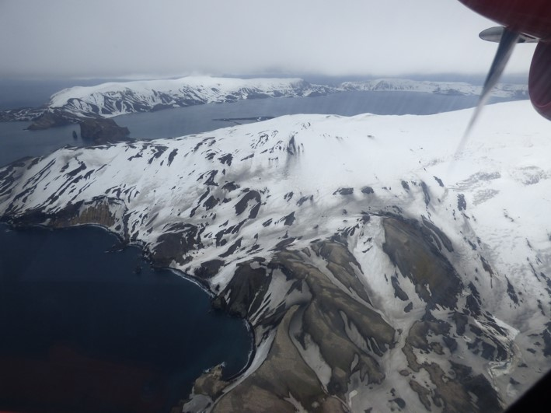
This image, taken by a researcher, shows the Baily Head colony on Deception Island (grey patches in the foreground). This colony is large and hard to cover on the ground, so aerial photos are preferable for coverage.

Threats to Antarctic species
Antarctica is the world’s highest, driest, coldest and windiest continent and is home to a range of exceptional species. However, scientists, politicians, and civil society have raised concerns over this unique ecosystem, and the risks it faces from climate change, fisheries and direct human disturbance. Over the latter part of the twentieth century, the Antarctic Peninsula has been amongst the most rapidly warming parts of our planet and this is causing significant reductions in sea ice and the collapse of ice shelves. This has important consequences for species living in these areas and for the management of local fisheries. Penguins are used by scientists as indicators of change within their ecosystem because, as easy to monitor species, any change in their breeding performance, or population size and distribution are likely to reflect changes to species at lower down the food chain, or in the Antarctic environment as a whole. Therefore, monitoring these species will provide valuable insight into the large-scale changes occurring.
Antarctic krill is the focus of a fishery that operates in the Southern Ocean and, following regional decreases in sea ice extent and duration, is now increasingly operating during the summer months at a time when krill-eating predators, such as penguins, are breeding. A key issue therefore, is how to manage krill fisheries so that they do not cause irreversible impacts on krill-eating predators like penguins. In order to do this, we need to closely monitor penguin populations, particularly those using areas that overlap with the fisheries. However, many of these colonies are challenging to access and have only been visited once or twice. We, therefore, must make use of remote techniques such as analysis of aerial photography to monitor these penguin colonies and to measure any population change that might have occurred.

Why aerial photos?
Aerial photos help us to monitor the number of penguins in specific colonies over time and allow us to gain highly accurate counts from some of the most remote places on Earth.
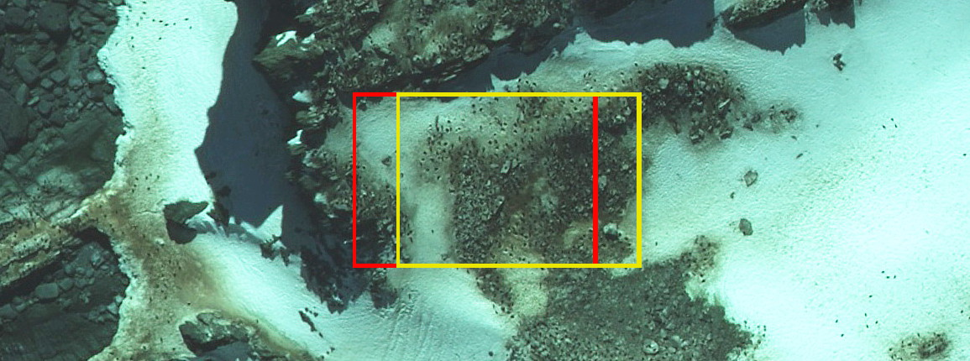
For example: this aerial photo comes from Cape James in the South Shetland Islands. The red box shows the section that you might see, and the yellow box shows part of the image that the next volunteer might see. We tile these images so that you can see and count roughly 30-60 penguins on average. We take several volunteers' classifications and cluster them around each of the penguin nests. The tiles overlap so that we can tell which penguins are counted on the edge of a tile (so that each nest site only appears once in the final analysis).

How did we collect these photos?
We used a specialised large-format camera designed for detailed topographic mapping to capture the photos. It’s the same type of camera used by National Mapping Agencies, such as the UK’s Ordnance Survey, to update their topographic maps.
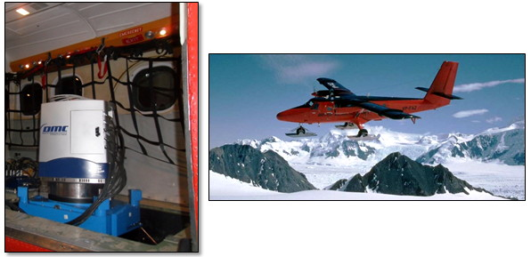
The camera (left image) is mounted within the British Antarctic Survey Twin Otter aircraft (right image) and looks downwards through a hatch in the floor behind the skis. The camera was installed using a self-levelling mount to keep it pointing vertically downwards.
It can capture 12 cm resolution images along a 1.6 km wide strip, giving the detail needed to count the penguins accurately but with enough ground coverage to photograph most of the colonies with only one over-flight. All the colonies in the study were photographed at between 6 and 12 cm resolution, depending on light and cloud conditions. The Twin Otter could cover about 1000 km on each photo-flight allowing us to include very remote penguin colonies along the Antarctic Peninsula. At all times, the aircraft follow specific guidelines to ensure there is no disturbance to the animals on the ground.
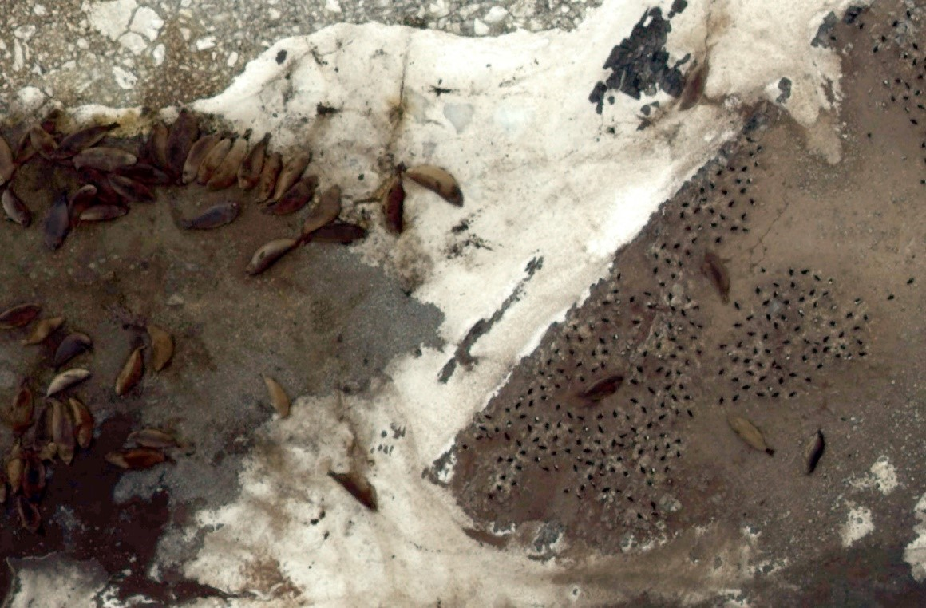
The images show amazing detail! For example, here we can see Adélie penguins and elephant seals on Avian Island, Marguerite Bay.

Education
Penguin Watch is an excellent tool for teaching students about a range of topics, including conservation, the scientific method, Antarctica and polar/cold habitats, and - of course - penguins!
Teach students about a range of topics, including conservation, the scientific method, Antarctica and polar/cold habitats, and - of course – penguins with Penguin Watch and WWF!
WWF work with schools to help young people build their knowledge and understanding of the environmental challenges facing our planet and develop the skills to do something about them. Thousands of schools across the UK participate in our education programmes and we offer a wide range of curriculum-based resources and real-world activities to engage and inspire pupils, covering issues such as deforestation, climate change, plastics and endangered species. Today’s young people are the generation who will be most affected by these issues; our work with educators is part of our mission to build a brighter future for both people and nature.
You can download lesson plans (https://www.wwf.org.uk/get-involved/schools) or timelapse, videos and photos here (https://drive.google.com/drive/folders/1j4SVog1qazCjFJsm_xUHE1Dp3KJywYCw?usp=sharing).

Outcome

Obscured / Blurred / Dark images
Studying night time/winter behaviour in penguins has never been done before because of the logistical difficulties of observing penguins in winter/at night. Sometimes the camera lenses get covered by snow/water/ice due to bad weather conditions in Antarctica. Please, try your best when you get such an image. Thank you!
Fully obscured / Too dark
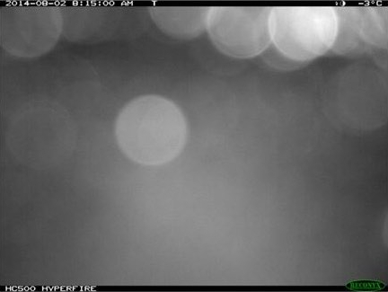
- If possible, mark as many penguins as you can.
- When you are not able to mark any individual animals (even when you think they’re present), check the box saying ‘This image is too dark or blurry.’ just below the marking options in the classification task.
Partially obscured / Bad lighting
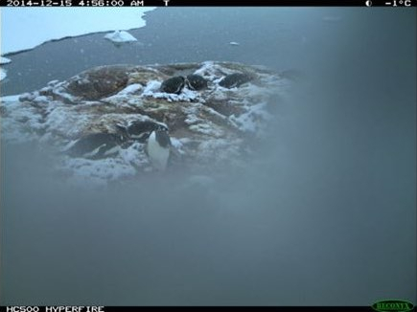
- Mark as many penguins as you can and then answer with 'There were too many penguins to count'.

Objects in image margins
Marking objects
- What objects to mark?
Any objects (penguins, ships, …) which are partly/mostly behind the image margin. Please, also mark visible reflections of vessels being behind the image margin (remember that these should be marked as ‘Other’).
- What objects NOT to mark?
Don’t mark any shadows. Your marks also help develop a recognition tool using machine learning (computers) so we need to mark only animals that are visible.Don’t mark penguins or other animals swimming in open water.
- Where to place marks in partly visible animals?
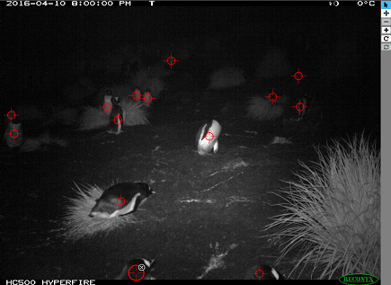
Place the mark in the center of the visible part (beak, head, foot, …) as visible in the image above (head marked at the bottom of the image).

Close versus distant objects and zoom options
Close versus distant penguin colonies
In the case of penguin colonies, find below the four most common scenarios related to their distance to the camera with instructions on how to mark them. Note that these instructions only apply to penguins and other objects should be marked whenever possible (see 5. Other objects, unlisted animals).
- Scenario 1: The penguin colony is present in the foreground. If so, mark all of the penguins or, if there are too many, mark as many as possible and then click ‘Next’ and select 'There were too many to count’.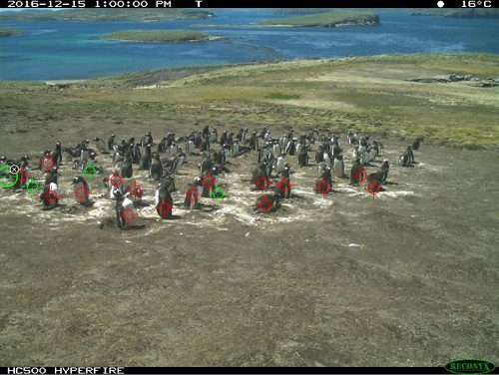
- Scenario 2: Same as scenario 1, but there are also tiny penguins in the background. If so, mark as many penguins as possible in the foreground and ignore the small ones in background. Then click ‘Next’ and select 'There were too many to count’.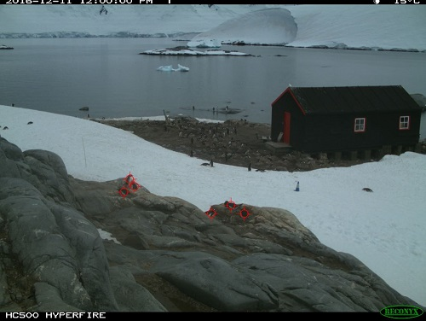
- Scenario 3: Penguins are only present in the background. If so, mark a few, click ‘Next’ and select ‘There were too many to count’ again.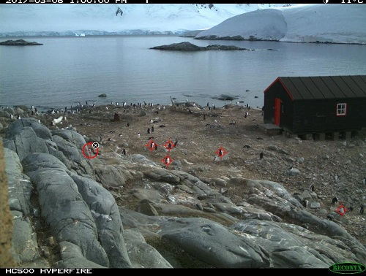
- Scenario 4: No penguins. If so, click ‘Next’ and select ‘Yes’ (you have marked all the animals).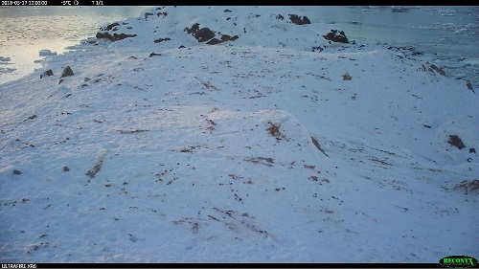
If the penguins on the far side of the colony are too small for you to mark, please see how to use the ‘Zoom-in’ tool in the Zoom Options section below.
You can also 'Hide previous marks' by checking the box at the bottom of the Task window (below the ‘Need some help with this task?' question). This is specially helpful when the penguins are obscured by the marks while standing close to each other. Make sure you check that no penguin has been marked more than once.
Swimming animals / Flying birds
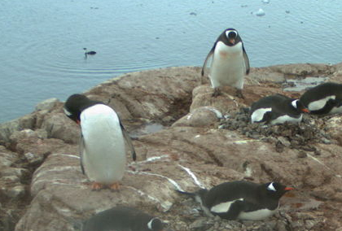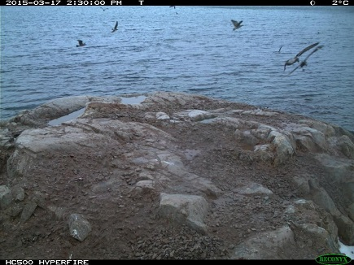
- You don’t have to mark any swimming animals.
- If there are distant birds flying above the sea/land and are too small to be identified, don’t mark them.
- If there are too many other animals, it is OK to mark only those closest to the colony.
Too many penguins to mark
We really appreciate when you mark them all but we understand there may be too many of them for you to mark. In such cases, start with the foreground ones and after you finish marking, don’t forget to answer ‘There were too many to count’.
Zoom options
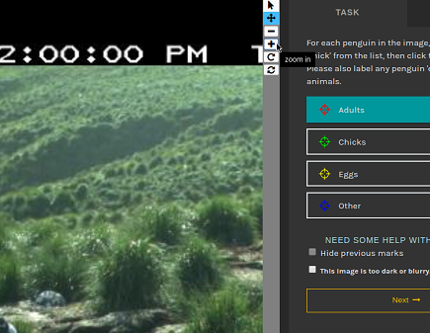
On the right side of the image, there is a list of useful tools. Use the ‘+’ shaped button to zoom in the image. Then you can pan over the image using the arrow keys on your keyboard. Use the ‘-’ shaped button to zoom-out the image.

Penguin species, chick or adult?
What species they are and how do we classify them?
- Penguin species? No need to worry about recognizing individual species (and no way to classify them either). We only need you to recognize adults from chicks. The key features for telling them apart varies in individual species and they change during the chick’s growth. Sometimes you can even see mixed colonies of 2-3 different species.
- Nests? No need to mark them in the ‘Time lapse cameras’ workflow. We only care about eggs/chicks/adults/predators.
- Eggs? We rarely see them. Mark only eggs you can really see. Don’t mark eggs outside the nest or broken ones/empty egg shells.
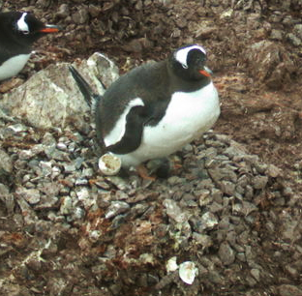
Empty egg shells or eggs outside the nest - We do not mark them.
- Chicks? Check out the breeding cycles in the Field Guide (to be found on the right side either on Talk or on the Classification page) to know when to expect to see chicks. Mark only chicks you can see and you are sure about.
- Moulting penguins? As long as you can see chick features on them (see them below) mark them as chicks. Otherwise we mark all moulting penguins as adults.
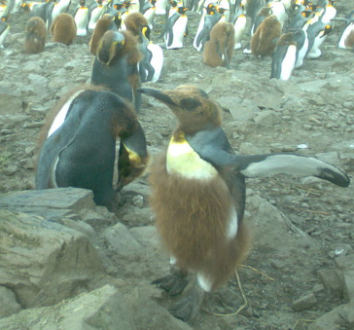
Moulting chicks of King penguins - you can clearly see some brown feathers = mark them as chicks.
Unsure what you see?
If unsure whether you’re looking at egg/rock then don’t mark it.If unsure whether a chick/adult, mark it as adult.
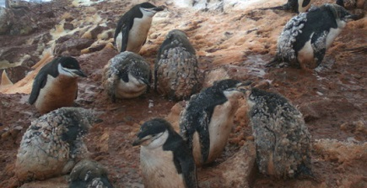
These may look like moulting chicks to you but they may be moulting adults as well. When they have all marks of maturity visible = mark them as adults.

Other objects, unlisted animals
You can see various objects although some of them aren’t listed for marking. Don’t forget to check the Field Guide for image examples of other animals you can see in our images.
What to mark:
- Humans, ships and other vessels (as ‘Other/People’).
- Any other animals (on the land), even when unlisted - you can mark them using the ‘Other’ (blue) mark without choosing any option from the list.
- Other flying birds that can be identified.
What “not” to mark:
- Human equipment such as cameras, bags, tents, buildings.
- Animals swimming in the water (neither penguins nor seals) and birds flying in the distance which are too small to be identified.
- Any nests (in time-lapse-cameras images), also we do not mark eggs/chicks that we don’t really see, or broken egg shells, or abandoned eggs (out of nest).
- Carcasses (dead chicks which are torn in pieces, being eaten or shrunken so we’re sure they’re not alive any more).
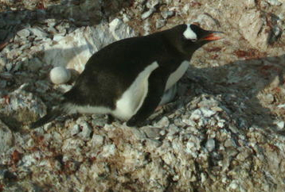
An abandoned egg - We do not mark these.
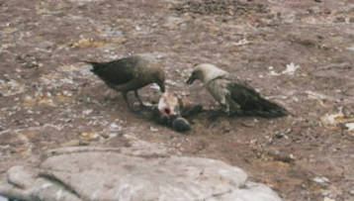
Skuas feeding on a dead penguin chick. We do not mark dead animals.
Group of people
If there are many humans present, it is OK to mark only the one closest to the colony. Where there is a group of humans close to the colony, place just one Human mark in the center of the group.

Cameras & locations
- Currently there are 100 cameras placed throughout the Southern Ocean and along the Antarctic Peninsula, each capturing 8000 images per year. The places where penguins nest are called rookeries. Most penguin species usually return to the same rookeries each year, but Gentoos tend to move their nests by as little as a few metres or even several kilometres from one year to the next.
- Here is a map showing some of the camera placement (not all!):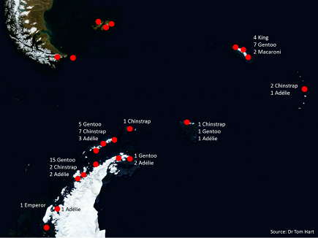

Talk: discussions boards, hashtags, notifications
Discussion boards
PW project Talk consists of:
Search
For filtering the posts by a keyword or by a tag; to be found at the top of the Talk page heading.
Notes
Image comments started by the ‘Done & Talk’ button directly from the classification.
To get a link to the image in full resolution click on the ‘Subject Image’ button (icon of a picture), below the image on the right. (Only available from the Talk interface.)
Individual Discussion boards:
- Science - for discussing project research and its goals, for discussing your observations, scientific discussions about penguins/Antarctica etc.;
- Help - for discussing technical problems with the project interface, FAQs etc.;
- Feedback - to let us know your feedback on the project interface, for sharing your ideas for an improvement;
- Chat - for anything else which doesn’t fit in the previous boards;
You can subscribe to get a notification when a new post appears; to be set just below the discussion title.
Recent comments
The most recent posts are displayed at the top of the page together with an image; 20 posts displayed on a page.
Popular Tags
The most popular tags listed by their frequency; Clicking on an existing tag will load all posts including that tag;
Comment box buttons, emojis
There’s a HELP button (with ‘?’ icon) for composing a new post (to be found in the top right corner of the comment box).The help includes list of supported emojis and Zooniverse markdown style and hashtags.You can ‘preview’ your post before submitting by clicking on the ‘eye-shaped’ icon, top right corner of the comment box. To be able to edit your post again, while in the preview-mode, click on the ‘pencil’ icon called ‘Edit’.
Hashtags - How to use them?
Using hashtags in comments is very specific here - it helps us find what we need. Here is a Hashtag guide to help you understand how to use them properly. The best way is to choose one of the suggested (existing) keywords that appear once you start typing after the ‘#’ symbol. List of the most popular tags can be found on the right side of the discussion boards. Only tag things you are sure that are visible in the image.
You can use:
- #interesting for interesting/extraordinary observations that deserve attention of the PW team.
- #DailyZoo to suggest images for Daily.Zooniverse blog. If you want to be sure your suggestion isn’t missed, then share the link to it in the DailyZoo suggestion discussion on the main Zooniverse Talk.
Mentioning/notifying users or moderators
You can use the @ symbol followed by a user name for mentioning and notifying others. Be careful and write the name accurately - don’t confuse capital with lowercase letters and vice versa. Also, Some users have a different ‘display-name’ than their ‘username’. In such cases use the one in grey letters, displayed below the ‘display-name'.
Using @researchers will notify the whole PW research team about your post; @moderators will notify all moderators.
When someone mentions you in a post or replies to your comment, you’ll get a notification (at the top level bar on the right, or via email - depends on the personal settings).
Other
Other Talk related information can be found in the ‘PW Interface changes guide’ on the Talk under the Help discussion board.

Technical problems, mistakes in the classification & other questions
Troubles with the interface
Zooniverse projects, such as PenguinWatch, which require you to mark an item on your screen have not been designed for touch screen devices. During any zooming/panning action marks can be left on the screen mistakenly thereby reducing the accuracy of the data submitted. The exception would be a large format television or whiteboard, the type found in class rooms, although even these are likely to be less accurate than a non-touch screen device. We therefore encourage you to always use non-touch screen devices.
When having any technical problems with the interface, there are few suggestions to try first:
- If the image/classification interface doesn’t load properly, go to the project Talk and then click on the ‘Classify’ page again (the same image is supposed to load for the classification).
- Reload the page (a different image is supposed to load).
- Clear your browser cache. Here is a clearing cache tutorial showing how to do that in various browsers.
- Open the project page in a private/incognito window/tab of your browser.
If none of them helps, please, let us know via the HELP discussion board, and mention @researchers or @moderators in your post. We’ll need to know what exactly happens (what steps have you taken; the more details the better), and also what device, what Operating System and what browser version you’re working on. You can use this page to figure out what we’re asking for and just copy & paste your details for us: http://www.whatsmybrowser.org/ If the problem is visible on the page, you can also make a screenshot and share it with us. (You’ll have to upload it somewhere on the internet first, using a free online gallery like www.imgur.com). You can also report issues directly on GitHub (first make sure it hasn’t been reported by someone else already).
'Already Seen' or 'Finished' banner over the image
If you see 'Already seen' banner over the image in the classification, it means you have seen all the available images.If you see 'Finished' banner over the image, it means that all images have reached the required number of classifications.
Mistakes in the classification
Don’t worry if you think you have made a mistake in the classification. Each image is reviewed by multiple volunteers (the retirement limit is currently set on 10 volunteers per image). The scientists will compare the classifications with each other and the consensus will be used as the result. Any mistakes should get sorted out this way.You can comment on the picture if you’d like to learn what to do another time. But remember that the comments are not part of the classification results. They can be read on the Talk only.
What to do when you aren’t sure how to classify?
- Check out the FAQs again, there may be a helpful section you have missed
- Revisit the project Tutorial on the classification page (to be found on the right side of the ‘Task’ window).
- If you aren’t sure whether the object is a penguin or a rock, then it is always better not to mark that.
- Check the Field Guide on the right side of the Classification/Talk page. It will help you to tell chicks/adults apart.
- If you aren’t sure whether there are two chicks huddling in the nest or just one, mark it as one please.
- If you aren’t sure whether you have marked all the penguins, just answer ‘There were too many to count’ after you finish marking.
- Take it easy & have fun!

References
Project website address
https://www.zooniverse.org/projects/penguintom79/penguin-watch/about/faq#4.-penguin-species%2C-chick-or-adult%3F

