Project Asteroid Hunting

Authors | Céline Laugel
Version | V1 – 07/07/2019

Table of contents:
1 Lesson plan 4
1.1 Method 4
1.2 Introduction 4
1.3 Materials 4
1.4 Concept 4
1.5 Objectives 5
1.6 Subjects 5
1.7 Skills 5
2 What the project is about 6
2.1 Citizen science program in Astronomy 6
2.2 How to participate? 7
3 Education 8
4 Outcome 9
4.1 Astrometrica software 9
4.2 True vs false signatures 9
4.3 Let’s hunt! 10
4.4 Moving object found 11
4.5 Minor Planet Center (MPC) report 12
4.6 Tips 12
5 References 14

The European Commission support for the production of this publication does not constitute an endorsement of the contents which reflects the views only of the authors, and the Commission cannot be held responsible for any use which may be made of the information contained therein.

Lesson plan

Method

Students participate in an interactive activity where they get familiar with a purpose of the Citizen Science project, they learn how to cooperate and help the project, discussing possible reasons to join such projects. They then participate on the project.

Introduction
The International Astronomical Search Collaboration (IASC, fondly nicknamed "Isaac") is an online educational outreach program for high schools and colleges, in which students make original astronomical discoveries. Within hours of acquisition, astronomical CCD images are made available via the Internet to participating schools around the world. Under the guidance of their teachers, students analyze the images using the software Astrometrica, searching for new asteroids and confirmations of Near-Earth objects (NEOs). They accurately measure the time and position of asteroids moving in the background. The measurements are recorded in a report sent to the Minor Planet Center (MPC; Smithsonian Astrophysical Observatory, Harvard), which gives the students published recognition in its MPC circulars.

Materials
Astrometrica provides the ability to easily compare astrometrical images for the purpose of moving object discovery. You definitively need to familiarize with the software before the campaign. There is also a set of images and a quiz on the website, so you can practice. Software, guidelines and sets of images can be downloaded at: http://iasc.cosmosearch.org/Astrometrica.html

Concept
Asteroids are rocky, airless worlds that orbit our Sun, but are too small to be called planets. Tens of thousands cluster in the main asteroid belt, a vast doughnut-shaped ring between the orbits of Mars and Jupiter. Asteroids within a close proximity to Earth are called Near-Earth Objects, or NEOs.
Asteroids can be classified based on their size, composition, colour, position in the solar system and even how they were formed. They can range in size from Vesta—the largest at about 530 kilometers in diameter – to bodies that are less than10 meters across.
It is important that we learn more about asteroids, through further research and documentation since asteroids can tell us about the origins of our solar system and even the origins of life itself. Asteroids are discovered with the help of (optical) telescopes by amateur astronomers, using specialized software, any citizen can make such a discovery!
International Astronomical Search Collaboration is giving students and teachers the opportunity to make their own discoveries by participating in asteroid campaigns.
Teams can download image set and search them for asteroids just hours after they have been taken along the celestial ecliptic at the University of Hawaii (Pan-STARRS). Using the software Astrometrica, they can accurately measure the time and position of asteroids moving in the background. These measurements can then be recorded in a report to be sent to IASC.
Teachers can ask for help from IASC teachers who have participated in asteroid search campaigns available through the website and are used to using the software.

Objectives
Students will learn:
- what an asteroid is and why they are being studied and observed.
- to use the software Astrometrica.
- to analyze pictures, search for moving objects and avoid ‘false signatures’ , moving object that are not asteroids.
- to write a report to the Minor Planet Center.

Subjects
‘Hunting asteroids’: searching for asteroids on astrometrical images using a specific software.

Skills
Using a new software, identifying moving objects, analyzing data to recognize asteroids among other moving objects, reporting on a clean and accurate way.

What the project is about

Citizen science program in Astronomy

The International Astronomical Search Collaboration (IASC) is a citizen science program. It provides high quality astronomical data to citizen scientists around the world. They are able to make original astronomical discoveries and participate in hands-on astronomy. This is a way to get people involved in scientific projects and be aware of the aims of Science.
You might discover a completely new asteroid never spotted before! But marking known objects is also very useful because it means you are perfecting the location of the object which enables the program to predict its location in the future.
To get the images, the International Astronomical Search Collaboration (IASC) works with the Panoramic Survey Telescope & Rapid Response System (Pan-STARRS).The Pan-STARRS camera is attached to the 1.8-m PS1 telescope located on Haleakala, Maui. It produces 1.4 billion pixel images that are partitioned into 64 sub-images for distribution to schools. During one night, PS1 produces 2 terabytes of data, equivalent to 500 DVD movies. One PS1 image is equivalent to a full 45-day campaign using images from the Astronomical Research Institute (ARI, Westfield, IL). IASC and the ARI have conducted search campaigns since October 2006.
Follow-up support is provided by Tarleton State University (Stephenville, TX), Western Kentucky University (Bowling Green, KY), Sierra Stars Observatory Network (Markleeville, CA), Faulkes Telescope Project (Wales), and Shiaparelli Observatory (Italy).
High school and college students participating in these campaigns are located in Brazil, Bulgaria, Germany, Poland, Taiwan, Turkey, China, Italy, Japan, Morocco, Portugal, Russia, and the United States.
Since starting in October 2006, participants have made over 1,500 asteroid discoveries. To date 52 have been numbered and placed into the world’s official minor bodies catalog maintained by the International Astronomical Union (IAU, Paris). Numbered asteroids can be named by their discoverers.

How to participate?
If your citizen science group would like to participate in an IASC search campaign, you should have a look on the website and choose the campaign you would like to join.
Example: 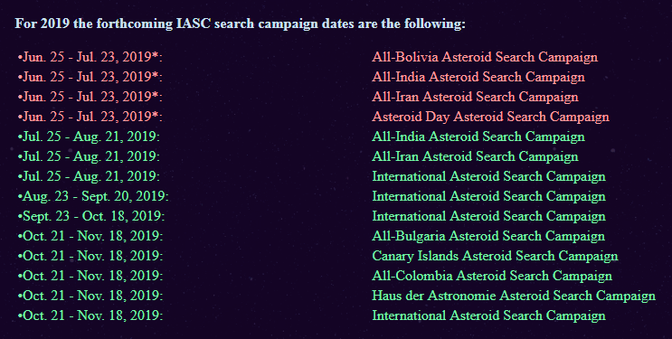
In red, the campaigns that are underway. In green, the ones you can apply for.
Before the campaign begins, contact the IASC Director, Dr. J. Patrick Miller by email at:
iascsearch@hsutx.edu.
You will be registerered and receive instructions on how to get started and practice with the software that has to be used, Astrometrica. You definitively need to familiarize with the software before the campaign. There is also a set of images and a quiz on the website, so you can practice: http://iasc.cosmosearch.org/Astrometrica.html
When the campaign starts, there will be a folder on the International Campaign page (http://iasc.hsutx.edu/iasc/international.html) with a specific name linked to your group. All the images for your workshop will be available here. When the work is done and all the imsages have been checked, you will need to check the students’ MPC reports. Then, you can send IASC a zip file of all the reports.

Education

The Campaign enables the students and amateurs to get exclusive access to astronomy images, which are otherwise not accessible till the post graduate level, and get training in advanced data analysis and software as well as interact with international scientists, all of which builds up to an invaluable real time research experience. Through this campaign, students have made confirmed discoveries of Main Belt Asteroids and important observations that contribute to the NASA Near-Earth Object (NEO) Program at the Jet Propulsion Laboratory (Pasadena, CA)
Software, guidelines and sets of images can be downloaded at: http://iasc.cosmosearch.org/Astrometrica.html

Outcome

Astrometrica software
Go to the IASC website, http://iasc.hsutx.edu, and click on Astrometrica.
Click on the quick start guide: you will download a compressed folder named READ ME FIRST , containing 3 files to help you download and install Astrometrica (READ ME FIRST), instructions for using Astrometrica and a signature guide to help recognize false and true signatures.
Follow all the instructions, register for free unlimited use and Astrometrica is ready to use.

True vs false signatures
An important key to a successful asteroid search campaign is being able to identify true and false signatures for moving objects. Not all objects that appear to move in the image sets are asteroids. You must know the difference and only measure the asteroids (the true signatures), and not the false signatures.
For an object to be accepted as a true signature the object has three characteristics:
- Moves along a straight line
- Moves at constant speed
- Magnitude is fairly constant
A simple test to use is to place the edge of a ruler along the path of the moving object to check if the motion is along a straight line. If not, then the object is a false signature and should not be measured and included in the MPC report.
For more details, have a look at the signature guide that can be downloaded (see 4.1)

Let’s hunt!
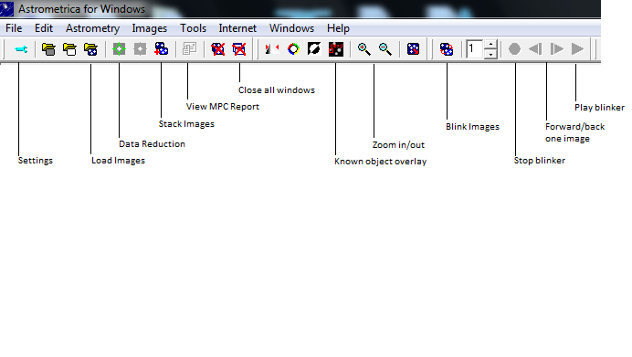
- Start Astrometrica. The following is the Astrometrica menu bar with its various functions:
- Astrometrica may ask you to overwrite the MPC report. Click “Yes” only if you have completed the MPC report. Click “No” If you have not completed the search on the image.
      - In Astrometrica select Load Images on the menu bar and load your image set (3 or 4 images per set), and click “Open”. After each image opens, a box will appear; click “OK” each time.
- Select Data Reduction on the menu bar, and select OK in the box that appears. This function will find reference stars in your images.
- Select Known Object Overlay on the menu bar, then select the Blink Images button and zoom in twice to enlarge the image.
- You can choose the option which inverts the images from black background to gray/white background.
- Visually scan the blinking image for moving objects: 3 to 4 images will go by and you must look for moving objects.
When you have found one, here are several things to look for, listed in priority order:
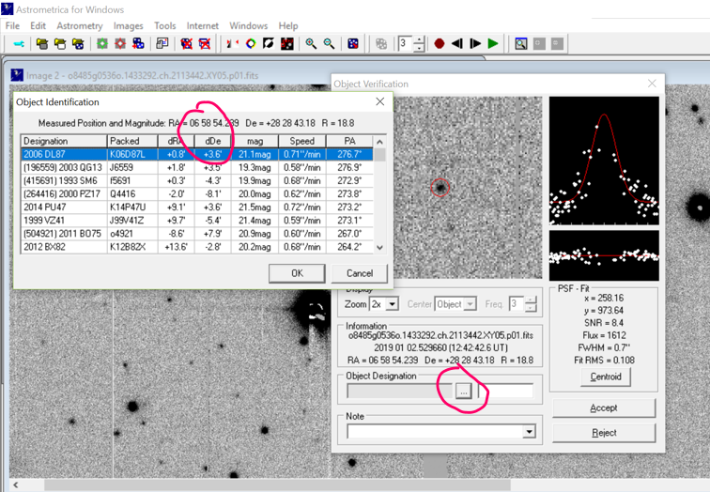
1. Is the object rounded with fading edges? Moving objects are more than one or a few pixels in size, have a rounded shape. The objects will be “blurry” on the edges then getting lighter/lightest in the centre.
2. Look at the R value (which is the visible magnitude) to see if it remains steady throughout the images. Most of the objects you will find that are unnamed have an R value of 20 or higher. You don’t want the R value to fluctuate much. A change in 1 is a change in 2.5x the brightness.

3. You also want the object to keep its path linear, not jump up/down/back
4. Look ‘a little’ at the graphs. The object is OK if:
- the white dots are scattered away from the red lines
- the SNR is more than 5
- the magnitude doesn’t fluctuate by more than 1.

Moving object found

- When a moving object is detected, select Stop Blinker on the menu bar.
- Begin by forwarding to Image 1, by clicking on the Forward or Back button.
- Center the object with the cross-hair and click on the object.
- Click on Object Designation and check for an object close to 0.00 in declination and right ascension, then select that object and click “OK”, then click “Accept”. If there is not an object close, then give the object a name by typing in 3 initials of your school and a 4 number designation.
- Repeat the procedure for images 2, 3, and 4 by forwarding to Image 2 and then to Image 3, and finally to Image 4, repeating the same procedure as with Image 1.
- Continue searching the image until all asteroids have been measured.

EXAMPLE

Minor Planet Center (MPC) Report
MPC report must be prepared for each image set and sent as an email attachment to: iascsearch@hsutx.edu . If more than one group of students analyzes the image set, only send in one report listing up to five students.
All the instructions are explained the file Instructions for Using Astrometrica.

Tips⁽¹⁾
There are several things to look for.

1. How « Data reduction » works
Astrometrica will attempt to find the brightest stars in the frame, and match them with known stars in a bright star catalogue. This process will last for a few minutes. Reference Stars that were used for the astrometric data reduction are circled green. 'Bad' reference stars that were rejected due to large residuals are marked by yellow circles. Stars (i.e., objects that were found at the same position in at least two images) are circled blue.
Once you get a fit (green starburst), then click the overlay option.
This will mark any known object in the images. Mark and report any moving object, whether known or unknown. NEVER mark a box for the report if nothing is in it! (an empty box means the object “should” be there). Marking known objects means you are perfecting the location of the object which enables the program to predict its location in the future.
2. Look at the R value (which is the visible magnitude) to see if it remains steady throughout the images. What you see on the screen before you click looks slightly different when you actually click. Before it is approximate, after it is exact or average. So you should read the R value directly on each image. Most of the objects you will find that are unnamed have an R value of 20 or higher.
3. When you click on the object, the data base appears. The first one highlighted is the one the program thinks might be the object. But you see that the R is different and the dRA and dDe are very different meaning this object is in a different location than the one highlighted.

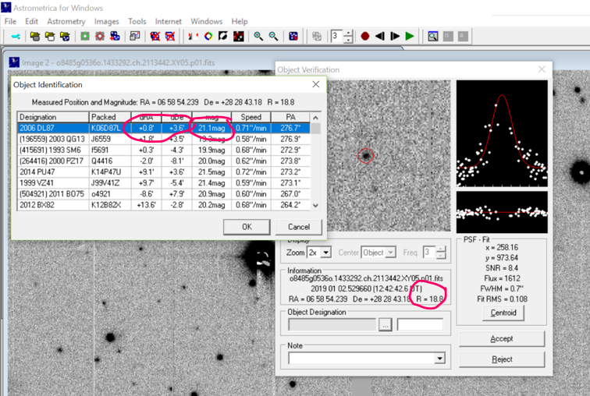

4. Look a “little” at the graphs. The top bell curve shows the brightness across the object, dark on the edges and brighter at the center then going darker again. If the object is known, the dots perfectly align with the graph. Here you see the dots don’t follow the graph well. The bottom linear graph is showing how well the dots on the bell curve fit. Think of it as a top or average view of the data points. Having yellow dots means over exposure which is not so good. In the end, 1 and 2 are the best, three is next.

(1) All these tips were given by Ginger Anderson, IASC teacher who is an expert and knows perfectly how to use Astrometrica and who was very helpful. Many thanks to her!

References
Project website address
http://iasc.cosmosearch.org/index.html?
https://www.facebook.com/iasc.news

