CSS Guide
Making an Educational Escape Room

Authors | Fernández Alonso, Laura
Version | V1 – 27/05/2019

Table of contents:
1. Introduction 3
2. Aim of the lesson 3
3. Materials 3
4. How it works 4
5. Challenges 4
5.1 Which country is the largest? 4
5.2 Puzzle 5
5.3 Which element am I? 5
5.4 Red acetate 6
5.5 The dancer black square 6
5.6 The final decoder 7
6 References 7

The European Commission support for the production of this publication does not constitute an endorsement of the contents which reflects the views only of the authors, and the Commission cannot be held responsible for any use which may be made of the information contained therein.

Introduction
Locked in a room with a time limit (35 minutes in this case) to escape by solving a series of puzzles, escape rooms are a live-action gaming trend which have become a craze throughout the world.
Escape room at school is a gaming-based activity. Teachers have to create a series of challenges and link them to have a chain of discovery. Students have to solve the puzzles, working together, to get codes and unlock “clues”. The final challenge...escape from the room!

Aim of the lesson
The goal of this didactic unit is develop several skills such as logic, maths, cooperative work and contents based on the curricular map. Moreover, escape room games are a worldwide trend so it is an opportunity to link real life and school which motivate and engage students to do their best. To sum up; Learning by gaming.

Materials
Students are organized in groups of 5 -6 people. Each team has an escape kit which contains a pencil, a pen, an adhesive tape, a pair of scissors, a pencil case, a locker (3 or 4 digits), a decoder wheel.
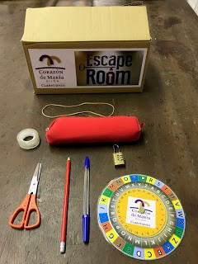
Moreover, in the room there are 4 boxes which contains 20 cylinders and 20 ribbons. On the floor there are 4 boxes. Inside, cylinder decoders and ribbons with letters. One box contains the message congratulations you have escape from the room. The other 3 boxes contain the message for those teams that fail: you have failed, you have not escaped.
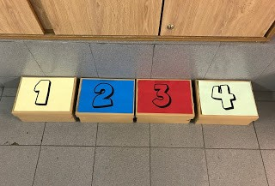 | 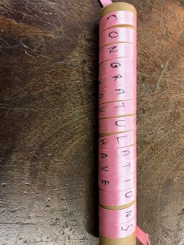
For this particular escape room, the specific material is a smartphone, a sealed book (with adhesive tape) which contains hints, a puzzle (inside the pencil case), a piece of red acetate (inside the book), a plastic folder which contains a challenge, a periodic table.

How it works
Teachers have to create a series of challenges and link them to have a chain of discovery. Students have to solve the puzzles, working together, to get codes and unlock “clues”. The final challenge...escape from the room! (in fact, students don't have to escape physically from the room but they get a final award!

Challenges

Which country is the largest?
When the box is opened, a plastic folder which contains the first challenge is visible: they have to organize the four countries (Belgium, Czech Republic, Belgium and Spain) from the largest to the smallest. To help them symbols are included.

Puzzle
The number combination opens the locker and inside a pencil case there is a puzzle. When all the pieces of the puzzle are fitted together, las letronas de Gijón appear and, at the back, a maths operation. The result indicates the book page to which they have to go.

Which element am I?
Inside the book there is a piece of paper. On one side there is a riddle. According to the clues given, they have to guess which element is. Using the periodic table, they find the atomic number. The symbol of the element and the atomic number they get the code to use the decoder wheel. Turning over the piece of paper, there is a message that is decoded using the wheel correctly.

Red acetate
The hidden message says open the browser and go to https://codemaer.blogspot.com.es/ . The post opens the students mind to use the red acetate that they found inside the book. In the post they also find the next message One member of the team (only one!) go to the gamemaster and say to her...COULD YOU PLEASE GIVE ME THE HINT...? The gamemaster give to the student a cardboard tube that contains a piece of paper with a message that has to be revealed using the red acetate. Hidden between senseless sentences there is one that says TAKE THE ENVELOPE UNDER THE TABLE.

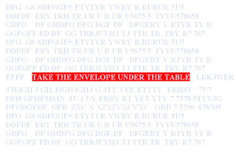

The dancer black square
The last puzzle leads the team to the ultimate “prize” to escape. This puzzle consists of 4 grids (see picture). Students have to realize that the trick is to rotate the grid until the black square is at the top. This way, if the grids are superimposed, all the cells are filled with a shape. Turning the piece of paper over there is a code that associates one number to each shape. Following the instructions, students have to do the operation using the numbers associated to the shapes located in the diagonal. The result is 4.

The final decoder
On the floor there are 4 boxes. The box number 4 contains the winner decoder. At the beginning students don't know what to do with the cylinder and the ribbon full of letters, it seems to be senseless! But when the ribbon is wound round the cylinder...CONGRATULATIONS YOU HAVE ESCAPED FROM THE ROOM! If a team fails (get number 1, 2 or 3) the message that appears is YOU HAVE FAILED, YOU HAVE NOT ESCAPED...
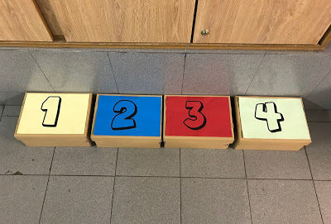 | 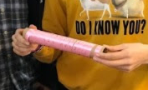

References
https://codemaer.blogspot.com/
In this blog material is available to download. The solutions of the challenges are also available

