The “Grand Tour”

The Grand Tour was the traditional trip of Europe undertaken by mainly upper- class European young men to the great centers of classical and Renaissance architecture and painting.

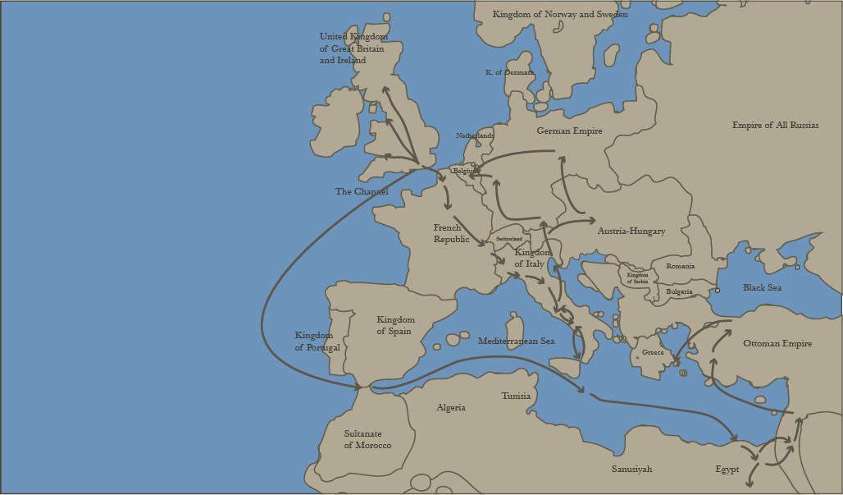

The primary value of the Grand Tour, it was believed, lay in the exposure both to the cultural legacy of classical antiquity and to the aristocratic and fashionably profile society of the European continent.

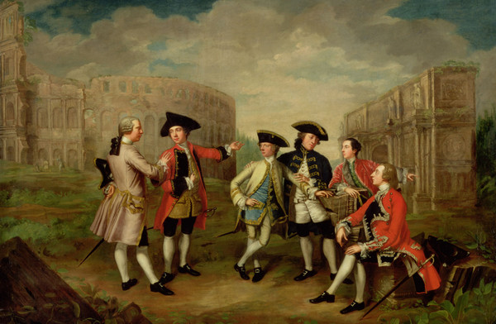

The first person to use the term Grand Tour was the Roman Catholic priest Richard Lessals (c. 1603- 1668), in his posthumous book The Voyage of Italy (1670).

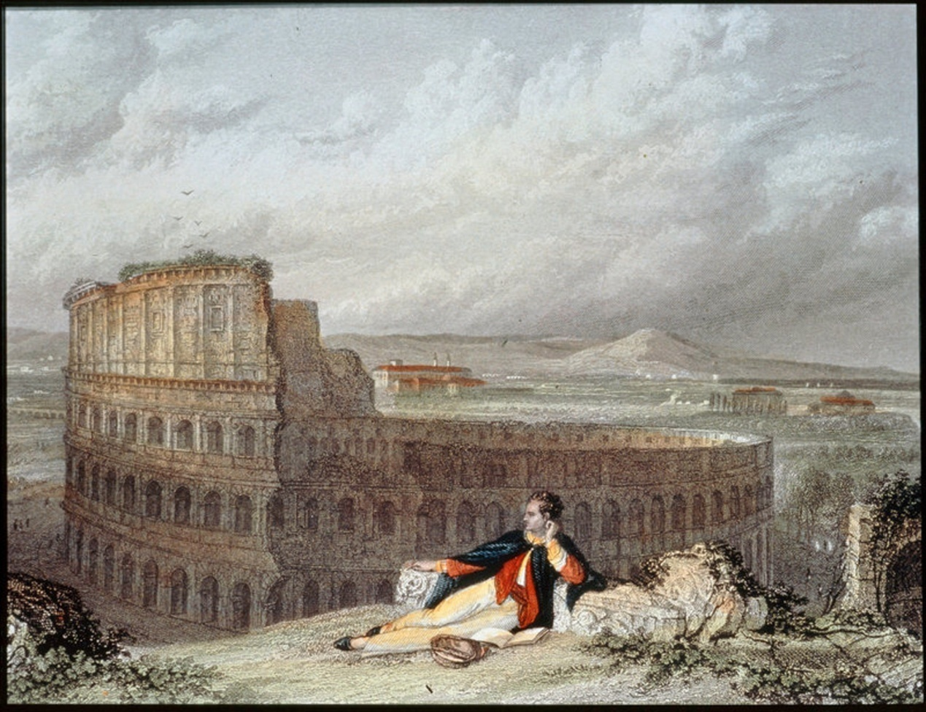

The main destination was Italy…

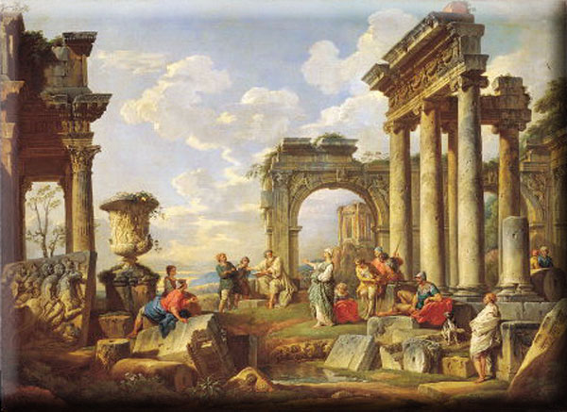

Rome …

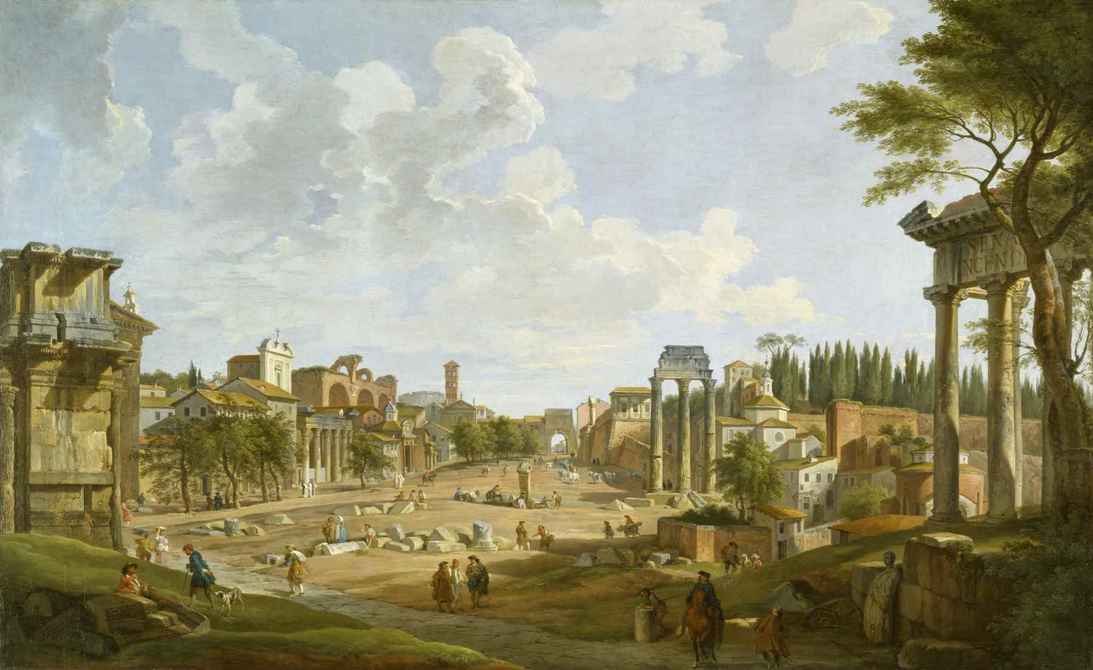

Venice …

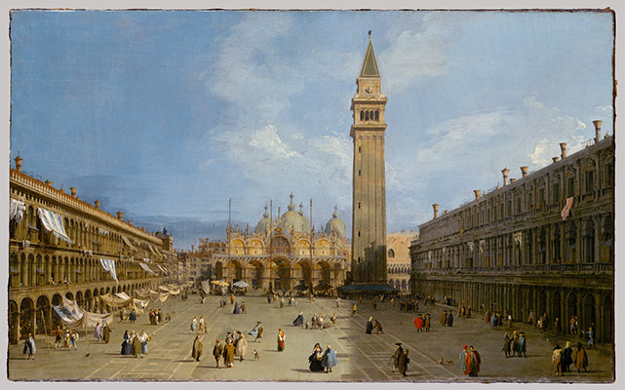

Florence …

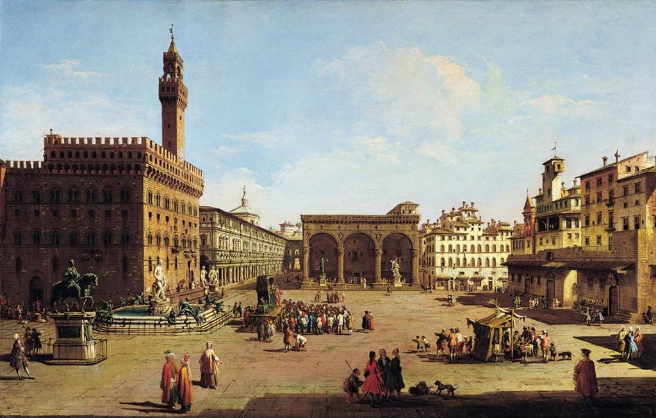

… but some of the most adventurous travellers crossed the Ionian Sea to the Greek mainland.

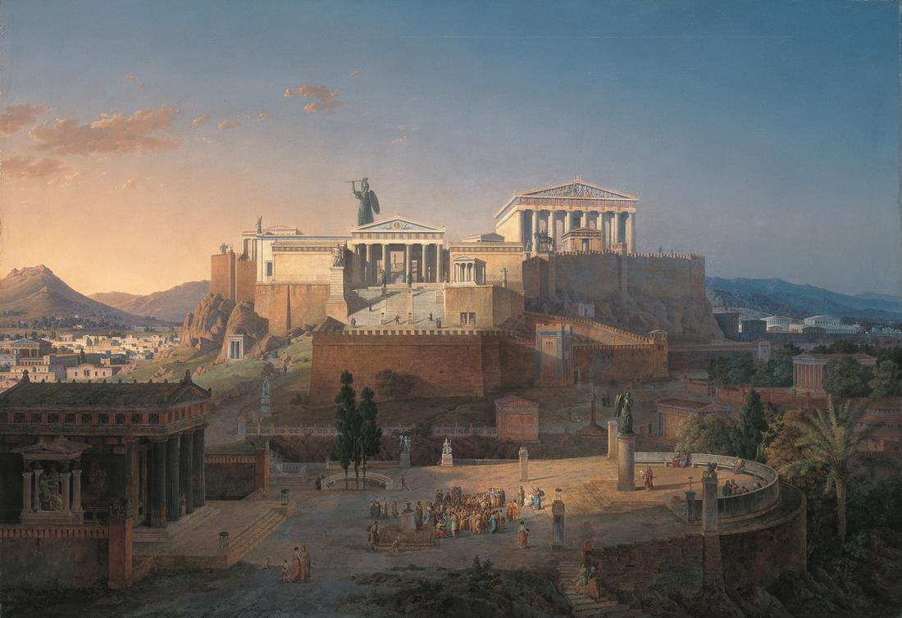

The custom flourished from about 1660 until the advent of large- scale rail transport in the 1840’ s.

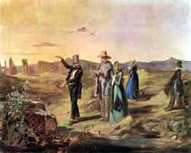

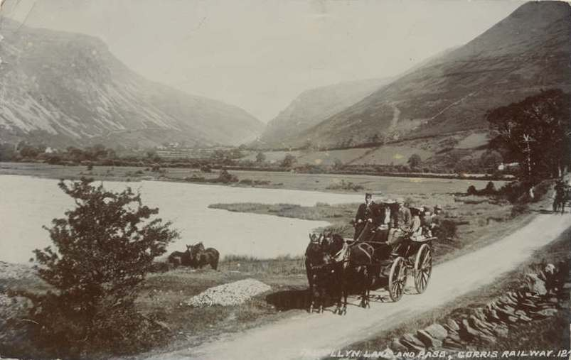

A Grand Tour might last from several months to several years. Travelers were often accompanied by a tutor or knowledgeable guide.

There is a constant flux of travelers from Western Europe to the Mediterranean from the 15th to 19th century. Choice of itinerary is often defined by reading works of ancient Greek and Latin literature. The traveler’s route is thus defined the reading as well as by chance events during the journey. In the mid-17th century travelers start to tour western Asia Minor, while some visitors also partly explore continental Greece.

Journeys by Europeans to Athens in search of the monuments of its historical past may be sporadically detected as early as the 15th and 16th centuries and are interpreted as the result of the increased interest of the Western Renaissance in Ancient Greek civilization. Of course, the top point of interest for the travelers was the partly ruined monuments of the Acropolis and mainly the Parthenon and the Erechtheion.

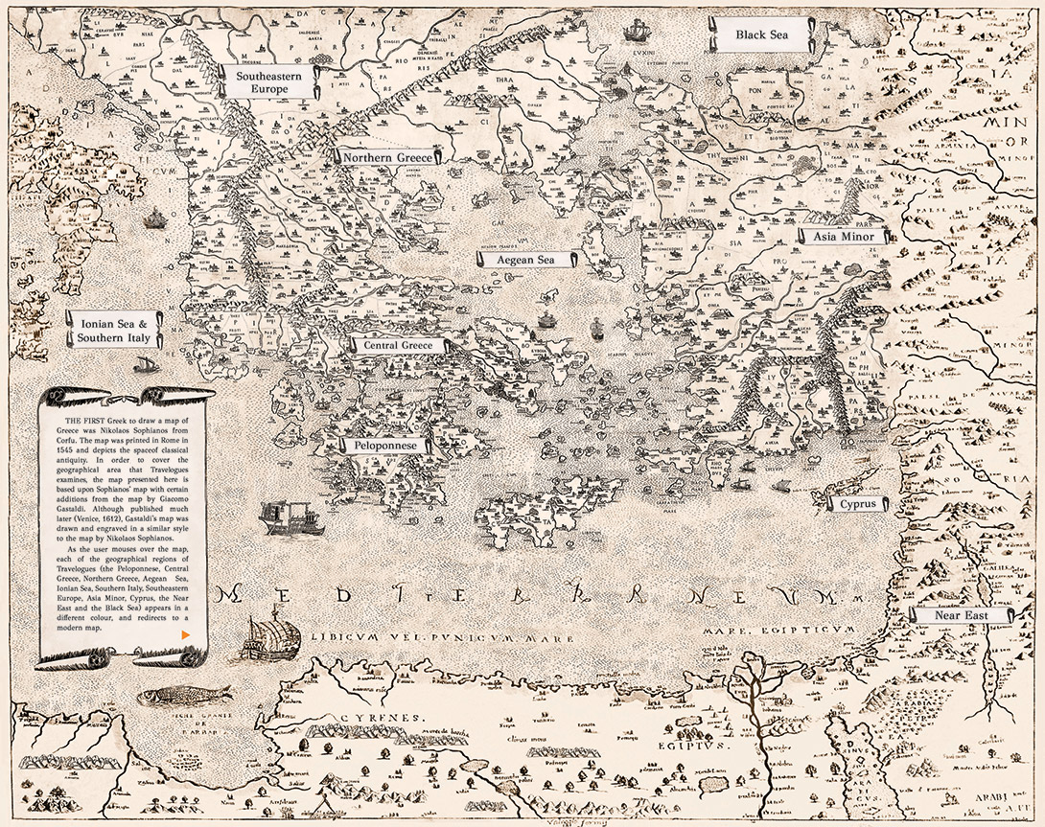

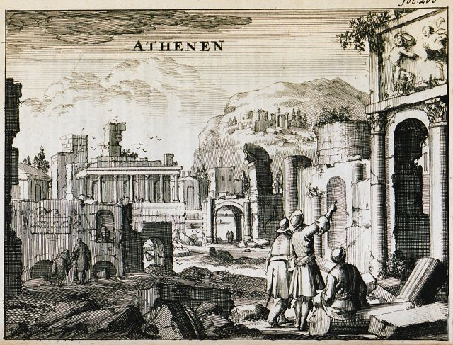

Jacob Spon and George Wheler visit the remains of ancient Athens

Spon, Jacob. Voyagie door Italien, Dalmatien Grieckenland, en de Levant
Amsterdam 1689

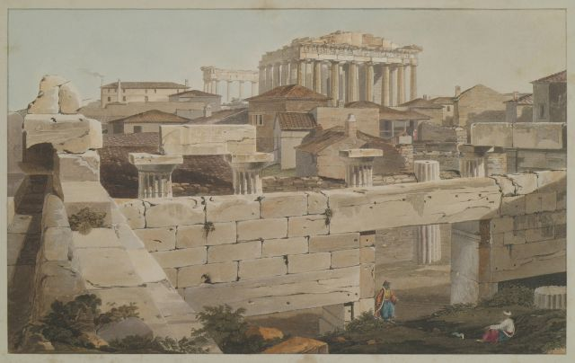

View of the Parthenon from the Propylaea. Seated on the ground is Disdar Aga, the governor of the fortress of Acropolis

Dodwell, Eduard. Views in Greece from Drawings by Edward Dodwell
London 1819

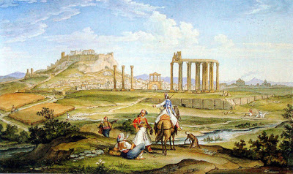

Temple of Olympian Zeus and the Acropolis
Wittmer, Johann Michael
Athens 1833
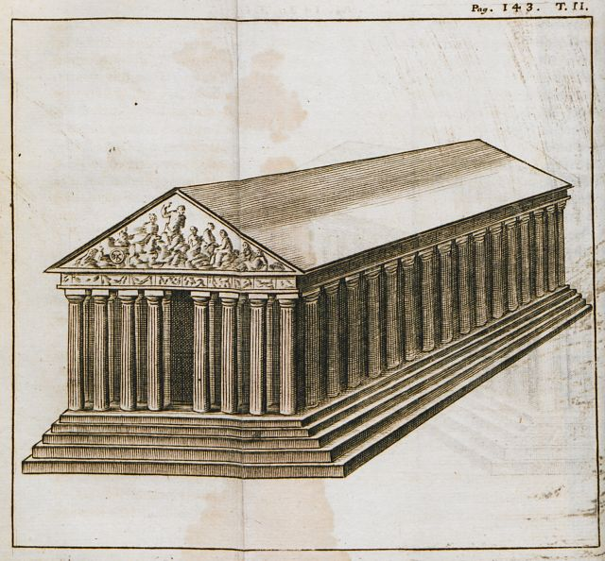

The Parthenon

Spon, Jacob. Voyage d’ Italie, de Dalmatie, de Gréce et du Levant, fait aux années 1675- 1676.

Lyon 1678

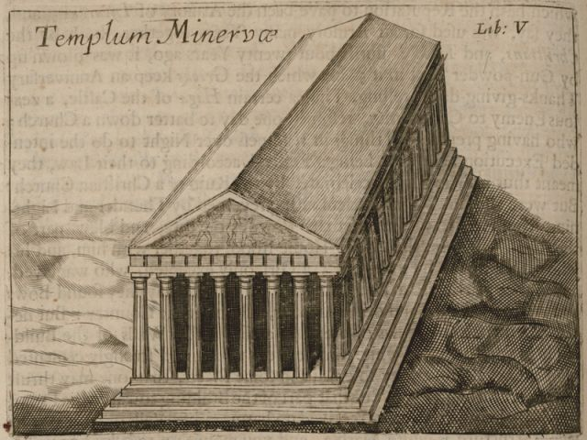

The Parthenon

Whelle, George. A journey into Greece … in company of Dr. Spon of Lyons. In six books.
London 1682

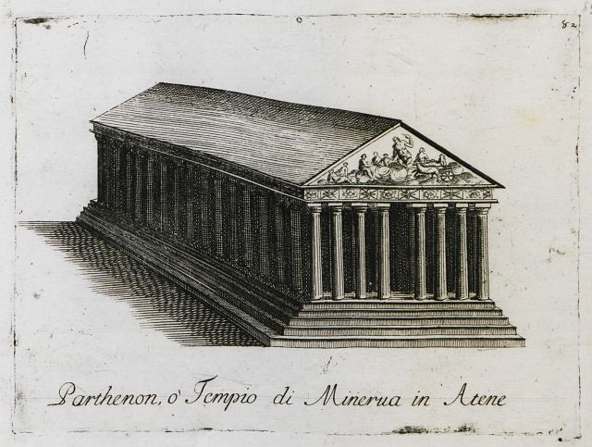

The Parthenon

Coronelli, Vincenzo. Memoire istoriografiche delli regni della Morea e Negreponte…
Venice 1686

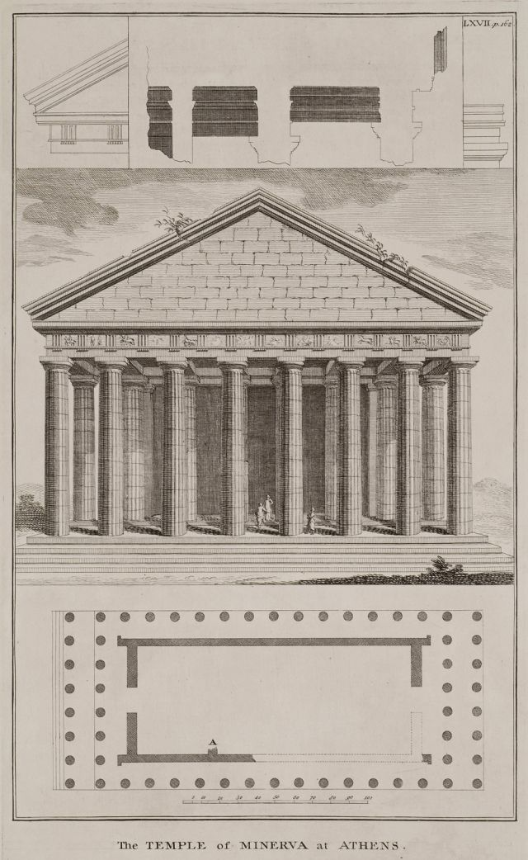

View and plan of the Parthenon
Pococke, Richard. A description of the East and some other countries… vol. II.
London 1745

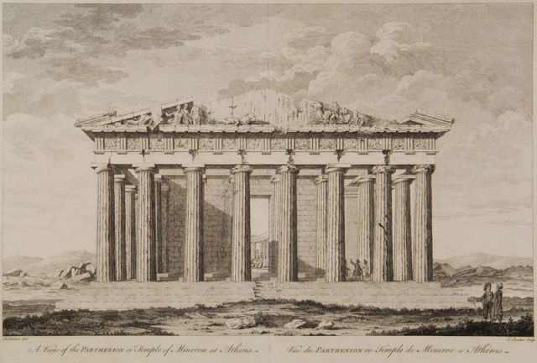

The Parthenon

Dalton, Richard. Antiquities and Views and Greece and Egypt.
London 1751- 1752

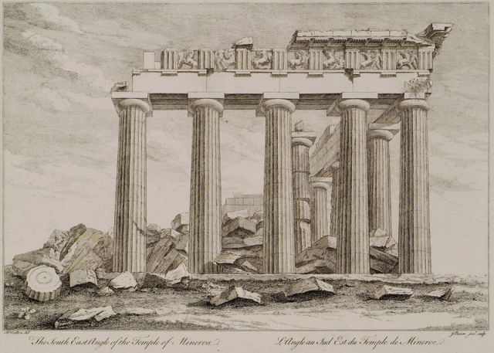

View of the Parthenon from southeast

Dalton, Richard. Antiquities and Views and Greece and Egypt.
London 1751- 1752

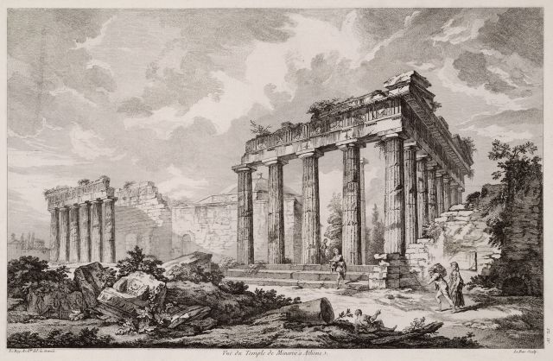

Southeast view of the Parthenon

Le Roy, Julien David. Les ruines des plus beaux monuments de la Gréce…
Paris 1770

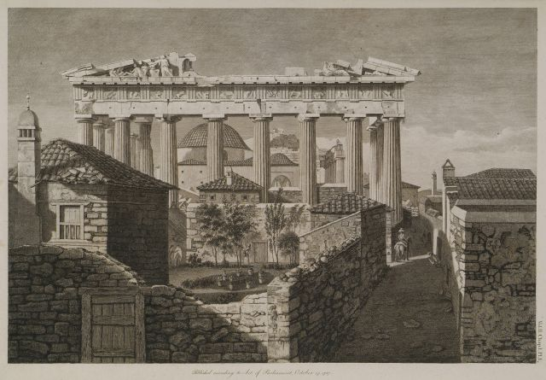

A view of the eastern portico of the Parthenon (in the interior, the mosque built after the 1687 explosion)

Stuart, James / Revett Nicholas. The antiquities of Athens measured and delineated by Stuart J. and Revett N. painters and architects
London 1787

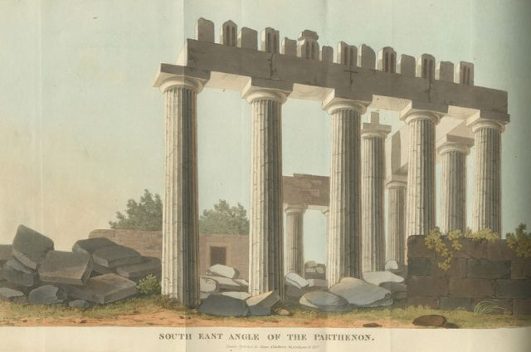

Southeast angle of the Parthenon

Hobhouse, John Cam. A Journey through Albania and other provinces of Turkey in Europe and Asia, to Constantinople, during the years 1809 and 1810
London 1813
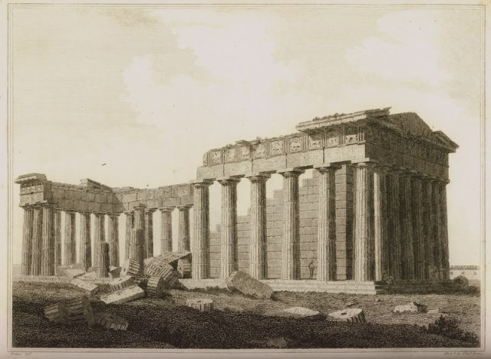

The Parthenon from the southeast

Clarke, Edward Daniel. Travels in various countries of Europe, Asia and Africa … vol. III
London 1814
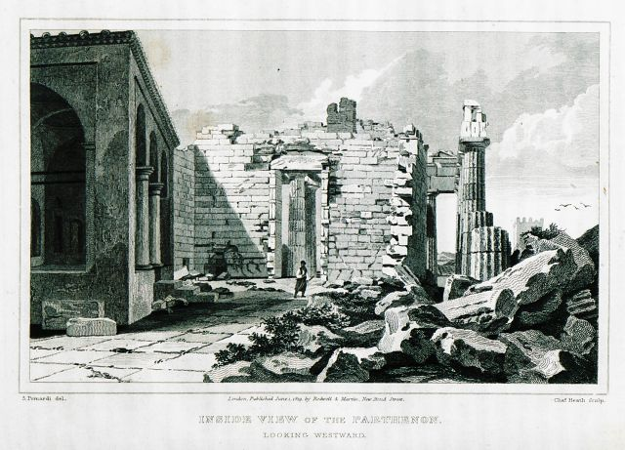

Interior view of the Parthenon

Dodwell, Edward. A classical and topographical Tour through Greece, during the years 1801, 1805 and 1806.
London 1819
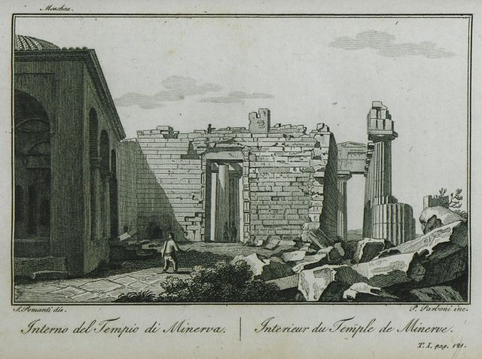

View of the Parthenon, with the mosque built on the site after the temple’s bombardment in 1687

Pomardi, Simone. Viaggio della Grecia fatto da Simone Pomardi negli anni 1804, 1805 and 1806.
Rome 1820

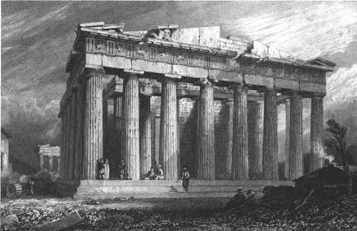

The Parthenon

Williams, Hugh. Select views in Greece with classical illustrations
London 1829
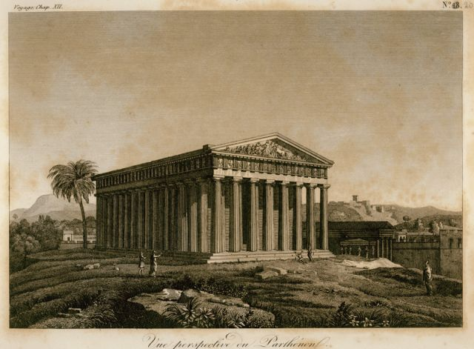

View of the Parthenon

Barthélemy, Jean Jacques. Voyage du jeune Anaharsis en Gréce, vers le milieu du quatrième siècle avant l’ ère vulgaire.
Paris 1832
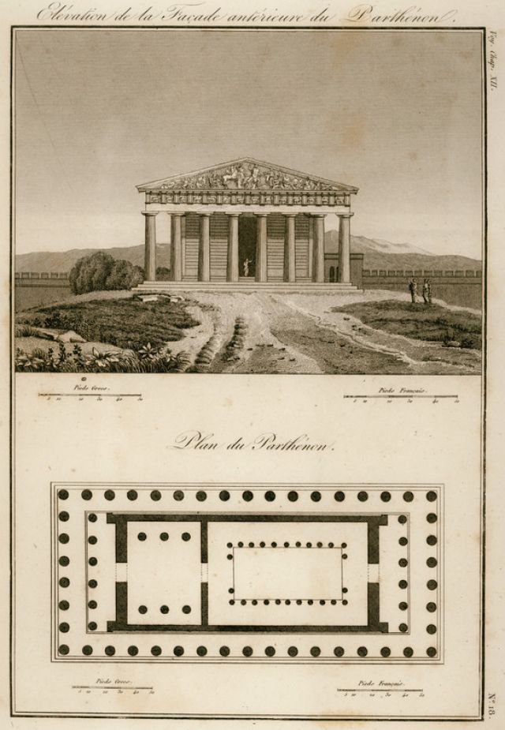

View and plan of the Parthenon
Barthélemy, Jean Jacques. Voyage du jeune Anaharsis en Gréce, vers le milieu du quatrième siècle avant l’ ère vulgaire
Paris 1832

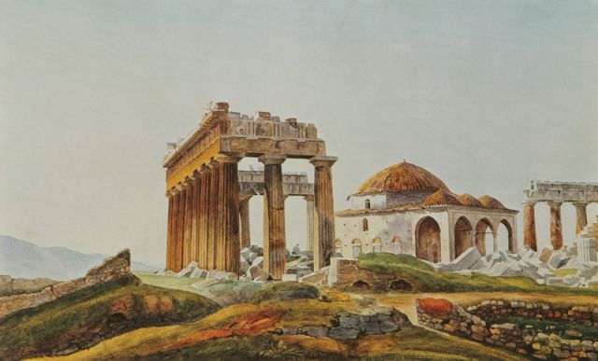

The mosque of the Parthenon from the northeast

Peytier, Eugène. (Liberated Greece and the Morea Scientific Expedition)
1829- 1832
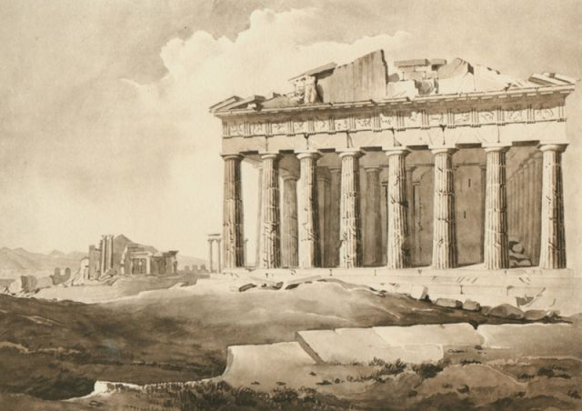

The Parthenon and the Erechtheion from the west

Peytier, Eugène. (Liberated Greece and the Morea Scientific Expedition)
1829- 1832 and 1833- 1836

