Travel as an element of European cohesion
ERASMUS + 2014 - 2016

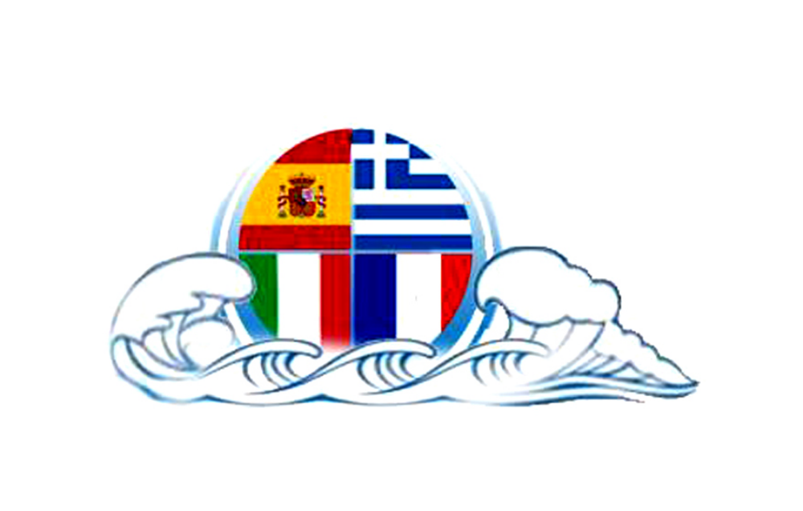

A27 NAMES OF GODS AND HEROES IN SEVERAL LANGUAGES AND CIVILIZATIONS

Working team of students on this project :
- Anastasia Demertzi
- Fotis Fotiou
- Chrysa Aslanidou

- Elli Tsiakalidou
- Ioanna Katemidou
- Vasilis Chatzigeorgiou
- Nick Papagiannoulis
Supervisor teacher : Asimina Vlachou, sociologist

GODS
The ancient gods’ memory is is still alive in our everyday life. What’s the meaning of the days of the week, for example?
The ancient Babylonians have inaugurated the seven days week. Each day was consecrated in a different deity. Number seven was a number of great importance in the Chaldean astronomy, since the sun, the moon and the five planets were seen with the naked eye. So, each one of them was representing a deity.
The week as a calculating time system in the western civilization owns to the Hebrew calendar too.
Only the Greek and the Portuguese calendar follow the Christian system of calculation having as center the Sunday (Κυριακή : our Lord’s day) and the days following as Second day, Third day etc – until the day before Saturday, noticed as day of Preparation (Παρασκευή)
So, the days of the week are as follows:
Greek &  Planets’ system | Languages derived by Latin | German languages | Celtic languages
Σάββατο  dies Saturni | samedi (*sambati dies, French)  sabato (Italian)  sábado (Spanish) | Germ. Samstag αλλά &  Germ Sonnabend  Engl. Saturday | Irish satharn,  Welsh dydd sadwrn.
Κυριακή  dies Solis | French dimanche,  Spanish domingo,  Italian domenica | Germ. Sonntag  Engl.. Sunday | Irish domhnach.  Welsh dydd sul.
Δευτέρα  dies Lunae | French. lundi,  Spanish lunes,  Italian lunedì | Germ. Montag  Engl. Monday | Irish luan,  Welsh dydd llun
Τρίτη  dies Martis | French mardi,  Spanish martes,  Italian martedì | Germ. Dienstag,  Engl. Tuesday | Irish mairt,  Welsh dydd mawrth.
Τετάρτη  dies Mercuri | French. mercredi,  Spanish miércoles,  Italian mercoledì | Germ. Mittwoch (mddle of the week)  Engl. Wednesday | Irish cēadaoin (<anc. Irish. dia cēt-ain «first fast-day»).  Welsh dydd mercher
Πέμπτη  dies Jovis | French. jeudi,  Spanish jueves,  Italian giovedι | Germ. Donnerstag  Engl. Thursday | Irish dardaoin «between two fast-days» (between Wed. – Fri.)», Welsh dydd iau.
Παρασκευή  dies Veneris | French. vendredi,  ιταλ. venerdì,  ισπ. viernes | Germ. Freitag  Engl. Friday | Irish aoine «fast-day»),  Welsh dydd gwener

https://el.wikipedia.org/wiki/Εβδομάδα

Let’s present the gods of the week :

- ΚΡΟΝΟΣ – SATURNUS
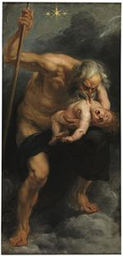 | 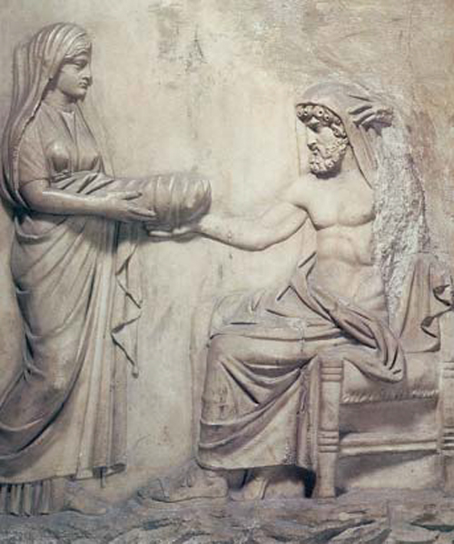
Rubens, Saturnus eating his son, Poseidon | Rhea, giving a stone to Saturnus to eat instead of Zeus

Saturnus (Kronos in Greek mythology), son of Mother-Earth and Uranus (Sky), has dethroned his father and got married with his sister Rhea. His parents foretold him that he would be dethroned himself by his son, too. Saturnus used to eat his children as soon they were born. When Zeus is born, Rhea gave to her husband a swaddled stone to eat. Then, she sent the baby to Creta island, to be brought up by Kourites. When Zeus became strong enough, released his sisters and brothers, and helped by the Cyclops and the Ekatohires (demons with 100 hands) won the war against Saturnus and his allies the Titans .
Kronia , Kronos holiday, took place during the night of the Spring equinox in Greece. This day, the slaves didn’t work and were sitting at the same table with their masters. All people were equal this day, in memory of the Golden Era of the human mankind, when there weren’t slaves, masters and hard works to do.
The Roman festival of Saturnalia was taking place during the winter solstice, the 17ht of December and later expanded with festivities through to 23 December . The holiday was celebrated with a sacrifice at the Temple of Saturn, in the Roman Forum, and a public banquet, followed by private gift-giving, continual partying, and a carnival atmosphere that overturned Roman social norms: gambling was permitted, and masters provided table service for their slaves..
https://el.wikipedia.org/wiki/%CE%A3%CE%B1%CF%84%CE%BF%CF%85%CF%81%CE%BD%CE%AC%CE%BB%CE%B9%CE%B1
- SUN (identified with god APPOLO)

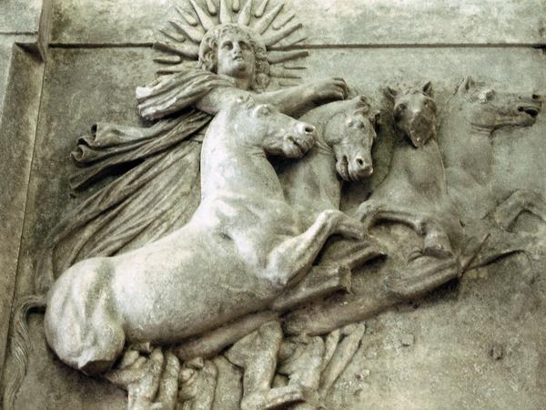
Troy VIII: metope from the temple of Athena showing the sun god, now in the Altes Museum (Berlin). This piece of art, made after c.390 BCE, was one of the first discoveries by Heinrich Schliemann.

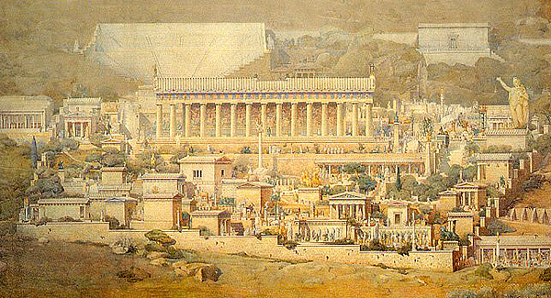
Representation of Delphi, the center of Apollo’s culture http://history-pages.blogspot.gr/2012/03/blog-post_26.html

Appolo was the son of Zeus and of a mortal woman, Leto. He was the twin brother of Artemis (Diana for the Romans) He represented the Sun (Helios), while Artemis represented the Moon (Selana), the two main stars. He has occupied the sanctuary of Delphes in Parnassos mountain, killing Python, the sacred serpent of Mother Earth. In Delphes he was adored as god of prophecy (Λοξίας : the one who gives ambiguous oracles) and protector of Fine Arts which were representing by the nine Muses (Μουσηγέτης). His surnames indicating his qualities are : Λοίμιος (the one who sends epidemic diseases), Ιατρός (the one who cures diseases), Φοίβος (shiny), Σμινθεύς (protector of agricultures), Κουροτρόφος (protector of young men), Λύκιος (light of the day) , Υπερβόρειος (the one who comes from the Northern countries). Helios is driving his chariot drawn by four white horses crossing the sky from his palace in East to the Islands of Makares in the West. He comes back following a stream of Ocean and he’s watching everything. His sacred pets are: the crow (representing the prophetic gift), the lion (symbol of the sun), the swan, the horse. (Robert Graves, the Greek Myths, greek transl. Cactus editions, 1998 )

- SELENA (identified with the goddess ARTEMIS – the Roman DIANA) 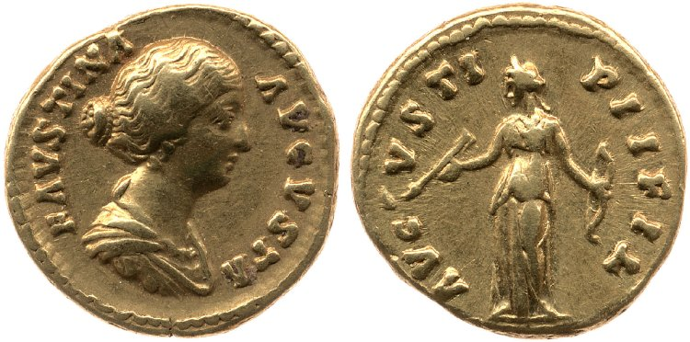

Golden Roman coin, about 145-161. In the front side:Faustina’s II head. In the back side :Diana holding bow and arrow. London, British Museum, 1964,1203.124 © The Trustees of the British Museum
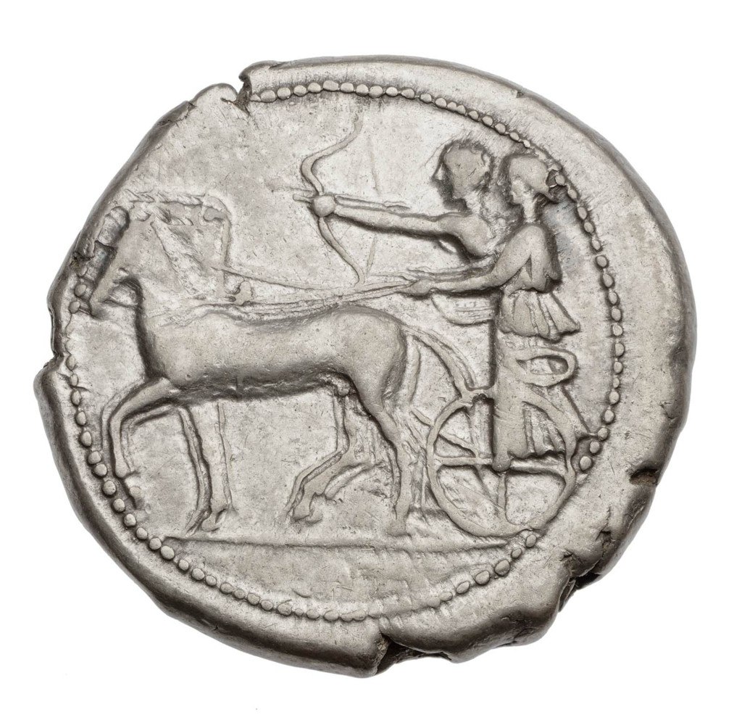

Appolo and Artemis on a chariot
A silver coin of four drachmas from Selinoundas about 445-435 b.C. Boston, Museum of Fine Arts http://www.greek-language.gr/digitalResources/ancient_greek/mythology/lexicon/gods/artemis/page_002.html

Artemis was identified with the Moon (selena). Zeus has given her the permission to stay free from the bounds of marriage, which means that she could give birth to anybody any time she would. Therefore, she was often representing with many breasts. She is wandering through the forests hunting (Τοξία, Εκατηβόλος) and she protects nature and wild animals (Ποτνία Θηρών). Other qualities are indicating as follows: Κουροτρόφος (protector of young girls), Λοχεία ή Λεχώ (she defines the childbirth), Ηγεμόνη/Ηγουμένη, Αγοραία, Βουλαία (protector of the civil life), Λιμναία, Ορτυγία, Ποταμία, Παραλία (protector of the waters), Κεδρεάτιδα και Καρυάτιδα (living into the cedar-tree / the walnut-tree), Bee (ancient symbol of the Mother of Gods in Creta), Αλφαία (white) Her pets are : the bear, the lion, the panther, the deer, the rabbit, the quails.

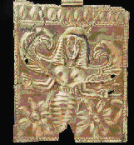 | 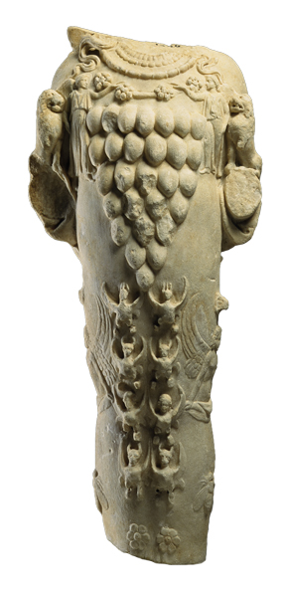 | 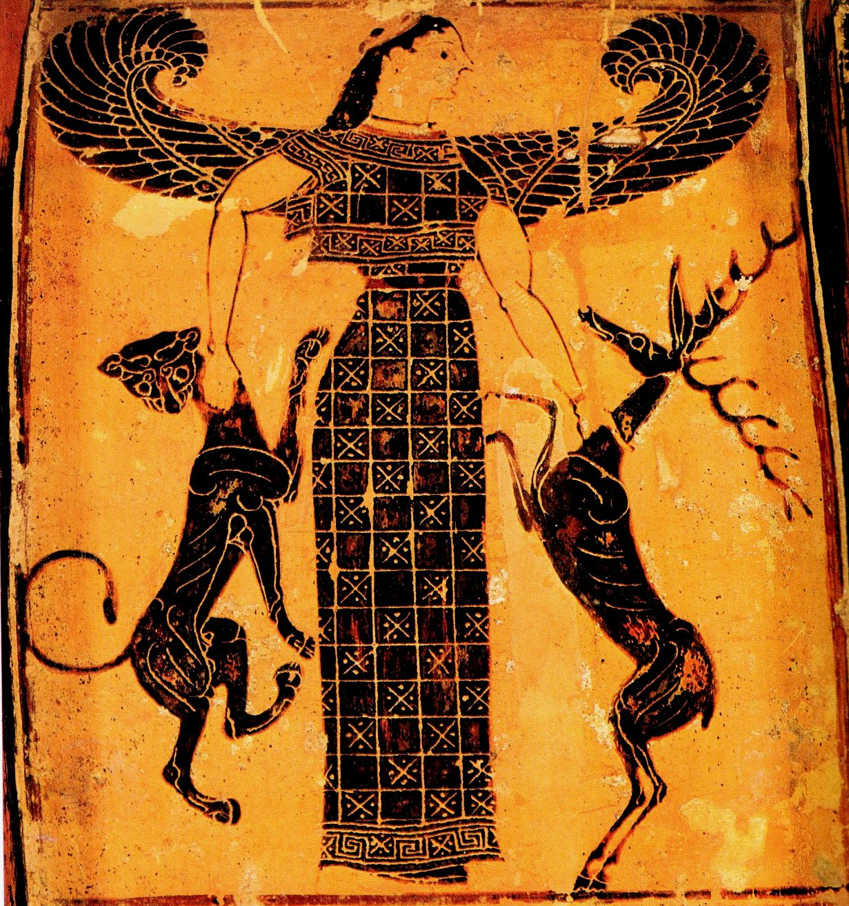
Artemis as Bee – Goddess  Plaquette from Kamiros, Rhodes, 660-630 b.C. Boston, Museum of Fine Arts | Marble statuette of Artemis of Efesso1st cent. b.C. The temple of Artemis in Efessos of Asia Minor was one of the seven miracles of antiquity. In this place Artemis was adored as the great goddess of nature and protector of animals. Her dress is decorated with symbols of fertility (28 breasts), figures of Victory, sphinx, gryphons and bees. Lions are on her hands. © National Archeaological Museum, 2008-2012 Athens, | Artemis as Goddess of Wild Animals with a panther and a deer.  A detail from the handhold of a black-figured pot known as pot "Francois", about 570 b.C... Firenze, Museo Archeolgico Etrusco

- ΑΡΗΣ – MARS – TEIWA for the Goths - Týr for the Scandinavians

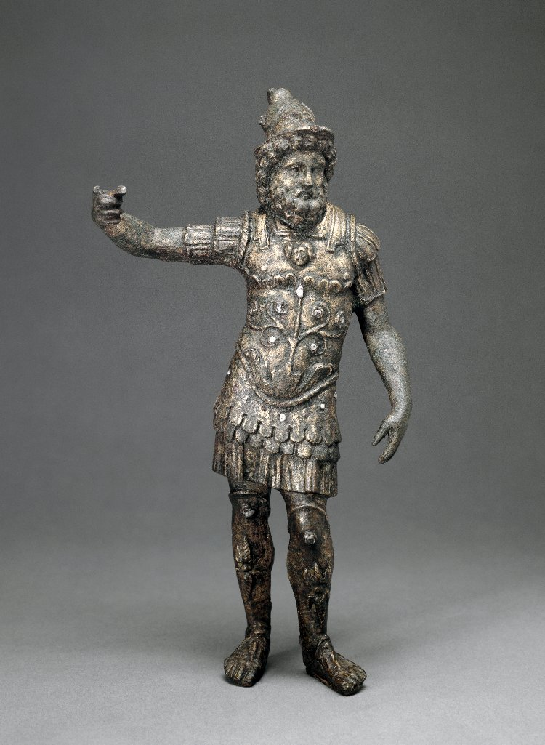 | 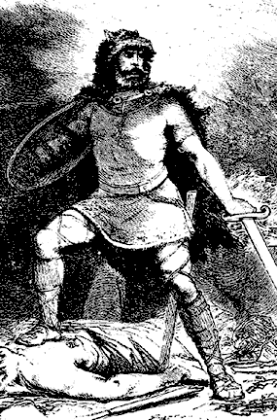
Άρης (Mars): Roman-British bronze statuette 2nd cent. A.D.. London, British Museum 1871,0601.1 © The Trustees of the British Museum | Tyr, according to various sources, was the son of Odin and Frigga (though some stories will say his mother was a giantess who was a personification of the sea itself). He is the God of various things: war, courage, victory. The Romans tended to try and identify him with Mars, who was their God of War, but Tyr was more than just that: some say that because his name is a derivative of the root word that made up Zeus, he was a sky God. Some sources, such as Germano-Roman dedications, see him as a God of both sovereignty and order. He was known as well as a God of honor, and was one of the twelve main deities of Asgard. Tyr even had a throne in the council hall of Glads-heim. http://bonekindred.weebly.com/tyr.html

Άρης, (Mars for the Romans, son of Zeus and Hera –Juno). He was usually accompanied by his two sons, Δείμο (Terror) και τον Φόβο (Horror), his sister Έριδα, (who represents the quarrel, the division) and his violent daughter or mother Ενυώ who represents the war (she is identified with the Roman Goddess of war Bellona). He was cruel, capricious and unstable, without the sense of measure. On the contrary, his sister Athena was wise and having a right strategy, she gained the battles against him. Aris – Mars had many love affairs and the most famous was the one with goddess Venus -Αφροδίτη. He was the ancestor of many celebrities of the antiquity, such as the people of Amazons, Lavdakides (the royal family of Thebes), Leda, the beautiful Helen, Klytemnestra etc.

- ΕΡΜΗΣ – MERCURIUS- ODIN, Wōdin, WUOTAN for the Germans
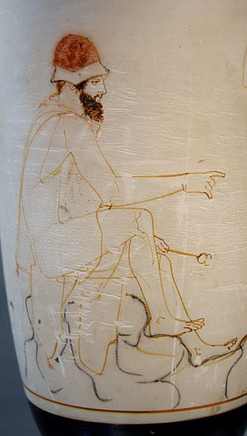 | 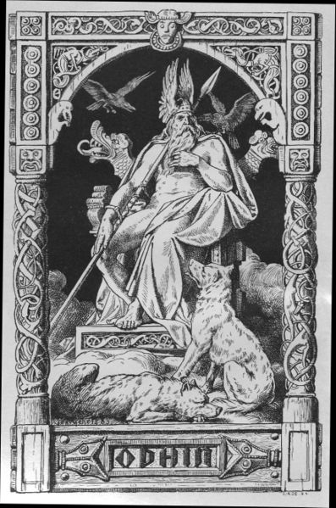
Ερμής-Mercury guiding the souls of the deads (psychopomp) to Hades, about 450b.C. Staatliche Antikensammlungen de Munich http://glyptiki.weebly.com/omicronkappataualphagammaomeganuiotakappa942-alphaupsilonlambda942-omicron-epsilonrhomu942sigmaf-tauomicronupsilon-mupiepsilonlambdabetaepsilonnutau941rhoepsilon.html | Odin, god of the kings, of the poetry, of the wisdom and of the war, was prophet and guide of the souls of the deads, father of Valkyrien, here he is representing with his pets: crows symbolizing the thought and the memory, his wolves and his divine spear which can never be broken. His common surnames are: the Grey God, the Wanderer https://el.wikipedia.org/wiki/%CE%8C%CE%BD%CF%84%CE%B9%CE%BD

Ερμής, was the son of the nymph Μαία and of Zeus. While he was still a baby, he stole the cows of Apollo. Then, he persuaded Apollo to give him the gift of prophecy. Zeus offered him the wing sandals, a hat which made him invisible and his sacred symbol, the caduceum. Zeus appointed Mercury as the Gods’ messenger, responsible for the commerce, the communications, the travelers and the thieves. Hermes -Mercury was also charged to guide the souls of the deads to the kingdom of deads, Hades. His qualities are indicating as follows:: Νόμιος –the divine shepherd, Εναγώνιος – god of the adolescents and protector of youth, Χαριδότης – god who gives beauty to the young men, Φάλλης - god of the fertility, Εμπολαίος – protector of commerce, Λόγιος – god of persuasion, of the eloquence and of the education.

- ΔΙΑΣ - ZEUS – JUPITER -JOVIS – THOR – DONNAR the god of the thunder for the Germans

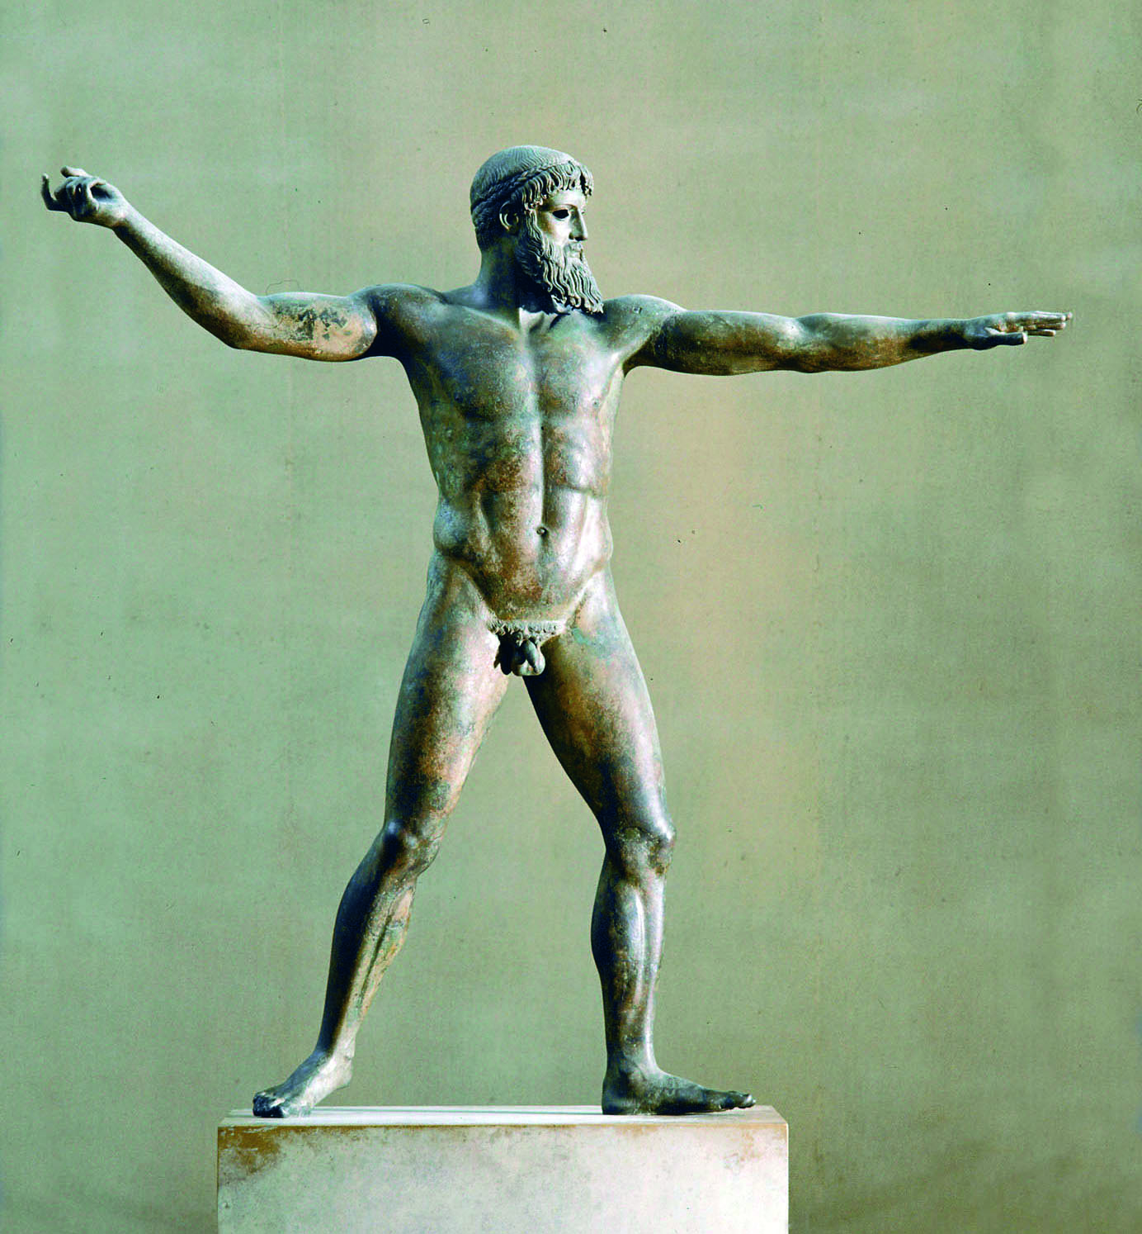 | 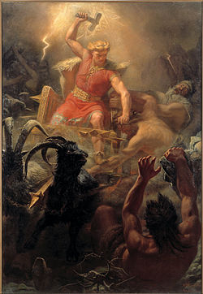
Zeus statue from a shipwreck near the cap of Artemision, 460-450 b.C. National Archaeological Museum of Athens. God is throwning his thunder http://www.greek-language.gr/digitalResources/ancient_greek/history/art/page_078.html | Thor’s battle against the giants by Mårten Eskil Winge, 1872. Thor is the red-haired and beard-bearered god of the thunders and the lightenings in the German and Scandinavian mythology. He’s the son of Odin and Fjörgyn. Thor owned a warrior’s, hammer Mjolnir, which used to return to his owner after having being thrown to the enemy,. Thor wore iron gloves and a belt which increased his power. https://el.wikipedia.org/wiki/Θωρ

Zeus, the son of Saturnus and Rhea, was born in Creta in secret. Kourites (inferior deities) and nymphs have brought him up, while his mother was giving a stone to Saturnus instead of the baby. Saturnus has been defeated by Zeus and this one became king of Gods. Her wife and sister Hera (Juno) was protecting the marriage. Their sons were: Aris, god of war and Hephaestus (Volcanus) god of blacksmiths and a daughter, Hebe, goddess of the eternal youth.. Zeus has had numerous love affairs both with goddesses and mortal women. To achieve his purpose, he was often transformed to an animal (bull, swan, etc). His qualities are indicating as follows: Όμβριος, Νεφεληγερέτης – master of meteorological phenomena, Κτήσιος – chthonic Zeus in the form of a snake. As a snake, he was protecting the house and the family’s owns. Όρκιος – protecting the laws and the vows. Μοιραγέτης – the master of Moires, goddesses who defined the destiny of mortals and gods. Μειλίχιος – a calm and quiet god whο received kindly the human prays. Έρκειος και Εφέστιος – protector of the family. Πολιεύς – the master of the city-state. Σωτήρας και Ελευθέριος – protector of the freedom of the city. Ικέτης was protecting the fugitives who were asking for asylum. Ξένιος – protector of the guests. Μετοίκιος – protector of foreign businessmen who lived in Athens. Καθάρσιος – god who purified the guild for murder. His symbols were the thunder, the oak (the prophet tree of Zeus in his temple in Dodoni, Epirus), the eagle.
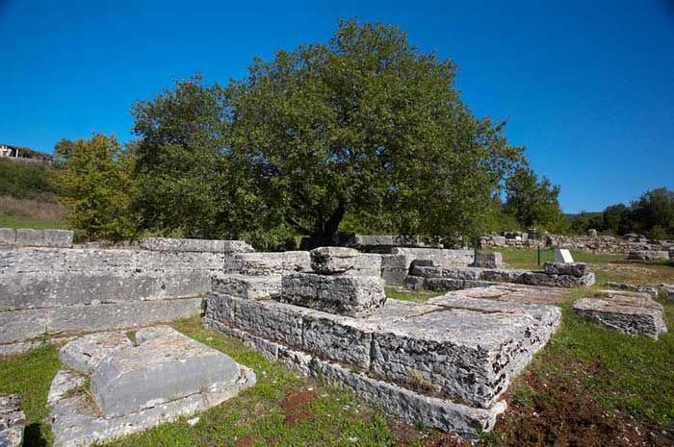
The temple of Zeus in Dod oni, Epirus and the oracle tree, the oak
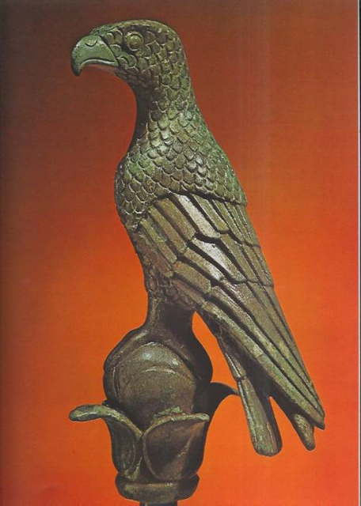 | The eagle, the Zeus pet, bronze statue, 10cm high, 5th cent. b.C found in the sanctuary of Dodoni

- ΑΦΡΟΔΙΤΗ - VENUS – FREYA for the Germans

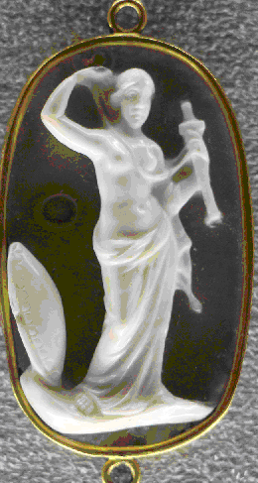 | 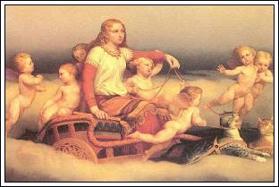
Venus armata, Ancient Roman glyptics in the Museo archeologico nazionale (Florence)‎ https://commons.wikimedia.org/wiki/Category:Venus_%28dea%29#/media/File:123_arte_romana,_venere_armata,_calcedonio,_II-III_sec._ca..JPG | Freyja means a lady, a female chief. She was the goddess of intimacy and she cried with golden tears. She was also the goddess of love and of sexuality, one of the most popular goddesses. Always willing to have sex with people and gods. Freyja rides a chariot drawn by eight cats. .Queen of elves. The giants were always trying to kidnap her. https://el.wikipedia.org/wiki/%CE%A6%CF%81%CE%AD%CE%B3%CE%B9%CE%B1

Aphrodite means the one who is born from the spume of the sea. She is born when the sperm of Uranus has fallen into the sea. She was travelling on a shell, when she arrived in the island of Kythira, then in Paphos in Cyprus island, where the Ores (deities of time, hours) came to dress her. Then, she was presenting in Olympus mountain, the residence of Gods, where all were charmed by her presence. Zeus gave her the famous “kestos”(an accessory like a belt) which made her irresistible. She is the goddess of love and beauty. She got married with Hephaestus (Volcanus) but she deceived him very often – especially with Mars. Her qualities are indicating as follows: Ουρανία – the goddess of the pure and loyal love, Πάνδημος – the goddess of the sensual love out of marriage, protecting the prostitutes, Εύκαρπος – the goddesss of the fertility, Πελαγία, Ευπλοία, Θαλασσία – the goddess who protects the sailors, Φιλομειδής, Χρυσείη, Ευστέφανος ​– goddess of beauty, dressed with luxurious clothes, Κύπριδα, Παφία (from Cyprus island) Αναδυομένη. Her symbols are the pigeon, the sparrow, the windflower, the myrtle, the sea-shells. Her son, Aeneas is born from her relationship with Anchises, prince of Troy. Aeneas is considering as the mythological ancestor of Romans. Roman titles of Venus : Armata (“Armed Venus”), Felix ("Lucky Venus") , Calva ("Venus the bald one", Cloacina ("Venus the Purifier"), Venus Erycina ("Venus of Eryx"), Heliopolitana ("Venus of Heliopolis Syriaca"),

Aphrodite’s culture came from Asia to Cyprus and then to the whole Greece. The goddesses Ishtar (Babylonians) and Cybele (Frygians) are similar to Aphrodite. Their culture included many orgiastic ceremonies.
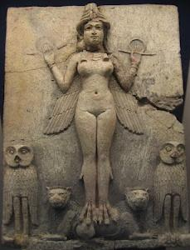 | 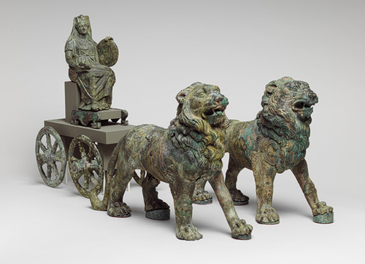
The goddess Ishtar with the lion’s feet and the wings on her shoulders came also from the sea and she’s considering as goddess of fertility, of love and of war | The goddess Cybele is identified with Mother Earth. Her chariot is .drawn by lions.
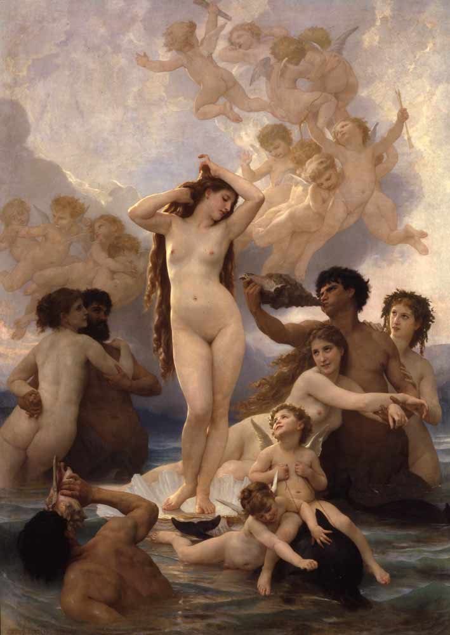
The birth of Venus (Bouguereau 1879)
HEROES
- Famous couples of twins in two mythologies

1. Romulus and Remus https://en.wikipedia.org/wiki/Romulus_and_Remus
Romulus and Remus were the twin brothers and main characters of Rome's foundation myth. Their mother was Rhea Silvia, daughter of Numitor, king of Alba Longa. Before their conception, Numitor's brother Amulius seized power, killed Numitor's male heirs and forced Rhea Silvia to become a Vestal Virgin, sworn to chastity. Rhea Silvia conceived the twins by the god Mars. Once the twins were born, Amulius had them abandoned to die in the Tiber river. They were saved by a series of miraculous interventions: the river carried them to safety, a she-wolf found and suckled them, and a woodpecker fed them. A shepherd and his wife found them and fostered them to manhood as simple shepherds. The twins, still ignorant of their true origins, proved to be natural leaders. Each acquired many followers. When they discovered the truth of their birth, they killed Amulius and restored Numitor to his throne. Rather than wait to inherit Alba Longa, they chose to found a new city.
While Romulus wanted to found the new city on the Palatine Hill, Remus preferred the Aventine Hill.^{[2]} They agreed to determine the site through augury but when each claimed the results in his own favor, they quarreled and Remus was killed.^{[3]} Romulus founded the new city, named it Rome, after himself, and created its first legions and senate. The new city grew rapidly, swelled by landless refugees; as most of these were male and unmarried, Romulus arranged the abduction of women from the neighboring Sabines. The ensuing war ended with the joining of Sabines and Romans as one Roman people. Thanks to divine favour and Romulus's inspired leadership, Rome became a dominant force, but Romulus himself became increasingly autocratic, and disappeared or died in mysterious circumstances. In later forms of the myth, he ascended to heaven and was identified with Quirinus, the divine personification of the Roman people.
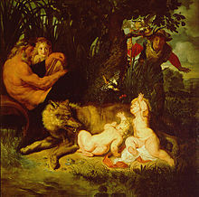 | 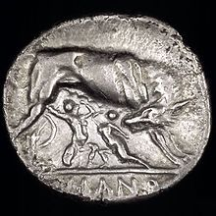
Faustulus (to the right of picture) discovers Romulus and Remus with the she-wolf and woodpecker. Their mother Rhea Silvia and the river-god Tiberinus witness the moment. Painting by Peter Paul Rubens, c. 1616 (Capitoline Museumsd | Romulus and Remus. Silver didrachm (6.44 g). c. 269–266 BC
2. Amphion and Zethos
Zeus seduced Antiope, a princess of Thebes and when she understood that she was pregnant, she asked for a refuge to the king of Sikyon in Peloponese. She got married with the king, but this marriage angered her uncle Lykos who claimed the war to Sikyon. The king of Sikyon is defeated and Lykos captured Antiope and kept her in prison When her twin sons of Zeus, Amphion and Zethos were born, Lykos has abandoned them to die to Kithaeron mountain .Shepherds have found the boys and raised them. When the twins were grown up, they took revenge for their mother, went to Thebes and they dethroned Laios. Then, they founded the down town, since Kadmos had founded the upper one. Amphion was an excellent musician. When he played his lyre, the stones bewitched were taken automatically place to the wall of the new town. So the walls have been built without fatigue. Antiope got married with Fokos, grandson of Sissyphos. Both twins were kings of Thebes. Zethos got married with Thebe, who gave her name to the new city (ex Kadmeia) and Amphion got married with Niobe with whom he has had 6 daughters and 6 sons. When Niobe boasted of her children, causing the indignation of Leto, Apollo killed the boys and Artemis the girls with their arrows. Since Amphion tried to take revenge in Delphes, Apollo has killed him too and condemned him to go to Tartaro, the hell of the ancient Greek.
Amphion and Zethos are buried in Thebes. When the sun is in the Taurus sign, the tomb was defended from the inhabitants of Tithorea, the near town, as they were trying to steel the earth of the twins’ tomb, in order to put it to the tomb of Fokos and Antiope. An oracle has foretold to the citizens of the two cities that this action would increase the fertility of Fokis, decreasing the production of Thebes. (Robert Graves, The Greek Myths, Cactus editions, 1998)
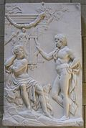 | 
Julius Troschel, "Amphion and Zethos" (1840-1850), "Neue Pinakothek". | The tomb of Amphion and Zethos in Thebes, which is actually a step-like pyramis (excavation of Th. Spyropoulos, dated 3.000b.C.)

Similarities-differeces
The similarities of the two myths are obvious : Both twins’ couples’ fathers are gods and their mothers princesses; so the twins are the legal heirs of the throne. That’s why the usurpers have exposed the babies to die. Both couples of twins are found and brought up by shepherds and finally they have founded famous cities. The difference is that the Greek twins love each other and share the kingdom, while the Latin twins quarrel and finally Remus is killed by his brother.
B. Heroes killing monsters

- Perseas and Medusa
Akrisios, king of Argos, in Peloponese, has been foretold that his grandson would kill him. So he kept her only daughter, Danae, in prison. Zeus fell in love with Danae and visited her transformed in golden rain. So, she conceived Perseas. . Akrisios has put Danae with her son in a box and left them to the sea to get drown. The waves led them to the island of Serifos, Cyclades, where they found a refuge to the court of the king Polydektis. When Perseas has grown up, Polydektis who would like to get rid of him, and get married with Danae, asked him the Medusa’s head. Medusa was a horrible monster having snakes instead of hair on the head. At her sight, people were petrified of horror. With a great help of the gods Hermes and Athena, Perseas killed Medusa and took her head. On the way home, he saw in Ioppe’s shore a young girl bound on a rock. It was Andromeda, king’s Kipheas and queen’s Kassiopeia’s daughter. The god Poseidon, sent a sea – monster to destroy the land, because Kassiopeia had insulted his daughters Nereeides. The Oracle of Ammon Zeus in Egypt claimed that only the sacrifice of Andromeda would release the country. Perseas, falling in love with Andromeda, asked her in marriage if he would be able to kill the monster.Nevertheless, he killed the monster but the king and the queen didn’t keep their promise. Perseas has punished them showing the Medusa’s head and turned them into stones. Later, Poseidon has put the figures of Kassiopeia and Kipheas among the stars and Athena this one of Andromeda. Years after, in athletic games, Perseas, throwing the discus, killed without his willing one of the spectators : it was his grandfather, Akrisios.
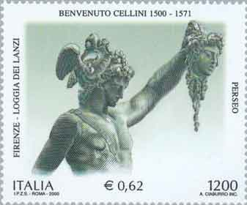
2. Hercules and Hesione
Hercules, on the way home from Amazons’ land, has seen on Troy’s shore a young girl bound on a rock. It was king’s Laomedon daughter, Hesione.. Laomedon hasn;t paid to Poseidon the money due for the construction of Troy’s walls and and to Apollo the wages because the god was keeping Laomedon’s cows. The gods took their revenge; Poseidon sent a monster who destroyed the cultivations, and Apollo sent an epidemic of plague. The Oracle of Ammon Zeus in Egypt consulted Laomedon to sacrifice his daughter. Hercules agreed to save the girl taking as reward the two immortal horses that Zeus had once offered to Laomedon. Hercules killed the monster but Laomedon didn’t keep his promise. Hercules attacked Troy, killed Laomedon and his sons and gave the throne to Priamos. Hesione, as a war prize, got married with Telamon from Cyprus, a companion of Hercules in the expedition of Argonauts in Kolchida. Their son was Teucros who has participated to the Troyan war years later.
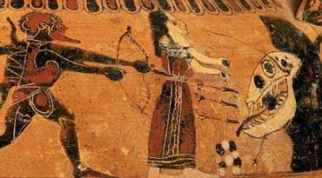
3. Vellerefontis and Chimera (https://el.wikipedia.org/wiki/Βελλεροφόντης)
Βελλερεφόντης, (means: the killer of Velleros), is a hero of the Greek Mythology. He was the son of Glaukos, king of Corinthe (Efyra) and of Eurynome. After having killed Velleros, he was exiled and found refuge in Tiryntha’s city, at king’s Proitos court. The queen Anteia has fallen in love with him, and as Vellerefontis repulsed her, she accused him to her husband. So, the king sent Vellerefontis to his father-in-law, Iovatis, king of Lykia (Western Asia Minor), giving him a sealed letter for Iovatis, in which he ordered the murder of Vellerefontis.
Therefore, the king Iovatis charged him with these dangerous missions:
- To fight against Solymoi (a clan of thieves eastern of Lykia). They were defeated by the hero
- To fight against the Amazons (the people of women warriors who lived in Asia Minor). They were defeated too.
- To kill Chimera (a terrible monster half- lion, half- dragon). Vellerefontis, riding Pegasus (a winged horse which has been caught by the hero near the Peirini fountain in Corinthe), killed the monster.
Finally, after having killed some noble citizens of Lykia who tried to murder him (after the Iovatis orders) has come back to the palace, where the king gave him his daughter Amfikleia as wife and made him his successor to the throne. The couple had two sons, Ippolochos and Isandros.
Full of arrogance, Vellerefontis riding Pegasus has tried to fly over Olympus to discover the Gods’ residence. Zeus, furious, has thrown his thunder on him. Vellerefontis has fallen to earth and became crippled for the rest of his life. So, he lost his kingdom and his horse, which has been returned to Gods.
The hero left Asia Minor and returned to Greece, poor and miserable. His last refuge was the court of king Oeneas, in Kaledona,
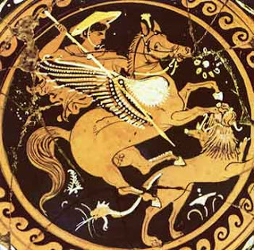
Riding Pegasus, Vellerefontis kills Chimera
bowl of the 4th cent. b.C., South Italy

Similarities-differeces
A recurring motif appears in Perseas’ and Vellerefontis’ stories: The hero undertakes the labours that a malicious king ordered to him. The king wants to get rid of the hero, but the hero achieves the labours successfully and gets the prize: the princess’ hand together with the throne.
In Hercules’ story, the hero saves the princess, but he doesn’t need the throne : he needs horses for the war, because Hercules is an explorer, a warrior, a conqueror ; he isn’t interesting in a kingdom.
Similar myths are common in Assyrian and Babylonian mythology: Sea-monsters destroy countries and asked princesses for sacrifice. The sea-monster Tiamat is killed by Marduk, in Enuma Elish, the Babylonian epic of creation.
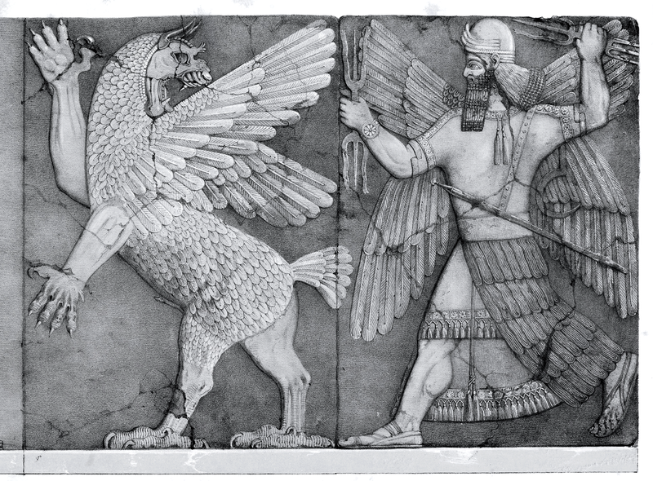
The archetype of the hero killing the dragon is also found in the Christian legend of St George who kills the dragon and releases either the country and the young girl.



