My dear members of the Gorgoglione family,

My name is Zuluf Adina and I am 14 years old. I live in Amara, a small town in Romania where I grew up. I am in my third year of secondary school at "George Valsan" Amara Secondary School, being the eighth grade A. I have emotions because this year is difficult and I have to enter a good high school. I don't know exactly which high school, but I know that I find myself in sports, but I also love children. So I have 2 options, to become a teacher or a policeman. I know, tough decision, but I have more to think about.
By the way, you know that my family consists of my two parents and my older sister that I showed you in the pictures. I hope that in a year I can return with them to Margherita di Savoia and come to your beach and meet you.
This summer I continued my hobbies. I am still fond of tennis, reading and have also started athletics in my spare time running 7 km a day.
I am grateful that during the week I was in Italy you made me feel like part of the family and maybe we will meet again to eat the famous Italian ice cream.
I miss you and hope you are well and happy like the day I met you.

With love,
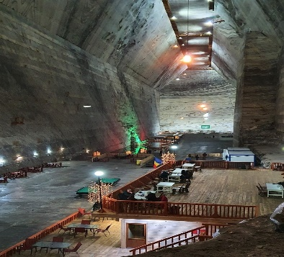
Adina

