HISTORY CLIL LESSON

School: Liceul Tehnologic Octavian Goga Jibou, Romania
Age of students/Grade: 11 years old /5th grade
Level of English: A1-A2
Teacher(s): Melinda Nagy
Subject(s): English / History
Topic: The Royal Grandchildren
Competences: cultural awareness and expression, digital competence, initiative

Aims:
-to revise vocabulary related to family relationships and jobs
-to lean about the British royal family
-to be able to create a family tree

Teaching points
Language | Content
official  air-sea rescue  helicopter  soldier  disabled | The British Royal Family

Resources: internet connection, laptop/tablet/smarphone, Google Meet, online textbook

Description of the activities:
Activity 1: Discussions
Before students read the text, they discuss the following questions:
- What do you know about the British royal family?
- What is the name of the Queen?
- Who is the future King?

Activity 2: Reading and writing
Students read the first two paragraphs of the text and complete the family tree for the royal family.
The United Kingdom has got a royal family. Queen Elizabeth II is the head of the family. Her husband is Prince Phillip and they’ve got four children: Prince Charles, Princess Anne, Prince Andrew and Prince Edward. The Queen has got eight grandchildren and five great-grandchildren.
The royal grandchildren are: Prince Charles’s sons, William and Harry; Princess Anne’s son and daughter, Peter and Zara; Prince Andrew’s daughters, Beatrice and Eugenie, and Prince Edward’s daughter and son, Louise and James.
The British monarchy today is different from in the past. The young generation of royals have got very different lives from their parents and grandparents. Their lives are more similar to the lives of ordinary people: school, university and work. They’ve got jobs but they’re also members of the royal family, so they’re often at official occasions, too.
Prince William’s an air-sea rescue helicopter pilot. He’s also a future king and he’s often the Queen’s representative on official occasions. His wife is Kate Middleton and they’ve got two children, George and Charlotte. His brother, Prince Harry, is a soldier and a pilot. Harry is a very popular young man and his favourite sports are rugby and polo. He’s the organiser of the Invictus Games, a sports event similar to the Paralympics, for disabled soldiers.
William and Harry’s cousin, Zara Phillips, is a sports champion. Her sport is horse-riding and she’s got lots of medals from international competitions. She hasn’t got a royal title – she’s just Zara Phillips. Her husband is a sportsman, too. He’s Mike Tindall, a rugby player. They have a very normal life – in the world of sport! They’ve got a daughter called Mia.

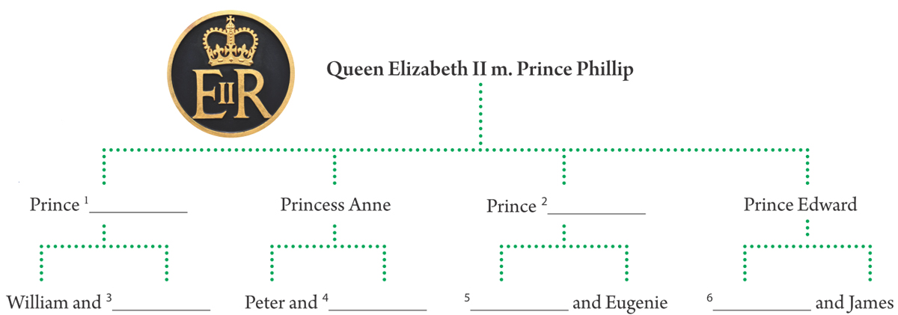
Activity 3: Reading and comprehension
Students continue to read the text and answer the questions:
1. What is the name of the Queen’s daughter?
2. What is Prince William’s job?
3. What is Prince Harry’s job?
4. Which are Prince Harry’s favourite sports?
5. Who is Zara Phillips?
6. What is her sport?

Activity 4: Project work
Find another royal family from Europe and create their family tree. Present it to the class.

