History CLIL lesson no. 5

School: Liceul Tehnologic Octavian Goga Jibou
Age of students/Grade: 11 years old /5th grade
Level of English: A1/A2
Teacher(s): Nagy Melinda
Subject(s): English / History
Topic: Famous Explorers

Aims:
-to find out about the lives and amazing achievements of famous explorers
-to enrich students’ vocabulary related to exploration, places and equipment

Vocabulary | Teaching points
The North Pole  The South Pole  Pacific Ocean  Arctic Circle  Antarctic Circle  space | Famous explorers  James Cook  Roald Amundsen  Valentina Tereshkova

Resources: internet connection, laptop/tablet/smarphone, Google Meet, online worksheets

Description of the activities
Activity 1: Introduction
Discusions about exploration with the pupils. T explains to them that much of the world has already been explored but there are still areas which we know very little about, like, for example, the oceans and space. T asks them to think about what kind of people explorers are. T explains that there have been many women explorers as well, although they are not usually as well known.
Activity 2: Warm-up
T shares a page with the following words: North Pole, Arctic Circle, the South Pole, Antarctic Circle, Pacific Ocean, space and the asks the pupils to imagine they are going to explore each of these places and asks them about the equipment they would need to take with them.
Explorers usually need to navigate: T asks thepupils if they know what explorers use to navigate (compass, map and, these days, GPS).

Activity 3: Reading and Comprehension
Pupils read the texts and match them to the pictures.
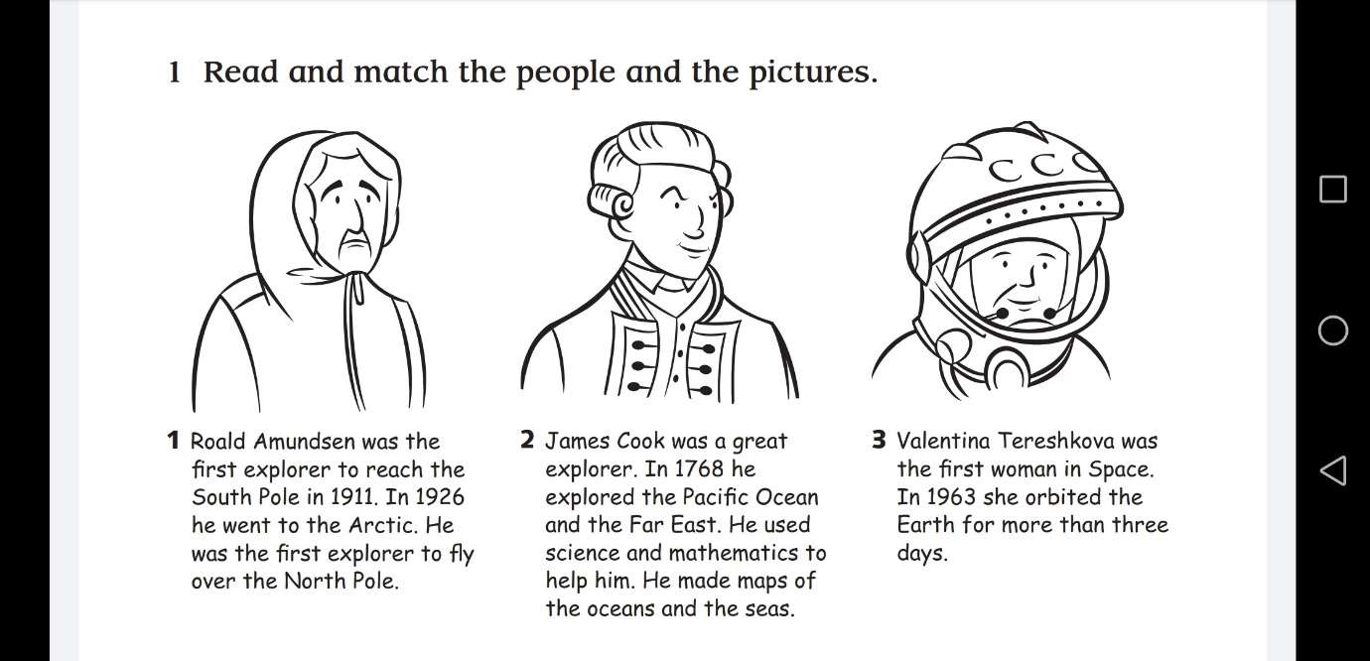

Activity 4: Reading and Comprehension
Pupils extract information from the texts and write it on the time line.
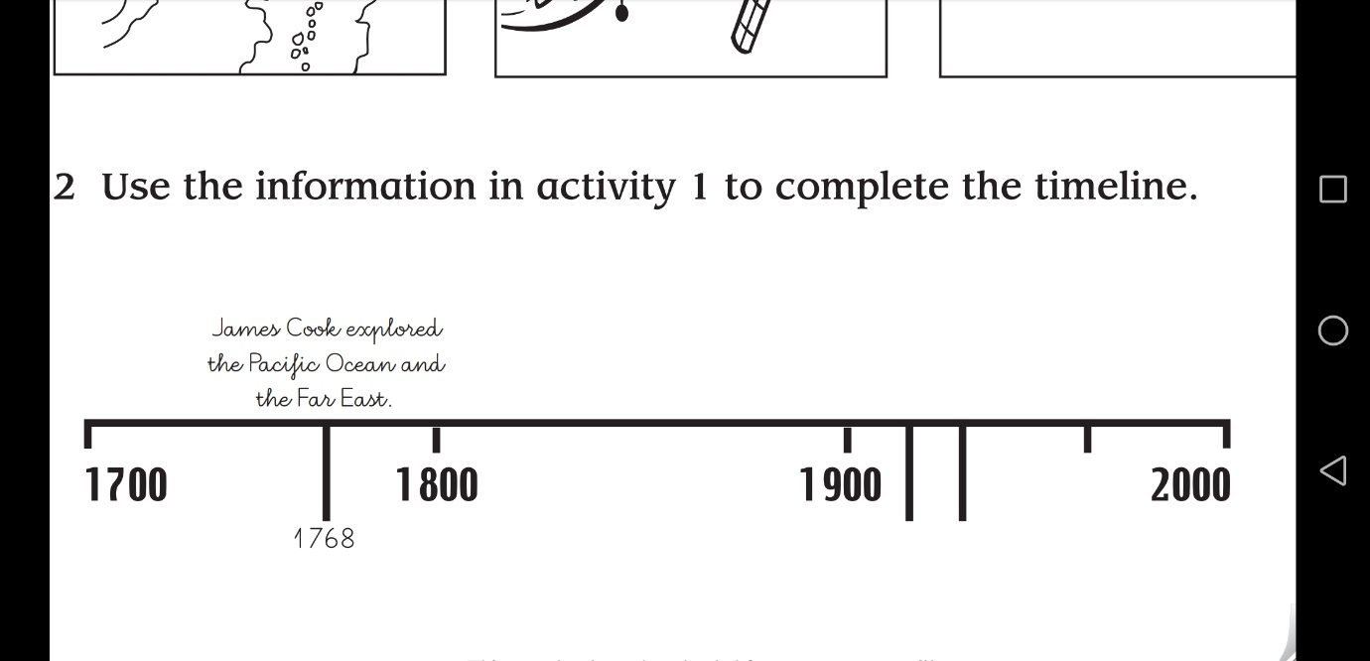

Activity 5: Project
Pupils research another famous person. They choose a century and find out how many famous
people you know were born then they put them on a time line

