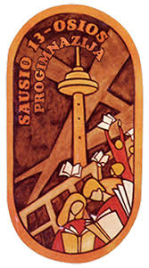

History CLIL Lesson Plan (Online lesson)

School: Vilniaus Sausio 13-osios progimnazija, Lithuania
Age of students/Grade: 12-13 years old /6th grade
Level of English: A1/A2

Teachers: Žana Šunina, Ieva Kildušytė
Subject(s): English / History
Topic: Monuments
Aims:
- To present new vocabulary through pictures
- To read for specific information
- To consolidate information in the text
- To prepare a poster

Teaching points:
Language | Content
- Monument  - Special  - Event  - Narrow  - Honour  - Structure  - Passageway  - Royal family  - Statue  - Military Hero  - Empire | - Monuments around the World  - Monuments in Lithuania

Resources: computers/laptops/tablets/mobile phones, Zoom app, internet connection.

Description of the activities:
Activity 1: To present new vocabulary through pictures.
- T directs Ss to the pictures (ANNEX 1).
- T asks Ss to describe each monument.
Activity 2: To read for specific information
- Ss read the text ‘’Our World of Monuments’’ (ANNEX 2).
- Ss choose the monument each text refers to.
Activity 3: To consolidate information in the text.
- T elicits three things Ss remember from the text from variuos Ss around the class.
Activity 4: To prepare a poster.
- T gives Ss time to collect pictures and information about monuments in Lithuania from the Internet.
- Ss prepare a poster.
- T asks Ss to present their posters to the class.

Supplementary materials:
“Upstream Elementary A1/A2” – Student’s book, Express Publishing, page 86.

ANNEX 1
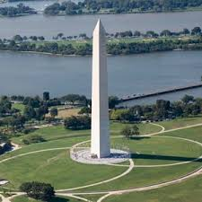
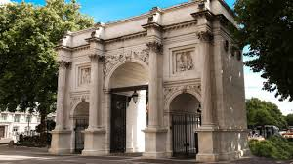
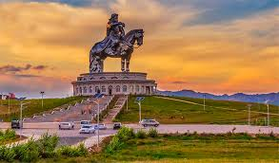

ANNEX 2
Our World of Monuments
People usually build monuments to remember a famous person or a special event. There are different types of monuments around the world.
A Obelisks
An obelisk looks like a tall narrow pyramid. One famous obelisk is the Washington monument in Washington, D.C. It honours George Washington, the first president of the USA. It has 897 steps inside it and visitors can also go up the monument in a lift.
B Triumphal Arches
A triumphical arch is a large structure that has a passageway that goes through it. Marble Arch in London was in front of Buckingham Palace in 1851. Only members of the royal family could pass through it. In 1851 they moved it to the northeast corner of the Hyde park.
C Equestrian Statues
An equestrian statue is a statue with a person on a horse. Most of them honour military heroes. One such statue is the Genghis Khan Statue in Mongolia. Genghis Khan ruled a large empire in the 12th century. The statue is in the countryside. Visitors can walk inside it and get great views from the horse’s eyes!

