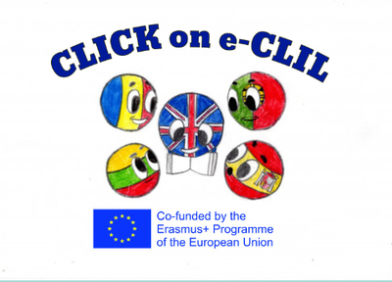

Geography CLIL Lesson Plan

School: Liceul Tehnologic Octavian Goga Jibou, Romania
Age of students/Grade: 11 years old /5th grade
Level of English: A1

Teacher(s): Nagy Melinda
Subject(s): English / Geography
Topic: United Kingdom

Aims:
- To present the United Kingdom
- To present a country of the UK
- To draw a map
- To collect information about famous landmarks in the cities

Teaching points:
Language | Content
- Island  - Monument  - Stadium  - Landmark  - Bridge  - Wall | - Countries of the United Kingdom  - Capital cities  - Important cities and landmarks in the UK

Resources: : hand-outs of the lesson, video projector, laptop, speakers, tablet

Description of the activities:
Activity 1: To present the United Kingdom
- T explains the use of “the” with geographical names and hands out the picture dictionary
- T asks Ss to look at the map. Plays the recording.
- Ss listen to and read the texts and identify the cities 1-8
- T checks Ss’ answers
Activity 2: To present a country of the UK
- T asks Ss to work in group and assigns each group a country and to copy the table into their notebooks, complete it with the information in the texts
- T asks various Ss to present one of the countries of the UK to the class
Activity 3: Digital Poster creation
- Ss work in groups of 4 and create a poster for the country they were assigned
- Ss present their work

Supplementary materials:
Poster creation using: PosterMyWall

