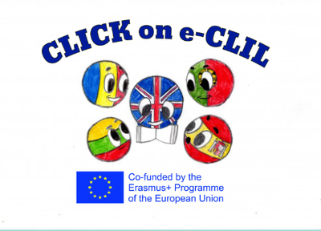
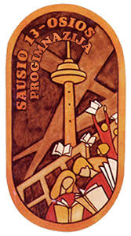

History CLIL Lesson Plan (Online Lesson)

School: Vilniaus Sausio 13-osios progimnazija, Lithuania
Age of students/Grade: 11-12 years old /5th grade
Level of English: A1

Teachers: Ieva Kildušytė, Žana Šunina
Subject(s): English / History
Topic: The Greatest Inventions of XIX Century

Aims:
- To enrich vocabulary related to inventions;
- To learn about the greatest inventions and transportation methods created during the Industrial Revolution;
- To develop research and ICT skills.

Teaching points:
Language | Content
- Invention  - Inventor  - Sewing machine  - Matches  - Typewriter  - Microphone  - Telegraph  - Traffic lights  - Roller coaster  - Diesel engine  - Barbed wire | - The Industrial Revolution  - Inventions of the XIX century

Resources: internet connection, laptop/tablet/smartphone, Zoom platform.

Description of the activities:
Activity 1: To enrich vocabulary related to inventions.
- T directs Ss to the pictures (sewing machine, matches, typewriter, microphone, telegraph, traffic lights, roller coaster, diesel engine, barbed wire and others) and asks questions. Ss look at the pictures, answer the questions.
- T explains/elicits the meanings of any unknown words.
Activity 2: To learn about the greatest inventions and transportation methods created during the Industrial Revolution.
- T presents the information about the Industrial Revolution. T demonstrates the greatest inventions and transportation methods created in the XIX century.

https://nevadainventors.org/30-inventions-1800s/

Activity 3: To develop research and ICT skills.
- Ss create digital posters about the greatest inventions of the XIX century using Canva (a graphic design platform). They search for information on the Internet.

