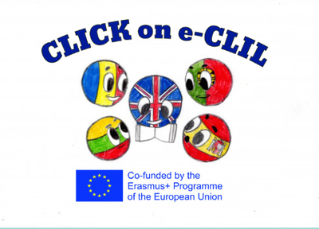
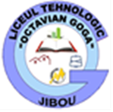

Geography CLIL Lesson Plan

School: Agrupamento de Escolas do Barreiro
Age of students/Grade: 12 years old /7th grade
Level of English: A2

Teacher(s): Ana Pina
Subject(s): English / Geography
Topic: World Heritage
Five most important or most interesting places which are considered to be world heritage in Portugal
Aims:
- To present the most interesting places which are considered to be world heritage in Portugal
- To present the places
- To draw a map
- To collect information about famous world heritages

Teaching points:
Language | Content
- Monument  - World  - Unesco  - Heritage  - Interesting  - Places | - Show its location  - Its date /historical period  - Main characterists  - Why is considered to be world heritage  - Photographs
Resources: hand-outs of the lesson, video projector, laptop, speakers, tablet

Description of the activities:
Activity 1: To present the 5 most interesting places in Portugal
- Asks to work in group and assigns each group an interesting place and to copy the power-point with the information
Activity 1: Digital presentation creation
- Work in groups of 4 and create a power-point for the interesting places
- Ppresent their work

Supplementary materials:
Power-point

