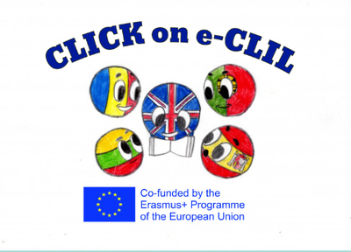
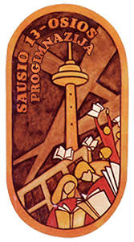

Civics Education CLIL Lesson Plan

School: Vilniaus Sausio 13-osios progimnazija, Lithuania
Age of students/Grade: 14 years old /8th grade
Level of English: B1.1

Teacher(s): Žana Šunina
Subject(s): English / Civics Education
Topic: Charity

Aims:
- To introduce the topic and new vocabulary
- To listen and read for specific information
- To reproduce information
- To extend information from a reading text into a longer piece of collaborative work including speaking and IT skills
- To give a presentation on the charity event

Teaching points:
Language | Content
- Charity  - To raise money  - Broadcast  - Fundraising  - Famine  - To be in need  - To set up  - To have in common  - Celebrities | - Charity organisation ‘’Comic Relief’’  - Charity events

Resources: video projector, laptop, speakers

Description of the activities:
Activity 1: To introduce the topic and new vocabulary
- T directs Ss to the pictures and asks questions. Ss look at the pictures, answer the questions. Ss predict the content of the text.
- T explains/elicits the meanings of any unknown words.
Activity 2: To listen and read for specific information
- Ss listen to the text.
- Ss read the text individually (ANNEX 1).
- Ss complete the summary (ANNEX 2).
- Ss compare their answers in pairs and report back to the class.
Activity 3: To reproduce information
- T divides the class into pairs and allows Ss time to prepare their questions and answers based on the text and the points given (the aim of the organisation, how it started, the special events it involves, who supports it).
- Ss act out an interview.
- T monitors Ss as they do the task.
- T asks some pairs to act out the dialogue in front of the class.
- T gives/elicits the feedback on the most important points
Activity 4: To extend information from a reading text into a longer piece of collaborative work including speaking and IT skills
- T divides the class into groups.
- Ss brainstorm ideas for fun activities for the charity events.
- Ss make a list of the suggestions and vote for the best ones.
- As homework, each group of Ss prepares a presentation on the charity event including donations, entrance fee, catchy pictures, titles, etc.
Activity 5: To give a presentation on a charity event
- Ss present their presentations (homework) the next lesson.

Supplementary materials:
“Upstream” – textbook for the 8th grade, Express Publishing, pages 111.

ANNEX 1
Read.
RED NOSES FIGHT POVERTY
Take a minute and ask yourself: What do charity and comedy have in common?

Nothing? Well, Comic Relief will certainly disagree with you.

Set up by a group of comedians, Comic Relief is a charity that uses laughter to raise money from the general public and help fight poverty in the UK and Africa. It began with a few live comedy events that were broadcast on BBC 1 on Christmas Day 1985, in response to the famine in Ethiopia. Since then, they have managed to raise about 300 million pounds!

Comic Relief is best known as the organisation behind Red Nose Day, the biggest fundraising event in the UK. On Red Nose Day, held every two years, people throughout Britain put on a red plastic nose and do the craziest things they can think of – all to raise money for those in need. Eating jelly with chopsticks, cutting the grass with a pair of scissors and eating grapes while wearing boxing gloves are just a few of the things people have done. The event includes moving documentary films and extraordinary comedy by some of the best British comedians, broadcast on national TV.

Over the years, many celebrities have taken part, each in their own special way. ‘’Mr Bean’’, Robbie Williams, and Victoria and David Beckham are only some of the famous people who have offered their time and talent in an event that unites the whole nation in trying to help other people and have fun at the same time!

ANNEX 2
Read the text again and complete the summary.

Comic Relief is a 1) ……………………………… . It started in the UK on 2) ………………………….. . So far they have raised 3) …………………………. . Every 2 years the British celebrate 4)……………………………….. . On this day people wear 5)………………………….. and do silly things. The money raised helps people in 6) ………………………. .

Answers: 1) charity; 2) Christmas Day 1985; 3) 300 million pounds; 4) Red Nose Day; 5) red noses; 6) need.

