Geography CLIL Lesson Plan (Online lesson)

School: Vilniaus Sausio 13-osios progimnazija, Lithuania
Age of students/Grade: 13-14 years old /7th grade
Level of English: A2/B1
Teacher(s): Žana Šunina
Subject(s): English / Geography
Topic: How Does a Waterfall Form?
Aims:
- To introduce the topic.
- To read for specific information.
- To develop research and speaking skills.

Teaching points:
Language | Content
- Hard rock  - Soft rock  - Erosion  - Plunge pool  - Surface  - Overhang  - Collapse  - Adapt  - Retreat  - Steep-sided valley  - Gorge  - Continent  - Length  - Widlife | - Formation of waterfalls  - Famous waterfalls

Resources: computers/laptops/tablets/mobile phones, Zoom app, internet connection.

Description of the activities:
Activity 1: To introduce the topic
- T asks Ss to think of the facts they already know about waterfalls and what Ss want to find out waterfalls.
- Ss watch the video about volcanoes:
https://www.youtube.com/watch?v=ilJzge07mcs
- Ss dicuss the video.
Activity 2: To read for specific information
- Ss read the text ‘’How does a waterfall form?’’ (ANNEX 1).
- Ss find the answers to the questions they have thought about.
Activity 3: To practise research and speaking skills
- T gives Ss time to find answers to the question (ANNEX 2) on the internet.
- Ss discuss the answers in pairs in breakout rooms.
- T asks various pairs of Ss to present the information they have found.

Supplementary materials:
“On Screen 3” – Workbook, Express Publishing, page 21.

ANNEX 1
How Does a Waterfall Form?
A waterfall occurs when a river, travelling on its way towards the sea, flows over a boundary between a hard rock and soft rock. Over time, the force of the water wears away the soft rock in a process called erosion.
As the water crashes over the fall into the river below, it creates a plunge pool – an area of deeper water right underneath the waterfall. The water hitting the surface of the river is also constantly splashing - called splash back – slowly eats away at the soft rock behind the waterfall, carving out a cave behind the falling water and leaving the hard rock above sticking out. This shelf of hard rock is referred to as an overhang. Eventually, there is not enough soft rock to support the hard rock above and the overhang collapses into the plunge pool below.
This process of erosion and collapse happens again and again over the centuries. This causes the waterfall to retreat up the river, leaving behind a steep-sided valley called a gorge.

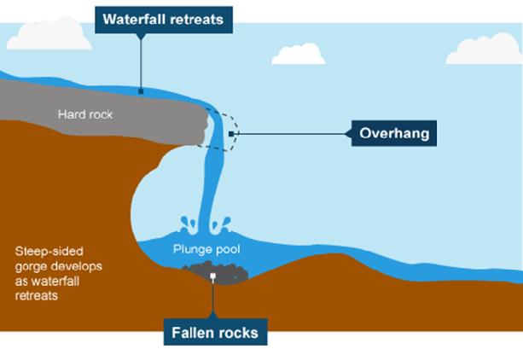

ANNEX 2
Questions for Pair Work
1. What is a waterfall?
2. How does a waterfall form?
3. How are waterfalls classified?
4. What are types of waterfalls?
5. What are the most famous waterfalls in the world? Present information about three famous waterfalls (country, height, interesting facts).

