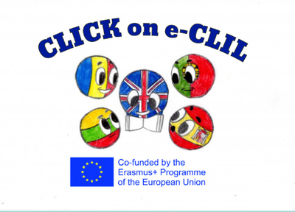
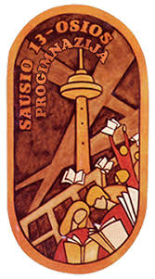

Civics Education CLIL Lesson Plan

School: Vilniaus Sausio 13-osios progimnazija, Lithuania
Age of students/Grade: 10-11years old /4th grade
Level of English: pre A1/A1

Teacher(s): Žana Šunina
Subject(s): English / Civics Education
Topic: 3Rs: Reduce, Reuse, Recycle

Aims:
- To introduce the topic and new vocabulary.
- To read for detailed understanding.
- To watch a video and consolidate information.
- To make a poster ‘’3Rs’’.

Teaching points:
Language | Content
- To reduce  - To reuse  - To recycle  - To avoid  - Waste  - Tornado  - Hurricane  - Flood  - To turn on (off)  - Global warming | - Global warming  - 3Rs

Resources: video projector, laptop, speakers

Description of the activities:
Activity 1: To introduce the topic and new vocabulary
- T directs Ss to the pictures and asks questions: ‘’How do we help the Earth?’’, ‘’What can we recycle?’’ Ss look at the pictures, answer the questions. Ss predict the content of the text.
- T explains/elicits the meanings of any unknown words.
Activity 2: To read for detailed understanding
- Ss read the text aloud (ANNEX 1).
- T checks the understanding of the text by asking questions: What are unwelcome events in the world? What do ‘’3Rs’’ stand for? What can you do to protect the Earth?
Activity 3: To watch a video and consolidate information
- Ss watch a video about 3Rs (reduce, reuse, recycle).
https://www.youtube.com/watch?v=OasbYWF4_S8
- T asks Ss to work in pairs and name the things they can reduce, reuse or recycle.
- Ss report their ideas back to the class.

Activity 4: To make a poster ‘’3Rs’’.
- Ss create a poster

Supplementary materials:
“Early School English 3: Yummy English”– textbook for the 4th grade. N. Sabeckienė, V. Rupainienė, V. Maskvytienė, ,,Šviesa’’.

ANNEX 1
Read.
3Rs (Reduce, Reuse, Recycle)
Every year we watch more and more unwelcome events in the world. Tornadoes, Hurricanes, floods... This is because of global warming. Everyone can protect the planet Earth. What can you do? This is the answer!
REDUCE
Use less... buy less... avoid waste...turn off lights... take shorter showers...
REUSE
Use things more than one time... use cloth shopping bags... fix things...
RECYCLE
Recycle products! Recycling one ton of paper saves seventeen trees. It is clear for everyone – me and you, him and her, us and them – why to reduce, reuse and recycle. Help our Earth stay nice and clear! Help our Earth stay strong and green!

