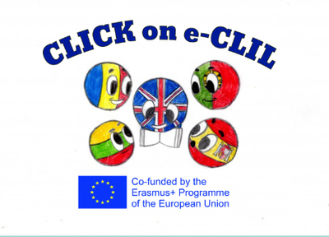
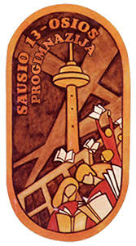

Parental Involvement 3rd Semester
School: Vilniaus Sausio 13-osios progimnazija, Lithuania
Age of students/Grade: 11-13 years old
Teacher(s): Žana Šunina, Ieva Kildušytė
Participants: students, students’ parents
Title of Activity: Christmas Past and Present
Aims:
- To present the project Christmas activity ‘’Christmas in my Country’’;
- To exchange Christmas experiences;
- To create a positive atmosphere, to bring families and school together.
Resources: computers/laptops/tablets/mobile phones, Zoom app, internet connection.
Description of the activities:
Activity 1: To present the project Christmas activities and results
- Ts present project Christmas activity ‘’Christmas in my Country’’ and its results on eTwinning platform
https://twinspace.etwinning.net/92765/pages/page/1198643

Activity 2: To exchange Christmas experiences
- Each parent shares his/her childhood memories about Christmas celebrations, shows pictures, shares Christmas stories that had happened to them in their childhood.
- Ss ask questions about Christmas traditions in the past. Parents answer the questions.
- Ss describe the way they celebrate Christmas at present.

Activity 3: To create a positive atmosphere, to bring families and school together.

- Playing a chain game: T begins by saying a Christmas wish. Then, he names the person who will be the next to say a Christmas wish/greeting.
- All the players must remember the people who have already said the congratulation as the player cannot pass the word to the person that has already presented a Christmas wish/greeting.
- Ts monitor the process, they make sure that all the participants presented the wish.

