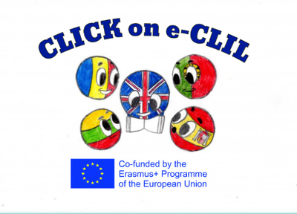
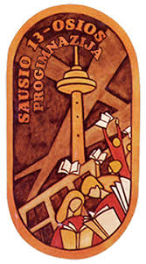

Parental Involvement 1st Semester

School: Vilniaus Sausio 13-osios progimnazija, Lithuania
Age of students/Grade: 10-14 years old
Teacher(s): Žana Šunina, Ieva Kildušytė
Participants: students, students’ parents
Title of Activity: What do you know about Europe?
Aims:
- To present the project activities and results;
- To find out information about Europe;
- To create a positive/family atmosphere that encourages learning;
- To develop collaboration between students, teachers and students’ parents.
Resources: video projector, laptop, speakers, jigsaw puzzles, board games.
Description of the activities:
Activity 1: To present the project activities and results
- Ts present project activities and results using Power Point presentation.

Activity 2: To find out information about Europe
- T asks students and their parents to answer the questions about Europe and European countries in groups (see Parental Involvement_Brain Battle_LT);
- T count the points and announces the winner.
Activity 3: To create a positive/family atmosphere that encourages learning; to develop collaboration between students, teachers and students’ parents.
- Ss and their parents play jigsaw puzzles and board games.

