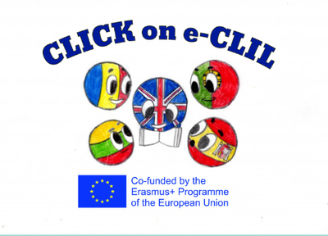
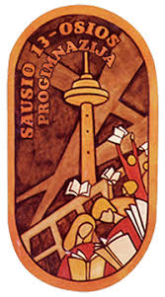

Civics Education CLIL Lesson Plan

School: Vilniaus Sausio 13-osios progimnazija, Lithuania
Age of students/Grade: 11-12 years old /5th grade
Level of English: A1

Teacher(s): Žana Šunina
Subject(s): English / Civics Education
Topic: Road Signs

Aims:
- To introduce the topic
- To read for specific information
- To consolidate new vocabulary
- To practise research skills; to develop presentation skills.

Teaching points:
Language | Content
- Coach  - To memorise  - Circle  - Triangle  - Rectangular  - Precise  - Warning  - Direction  - Condition  - Motorway  - Recreational  - To watch out | - Road signs  - Traffic signs  - The importance of road and traffic signs

Resources: computers/laptops/tablets/mobile phones, Zoom app, internet connection.

Description of the activities:
Activity 1: To introduce the topic
- T directs Ss to the traffic signs and asks questions: How do you like to travel? How do traffic signs differ? Ss look at the pictures, answer the questions. Ss predict the content of the text.
- T explains/elicits the meanings of any unknown words.
Activity 2: To read for specific information
- Ss read the text individually (ANNEX 1).
Activity 3: To consolidate new vocabulary
- T reads the answers aloud.
- Ss answer the questions (ANNEX 2).
- Ss do matching activities online.
Activity 4: To practise research skills, to develop presentation skills
- Ss collect information about traffic signs as their homework.
- Ss present the information next lesson.

Supplementary materials:
“Access” – Student’s book for the 5th grade, Express Publishing, page 95.
https://www.liveworksheets.com/worksheets/en/English_as_a_Second_Language_(ESL)/Colours/Road_Safety_-_Signs_jb15257gq
https://www.liveworksheets.com/worksheets/en/English_as_a_Second_Language_(ESL)/Road_signs/Road_signs_mp802206xq
https://www.liveworksheets.com/worksheets/en/English_as_a_Second_Language_(ESL)/Road_signs/Road_Safety_-_Signs_groups_qm15259ez

ANNEX 1
Read the text.
Road Signs
If you think that you don’t need to pay attention to road signs because you don’t drive a car, think again.They are there for everyone’s safety. So, if you ride a bicycle or even just walk, you need to know what the signs mean.
There are many different signs and it’s hard to memorise all of them, but you should try to remember the most important ones.
Signs with red circles show speed limits and tell you what you mustn’t do, while signs with red triangles give warnings.
Signs with blue circles usually give positive instructions about which direction to follow, while rectangular blue signs give information and directions on motorways and tell us lanes bicycles can use in towns.
Green signs give precise information about directions and distances.
Yellow signs with black letters or symbols give warnings to drive carefully and inform you about the condition of the road.
Orange signs with black letters or symbols inform you that there are road works ahead.
Brown signs give directions to places of historic, cultural or recreational interest.
So next time you’re out and about, watch out for the signs.

ANNEX 2
Answer the questions.
1. Which sign tells you what you mustn’t do?
2. Which sign gives you information about the condition of a road?
3. Which sign tells you how fast you can drive?
4. Which sign shows you which direction to follow?
5. Which sign tells you where there is a museum?
6. Why should you watch out for the signs?

