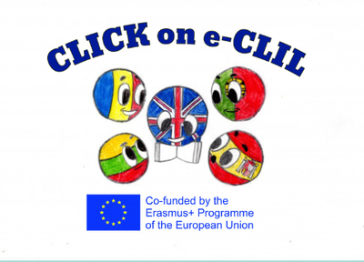
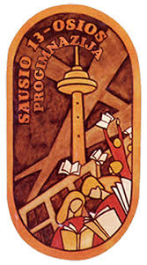

Geography CLIL Lesson Plan

School: Vilniaus Sausio 13-osios progimnazija, Lithuania
Age of students/Grade: 12-13 years old /6th grade
Level of English: A2

Teacher(s): Žana Šunina
Subject(s): English / Geography
Topic: Clouds

Aims:
- To introduce the topic and present new vocabulary
- To read for comprehension
- To identify antonymous words
- To consolidate information in a text through comparisons
- To consolidate new vocabulary
- To consolidate information in a text

Teaching points:
Language | Content
- Be made of  - Drop  - Ice  - Thin  - Float  - Reflect  - Thick  - Flat layer  - Light rain  - Sprinkle of snow  - Blanket  - Hang low  - Ground  - Fog  - Fluffy  - Cotton wool  - Fair weather | - Types of clouds.  - Differences between clouds.

Resources: videoprojector, laptop, handouts of the text, dictionaries

Description of the activities:
Activity 1: To introduce the topic and present new vocabulary
- T reads the title of the text ‘’Clouds’’ and invites Ss to tell the class what they know about clouds.
- Ss look at the pictures of the clouds. T explains that there are four types of clouds and elicits their names (Stratus, Cumulus, Cirrus, Nimbus).
- T reads the sentences (ANNEX 1) aloud and explains the meaning of any unknown words.
- Ss match the sentences to the types of clouds shown in the pictures.
- T elicits answers from Ss around the class.
Activity 2: To read for comprehension.
- Ss read the text ‘’Clouds’’ (ANNEX 2). T explains any unknown words.
- Ss answer the questions (ANNEX 3).
- T checks Ss’ answers.
Activity 3: To identify antonymous words.
- T reads out the words from the list (thick, ordinary, uneven, heavy, far, small, bright) and gives time to match them to the highlighted words in the text. Ss can use dictionaries if necessary.
- T checks Ss’ answers (thick-thin; special-ordinary; flat-uneven; light-heavy; near-far; big-small; dark-bright).
Activity 4: To consolidate information in a text through comparisons.
- T asks Ss to read the text again and compare the different types of clouds.
- T elicits sentences from Ss around the class.
Activity 5: To consolidate new vocabulary.
- Ss complete the mind map with words connected to the clouds.
- T gives Ss handouts with new words/phrases and their meanings/definitions. Ss have to match the words to their definitions (ANNEX 4). Before the lesson T cuts the sheet of paper (ANNEX 4) so that the definitions of the words are on separate slips of paper. Ss do the task in pairs or in groups of three.
- T gives time to look up the meanings of the words in dictionaries.
- T checks Ss’ answers.
Activity 6: To consolidate information in a text.
- Ss tell the class four things they learnt from the text.

Supplementary materials:
“The Weather” – CLIL readers, Express Publishing, pages 6-7, 26.
‘’On Screen 2’’ Student’s book, Express Publishing, page 58.

ANNEX 1
Match the sentences to the correct type of cloud.
1. They are big and fluffy.
2. They form in flat layers.
3. They cover the sky.
4. They are wispy and made of ice crystals.
5. They look like a grey blanket that hangs in the sky.
Answers: 1. Cumulus; 2. Stratus; 3. Nimbus; 4. Cirrus; 5. Stratus.

ANNEX 2
Read the text.
Clouds
Clouds are made of drops of water or ice. These drops are small and thin so they can float in the air. Clouds are white because they reflect the light of the sun. When they get thick or high above light, they look grey. There are four types of clouds, each one different and special.
STRATUS
These clouds form in flat layers. They often bring light rain or sprinkles of snow. They look like a grey blanket that hangs low in the sky. When they are near the ground, we call them fog.
CUMULUS
These clouds are big and fluffy and look like balls of cotton wool one on top of the other. People call them ‘’fair weather clouds’’ and we see them in the middle of the sky when the weather is good. Sometimes, they are white, other times they are grey.
CIRRUS
These clouds are thin and are high up in the sky. They are made of ice crystals. If you see them in the sky, yhen it will be a nice day.
NIMBUS
These clouds cover the whole sky and are dark. They are low in the sky and bring heavy rain or snow.

ANNEX 3
Answer the questions.
1. What do cumulus clouds look like?
2. Which clouds can be grey?
3. When do we call stratus clouds fog?
4. Which clouds can bring rain or snow?
5. Which clouds suggest the weather will be nice?

ANNEX 4
Match the words/phrases to their definitions.
be made of | consist of
drop | a small amount of liquid
ice | frozen water
float | to hang in the air
reflect | to send light back from its surface
thick | not thin
flat layer | a level of sth that is smooth
light rain | drizzle
sprinkle of snow | a light snowfall
blanket | covering
hang low | to be suspended not far off the ground
ground | the earth
fog | thick clouds near the ground that make it difficult to see
fluffy | soft and light
cotton wool | a soft mass of cotton
fair weather | good weather, sunny and not rainy

