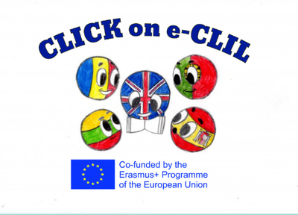

Civics Education CLIL Lesson Plan

School: Vilniaus Sausio 13-osios progimnazija, Lithuania
Age of students/Grade: 11 years old /5th grade
Level of English: A1

Teacher(s): Žana Šunina
Subject(s): English / Civics Education
Topic: How to Volunteer during the Spread of COVID-19?

Aims:
- To present new vocabulary and introduce the topic
- To read for specific information
- To consolidate new vocabulary by answering comprehension questions and making true sentences
- To prepare a poster; to practise research skills.

Teaching points:
Language | Content
- Volunteer  - Community  - Homelessness  - Donation  - Charity  - To make a difference  - Pandemic spread  - Coronavirus | - Ways of volunteering  - Volunteering during spread of COVID-19

Resources: computers/laptops, Internet, newspapers.

Description of the activities:
Activity 1: To present new vocabulary and introduce the topic
- T directs Ss to the pictures and asks questions. Ss look at the pictures, answer the questions. Ss predict the content of the text.
- T explains/elicits the meanings of any unknown words.
Activity 2: To read for specific information
- Ss read the text individually (ANNEX 1).
Activity 3: To consolidate new vocabulary by answering comprehension questions and making true sentences
- Ss read the text aloud.
- Ss answer the questions (ANNEX 2).
- T checks the answers.
- Ss make true sentences (ANNEX 3).
- Ss read true sentences aloud.
Activity 4: To prepare a poster; to practise research skills
- T divides the class into groups.
- T gives Ss time to collect pictures and information about spread of COVID-19 from the Internet, newspapers.
- Ss prepare posters.
- T asks Ss to present their poster to the class.

Supplementary materials:
“On Screen 1 Workbook” – workbook for the 5th grade, Express Publishing, pages 31.

ANNEX 1
Read.
HOW TO VOLUNTEER
Do you know that thousands of teenagers volunteer in their free time all over the world? There are so many things that someone your age can help with. You can make a difference in your community, meet new people and learn new skills. It’s important, however, to do it right.
1. Choose a charity or group you care about. Do you want to help children? Perhaps you feel strongly about certain issues like pollution or homelessness. There are a variety of charities out there to choose from.
2. Look for an activity that you can do. Are you very good at sports? Can you use the Internet? There is a charity that needs your skills. Volunteer for something that you are good at and like doing.
3. Look for something in your area. Start with something near your home. Your community needs you and you can meet new friends, too.
4. Volunteer for an hour or two at first, or one day a month. If you like the work and have free time, then you can volunteer more often.

ANNEX 2
Read the text again and answer the questions.
1. How should you choose which charity to volunteer for?
2. Where should you volunteer? Why?
3. How often should you volunteer?

ANNEX 3
Use the information in the text to write about you.
I care about ................. . I am good at ................... . Maybe I can volunteer at a ...................... charity for .................... hours every week.

