Evaluation - C3 - Click on e-CLIL
2019-1-RO01-KA229-063080
C3: Short term exchange of groups of students
Vilnius, Lithuania, March 2022

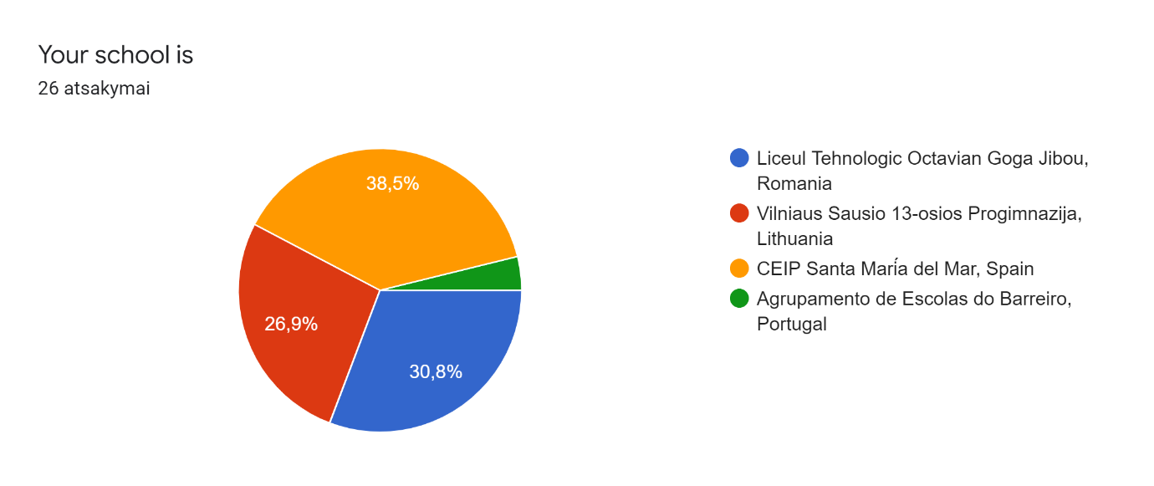

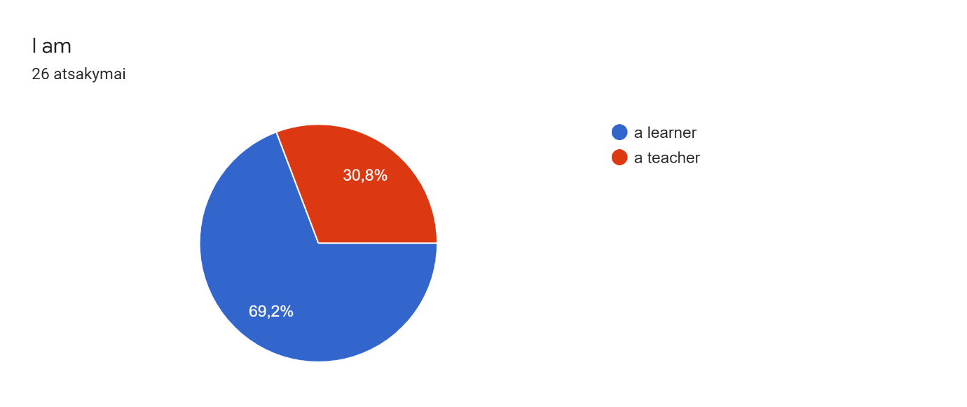
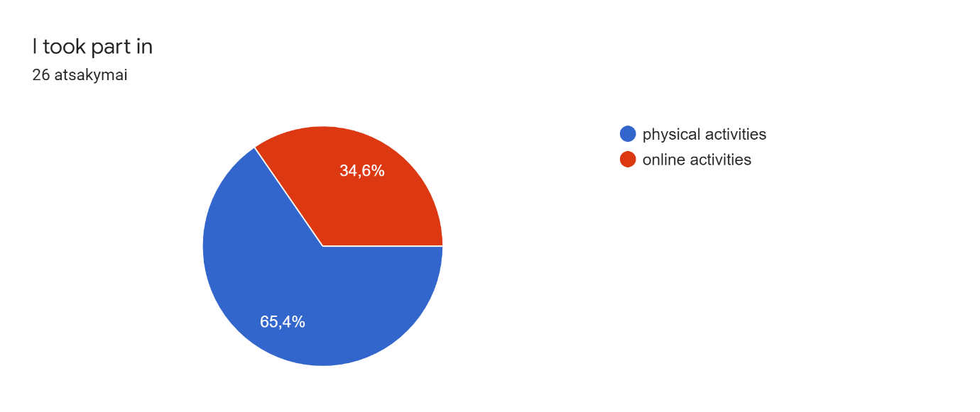
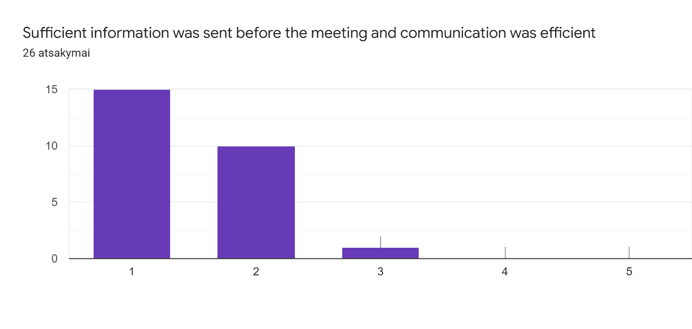
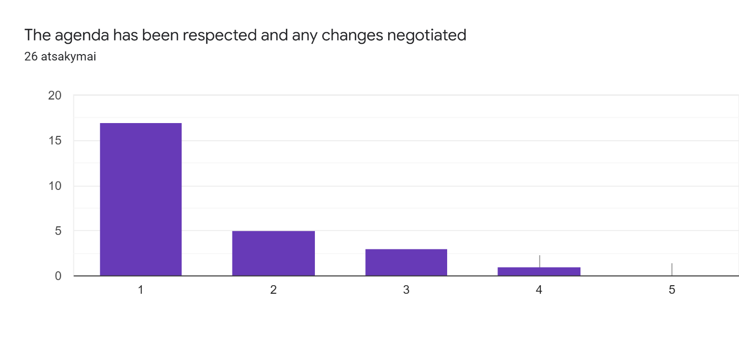
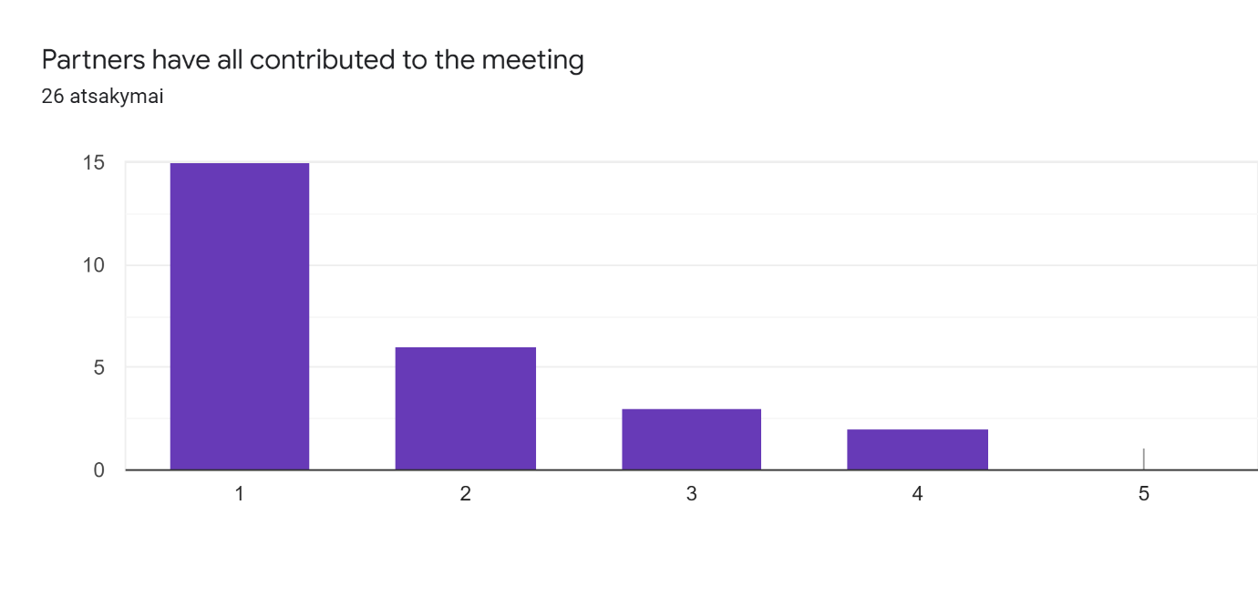

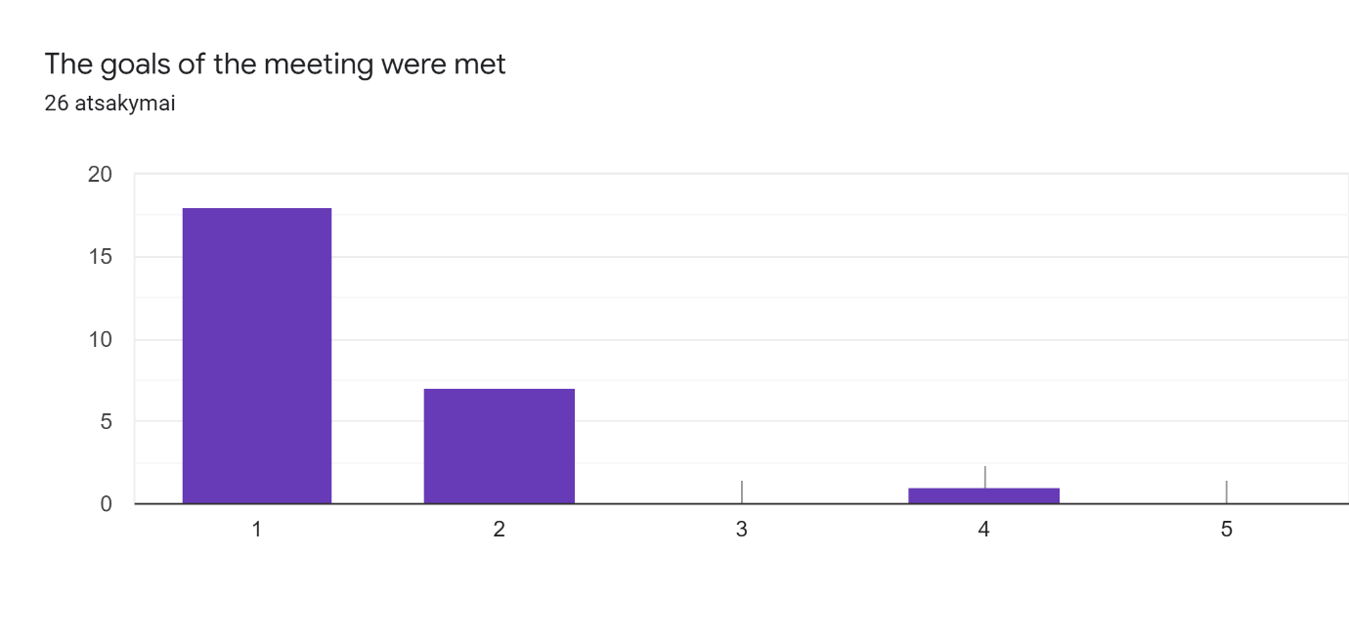
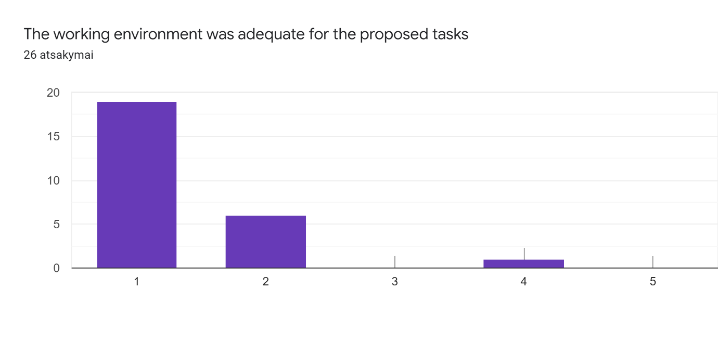
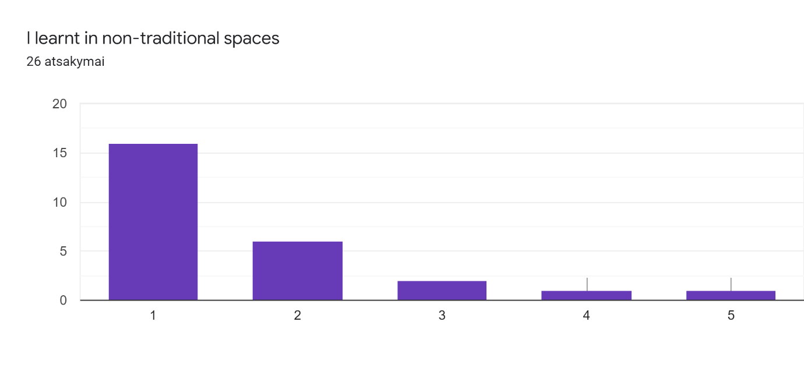
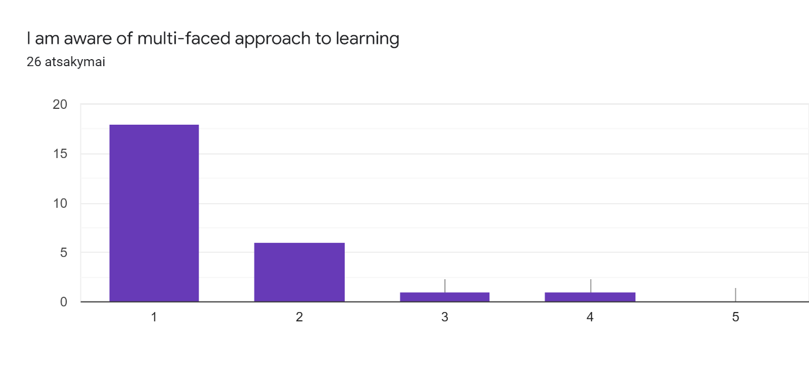
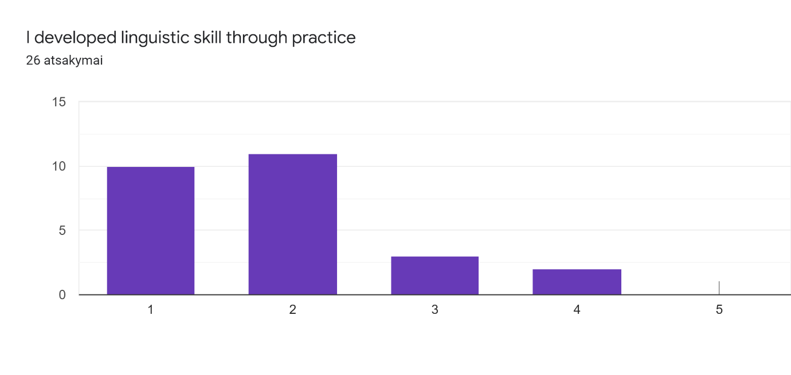
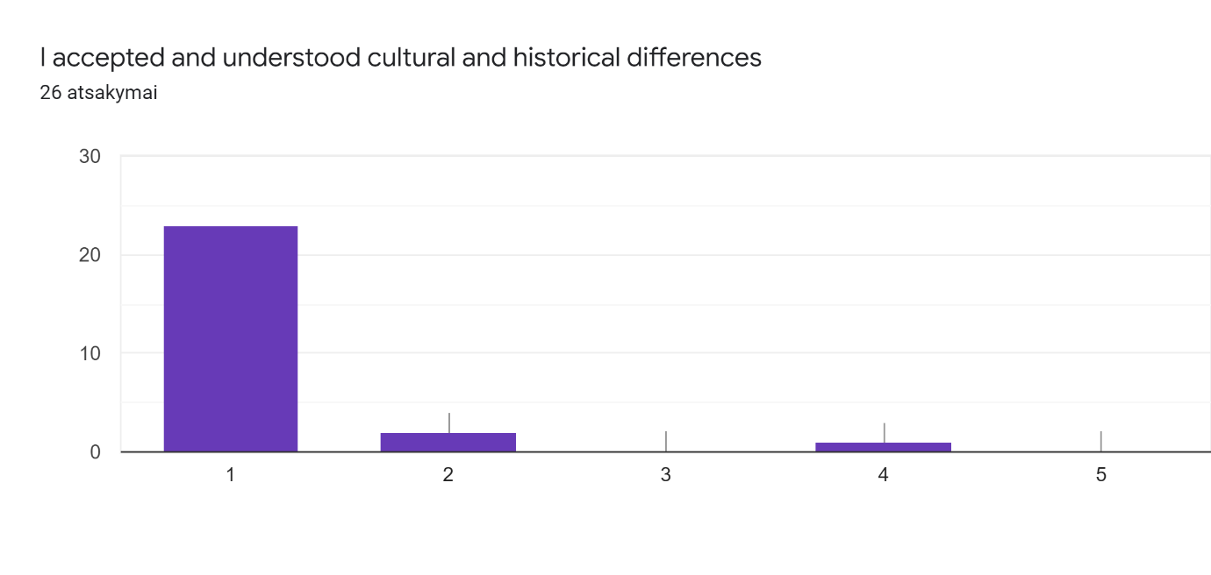
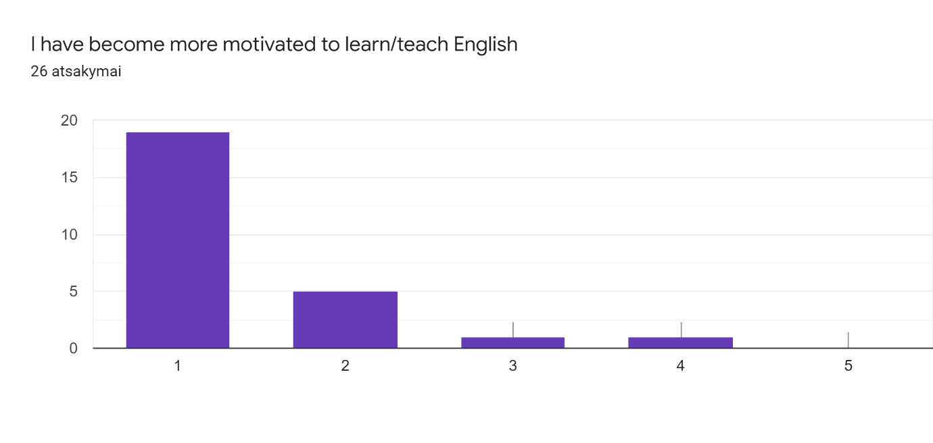
Any other comments, observations, suggestions:
- 4. Alejandro Prieto Baute I couldnt hear sometimes because of the noise in the steet
- Access problems: students account are not allowed to use the link. With my own link, I will provide with the name of each student: 1.- Eileen Díaz Luis Comments: i do not know about changes in the agenda
- 2.- Iker Díaz González Comments: I liked everything a lot. I enjoyed very much.
- 6. Valeria Muñoz Hernández. Comment: Every activity was very interesting. I wanted to be in Lithuania.
- 3.- Aarón Santana Rodríguez Comments: activities are interesting but sometidos we cannot listen properly.
- Oliver Marquez Rodriguez: Nobody asked me for changes but i liked the program a lot
- It was a wonderful week, with lots of fun activities. Thank You Zana.
- The meeting was very successful and I am very happy to see Vilnius.
- To the question "The goals of the meeting were met" I did't write a number 1 because not all the partners participated equally and I think that fully participation was one of the main goals. About information before meeting, I didn't write 1 because due to COVID 19 and War, the mobility scenario changed and our pupils participated online and some last-minute changes happened, not being responsabiity of organization at all.
- none.
- Congratulations for a wonderful organisation of this mobility. Thank you very much for the unforgettable experience.
- Thank you.

