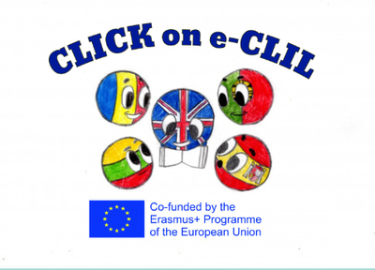

Parental Involvement 4th Semester
School: Vilniaus Sausio 13-osios progimnazija, Lithuania
Age of students/Grade: 10-14 years old
Teacher(s): teachers of the progymnasium
Participants: students, students’ parents
Title of Activity: Toys and Games
Aims:
- To boost connection between school and students’ families;
- To make toys and board games;
- To teach skills through fun.
Resources: cardboard, paper, plastic figures, coins, buttons, shells, markers, crayons, dice, sticky notes.
Description of the activities:
Activity 1: To boost connection between school and students’ families.
- Ss and their parents discuss at school and at home the kinds of self-made games. They search for ideas on the platform: https://lt-lt.facebook.com/thedadlab. They share the ideas with teachers.

Activity 2: To make toys and board games.
- Students and their parents make different toys and board games, such as monopoly, memory game, checkers, etc.

Activity 3: To teach skills through fun.
- Students and their parents play the games they created together. Toys and games are used for students to play during breaks.

