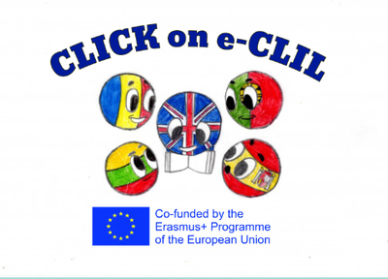
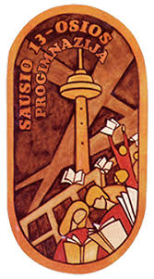

History CLIL Lesson Plan

School: Vilniaus Sausio 13-osios progimnazija, Lihuania
Age of students/Grade: 11 years old /5th grade
Level of English: A1

Teacher(s): Žana Šunina
Subject(s): English / History
Topic: Queens of England

Aims:
- To introduce the topic and new vocabulary
- To present and practise Roman numerals
- To listen for specific information
- To consolidate information in the texts
- To develop research skills; to give a presentation on biography of Queen Victoria

Teaching points:
Language | Content
- To be beheaded  - Throne  - Sewing  - To shoot a bow and arrow  - Pale  - Jewellery  - Follower  - Reign  - Scholar  - Coronation  - Duke | - Biography of Queen Elizabeth I  - Biography of Queen Elizabeth II  - Biography of Queen Victoria

Resources: video projector, laptop, speakers

Description of the activities:
Activity 1: To introduce the topic and new vocabulary
- T directs Ss to the pictures and asks questions. Ss look at the pictures, answer the questions.
- T explains/elicits the meanings of any unknown words.
Activity 2: To present and practise Roman numerals
- T explains the Roman numerals 1-10.
- Ss write numerals 11-20 in their notebooks. T checks Ss’ answers on the board.
Activity 3: To listen for specific information
- Ss listen to the article on Elizabeth I and Elizabeth II.
- Ss fill in the gaps with numbers.
- T checks Ss’ answers.
Activity 4: To consolidate information in the texts
- Ss read the article.
- Ss read sentences and put ‘’I’’ for Elizabeth I and ‘’II’’ for Elizabeth II (ANNEX 1).
- In pairs, Ss read the royal quiz and choose the correct alternative (ANNEX 2).
Activity 5: To develop research skills; to give a presentation on biography of Queen Victoria
- T explains to students that they have to find information about Queen Victoria. T points out that Ss may collect data through the Internet, encyclopaedias and other published sources.
- Ss use this information to do PowerPoint presentations about Queen Victoria. Ss do this task at home.
- Ss present their homework the next lesson.

Supplementary materials:
“Welcome 3” – textbook for the 5th grade, Express Publishing, pages 106-107.

ANNEX 1
Read and put I for Elizabeth I or II for Elizabeth II.
- She was born in Greenwich Palace.
- Her father was King Henry VIII.
- She married Philip Mountbatten.
- She became Queen of England in 1952.
- She loved shooting a bow and arrow.
- She had lessons at home with her sister, Princess Margaret.
- She named her first son Charles.
- She lived at the same time as William Shakespeare.
Answers:
1-I; 2-I; 3-II; 4-II; 5-I; 6-II; 7-II; 8-I.

ANNEX 2
Royal Quiz
Work with a partner. Try to guess the correct answer.
- Who is Prince Charles’ eldest son?
- Prince Andrew
- Prince William
- Prince Henry
- What is Prince Andrew’s title?
- Duke of York
- Prince of Wales
- Sir Andrew
- Who’s the Duke of Edinburgh?
- Prince Edward
- Prince Charles
- Prince Philip
- Who did Prince Charles marry?
- Lady Diana Spencer
- Lady Jane Grey
- Sarah Ferguson
- Where is Buckingham Palace?
- London
- Edinburgh
- Cardiff
- What is one of Prince Charles’ favourite hobbies?
- Bowling
- Dancing
- Gardening
- When was the Queen Mother born?
- 1926
- 1952
- 1900
- Where does the Queen spend her summer holidays?
- Windsor Castle
- Balmoral Castle
- Edinburgh Castle
- When you speak to the Queen, you must call her…
- Mrs Windsor
- Your Majesty
- Madam Elizabeth
- Where can you see the Crown Jewels?
- Big Ben
- St Paul’s Cathedral
- The Tower of London

Answers:
1-B; 2-A; 3-C; 4-A; 5-A; 6-C; 7-C; 8-B; 9-B; 10-C.

