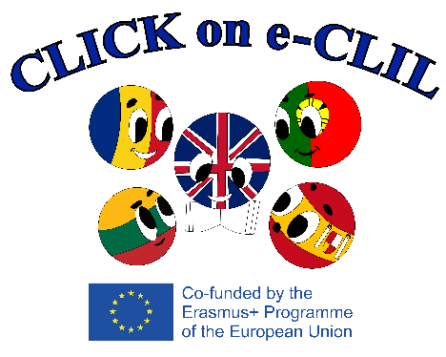
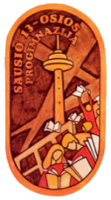

AGENDA of the EVENT
Project Title and Number: Click on e-CLIL, 2019-1-RO01-KA229-063080
C3: Short-term exchange of groups of pupils ‘’Get to Know our Culture’’
Venue: Vilniaus Sausio 13-osios progimnazija, Lithuania
21-25 March 2022

Date | Time | Activity
Sunday, 20th March 2022 |  | ARRIVAL DAY
Monday, 21st March 2022 | 10.00  10.30  11.40  12.30  13.15  14.00  14.30  16.00  16.30 | Pick up at the hotel  Welcome ceremony at school  Drama CLIL Lesson ‘’Games and Dances’’ (*Each group of students is supposed to demonstrate a game or a dance and teach other students to play or dance)  Introduction of participants. Team building activities (*Each group of students is supposed to introduce themselves 2-3 min.)  Lunch break  Tour of the school  History CLIL lesson ‘’Memorable Stories’’. Visiting TV tower  Discussions and evaluation of the lessons and of the day  Free time
Tuesday, 22nd March 2022 | 8.20  9.00  11.00  12.00  13.00  14.30  15.00 | Pick up at the hotel  Citizenship CLIL lesson ‘‘Democratic Values‘‘. Visiting the Parliament of the Republic of Lithuania. Discussion with members of the Parliament  History CLIL lesson ‘’Gediminas Avenue: the Main Artery of Vilnius’’. Walking down Gediminas Avenue and spotting the architectural transition of Vilnius  Lunch break  History CLIL Lesson ‘’The Past Opens up for the Future’’. Visiting National Museum – Palace of the Grand Dukes of Lithuania  Discussions and evaluation of the lessons and of the day  Free time
Wednesday, 23rd March 2022 | 8.40  9.30  10.00  11.30  13.30  15.00  15.30  16.20 | Pick up at the hotel. Departure for Trakai  Geography CLIL lesson ‘’Trakai - a Town built on water’’  History CLIL lesson ‘’Trakai Castle’’  Art CLIL Lesson ‘’Easter Candle Casting’’  Food Technology CLIL Lesson ,,Kibinai: National Heritage of Karaites’’. Baking and tasting kibinai  Discussions and evaluation of the lessons and of the day  Heading to Vilnius  Free time
Thursday, 24th March 2022 | 8.30  9.00  11.00  12.00  13.00  14.30  15.00 | Pick up at the hotel  Social Studies CLIL lesson ‘‘Glimpses of Vilnius‘‘. A Walking Tour around Vilnius Old Town (UNESCO World Heritage Site)  Drama CLIL lesson ‘’Toys Now and Then’’. Visiting Toy Museum  Lunch break  History CLIL Lesson ‘’Gediminas Tower: a Symbol of Vilnius’’. Walking up Gediminas Hill, visiting Gediminas Tower  Discussions and evaluation of the lessons and of the day  Free time
Friday, 25th March 2022 | 8.20  9.00  11.00  12.00  13.30  14.00  14.30 | Pick up at the hotel  Citizenship CLIL lesson ‘‘Responsilble Citizens‘‘  Lunch break  Art CLIL Lesson ‘’Art without Frontiers’’. Visiting National Art Gallery  Discussions and evaluation of the lessons  Evaluation of the meeting & Certificate ceremony  Free time
Saturday, 26th March 2022 |  | DEPARTURE DAY
Expected Results:
- Presentations of a traditional game or a dance from different countries.
- Materials of various historical places of interest of Lithuania.
- Learning in non-traditional spaces.
- Students’ acceptance and understanding of cultural and historical differences.
- Development of linguistic skills through practice.
- Awareness of multi-faceted approach to learning.
- Enhanced students’ interest in learning the English language.

Name and signature of the legal representative

Stamp of the institution

