- READ THE TEXT AND FIND THE FOLLOWING WORDS:
tricky, addressing, engaged, stare, at ease, slouch, daunting, awkward, endear, shaky, steadying breath, beforehand, nickname, chances, involved, avoid.
THEN FIND A SYNONYM OR WRITE A DEFINITION FOR THEM.
1.
2.
3.
4.
5.
6.
7.
8.
9.
10.
11.
12.
13.
14.
15.
16.

2. ANSWER THE FOLLOWING QUESTIONS ABOUT THE TEXT
- What does “introducing yourself” represent?

- What is important in introducing yourself?

- What does “eye contact” show?

- How can you communicate that you are confident?

- Which are the steps that help you introduce yourself with confidence?

- How does smiling help mask your nervousness?

- When introducing yourself which are the details you should give?
HOW TO INTRODUCE YOURSELF

Introducing yourself is much more than saying your name; it’s a way to connect with someone new by exchanging words and often, physical contact. Introducing yourself to strangers can be tricky because what you say depends entirely on the context. You may introduce yourself differently depending on whether you are addressing an audience before you give a speech, meeting someone at a networking event, introducing yourself to your class, or just starting a conversation with a new person at a party. What is important is to introduce yourself in a way that is appropriate and makes people like and remember you.

1 Introducing Yourself in Any Social Situation
A.Make eye contact. Eye contact shows that you're engaged in the interaction. Eye contact is one way to connect with another human and show that the other person has your attention. When you make eye contact, it shows that you are open and engaged.
- If you're not comfortable looking straight into someone's eyes, stare at the point between the eyebrows; she won't notice the difference.
- If you’re in a group setting, make periodic eye contact with those around you.
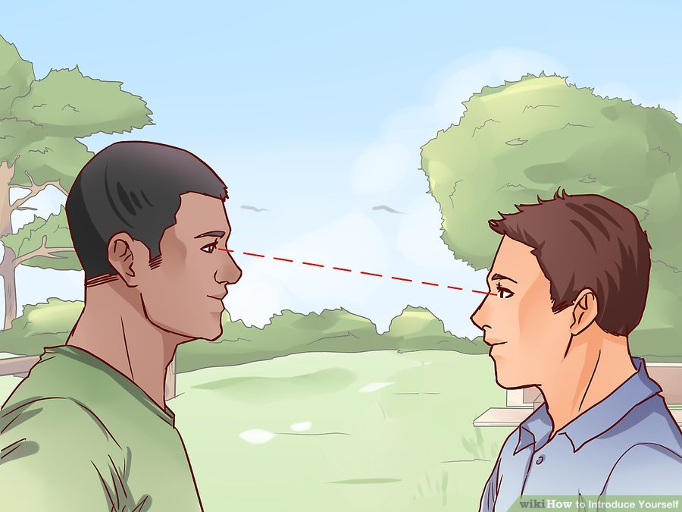
B. Smile. It is important to keep a genuine, bright smile when you meet a new person. Be genuinely happy to meet someone new and to share a positive experience and it will help create a genuine smile. Including the upper part of your face in your smile creates a more genuine and less fabricated smile.

C.Use appropriate body language. Your body language should communicate that you are confident and at ease. Stand with your head high and your back straight, being careful not to slouch. Mirror the body language of people around you.

2 Introducing Yourself in Class
Introducing yourself in class, whether you are the student or the teacher, can feel daunting. Deciding what and how much to share, overcoming anxiety, and presenting yourself as an interesting and engaged person are steps that will help you introduce yourself with confidence, both in a physical classroom or in an online setting.

A. Stand up when it’s your turn to introduce yourself. This will make you appear more confident and will help you speak more clearly than if you were to stay seated. It may feel awkward to stand up, but your introduction will be over more quickly than you think.
- If you are sitting in the middle of the room, you may want to turn your head from side to side occasionally as you speak so you can address the entire class.

B.Smile when you speak. Even if you are super nervous, smiling will make your voice sound calmer and will help you mask that nervousness. It also shows your classmates and your teacher that you are friendly and approachable. Also, smiling stimulates the production of endorphins, so you are helping yourself to feel a little happier, too!
Scientific studies have shown that making yourself smile when publicly speaking endears others to you as they naturally will want to smile back.

C. Speak with confidence. Chances are that even if your voice is shaky, others won’t notice that. You want everyone to be able to hear you, so when you introduce yourself, do so in a clear, loud voice. Don’t mumble or stare down at the ground. It’s perfectly okay to be nervous—lots of people are when speaking in front of others! But if you can take a steadying breath and project confidence, you’ll be through your introduction before you know it.
- Try practicing your introduction in a mirror to prepare yourself beforehand.
- A lot of the people in your class will be thinking about what they are going to say when it’s their turn and may not even be watching you the entire time you’re speaking.

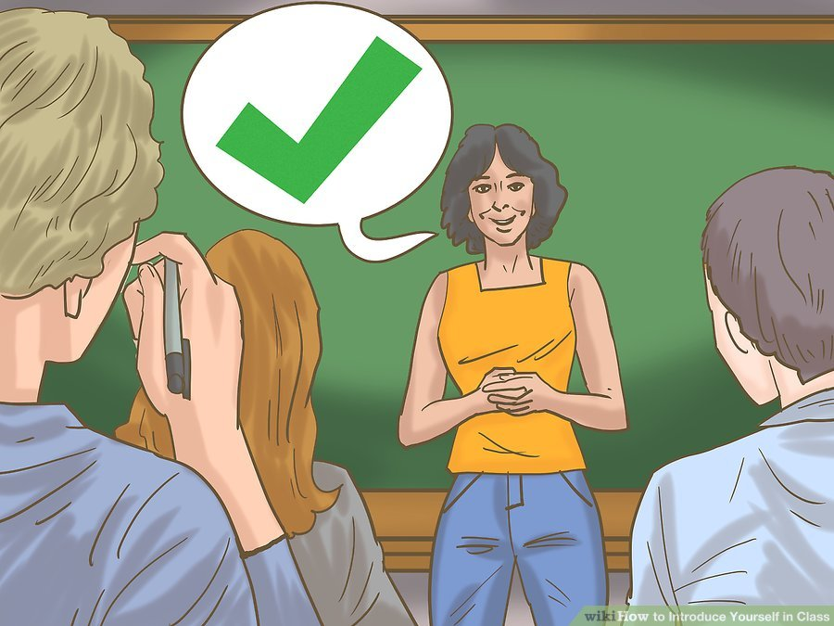

D.Give your name first. It’s helpful to give your first name, pause, and then give your first and last name, like “Hello, my name is June, June Thompson.” The repetition makes it more likely that others will remember your name.
- If you prefer to go by a nickname, this is the time to give that detail. Say something like, “Hi, my name is Marcella, Marcella Smith, but you can call me ‘Marcie.’”
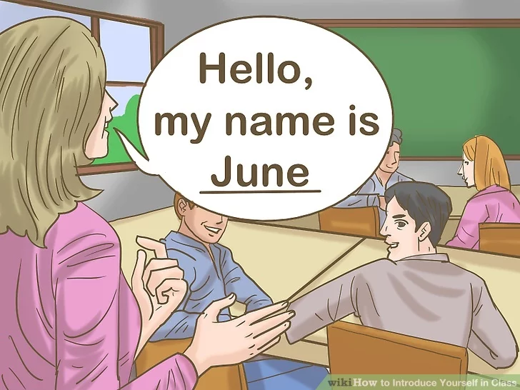

E.Share why you are taking the class. If you’re in a college course, you can share your intended major. Or if you’re taking a class for a certification for a job, you could share what it is you do for work. For example, you could say, “Hi, I’m Mark, Mark Palmer. I’m an Economics major, and this class is helping me get a certification I need to graduate.”
- If you are only in the class because you have to be (like a general education course that all students are required to take), you don’t need to say that—chances are a lot of other people are in the same boat.
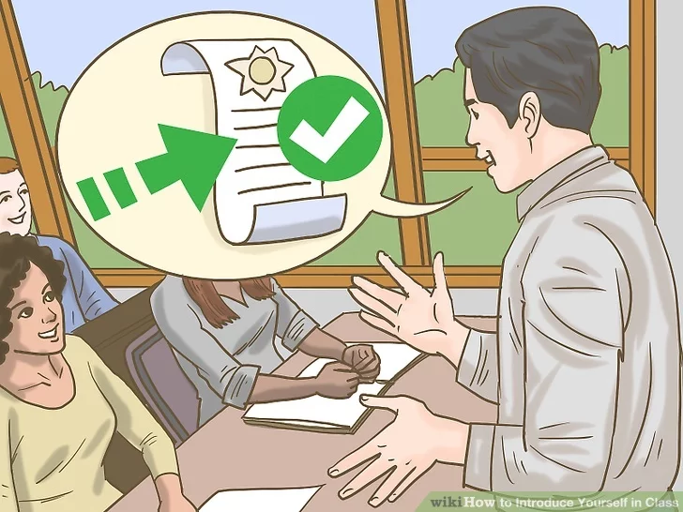

F. Offer personable details, like hobbies or interests you have. If you are involved in sports or have pets or like to travel, the end of your introduction is a good place to give this information. You could say something like, “When I’m not studying, I like to train for and run in half-marathons.” This gives your classmates and teacher a memorable activity to tie to your name.
- Avoid sharing overly personal details, like if you’re going through a divorce or recently lost your job. Try to keep things positive and upbeat—you don’t want your first impression to be negative or make other people uncomfortable.

