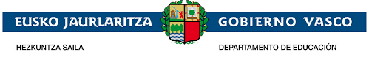
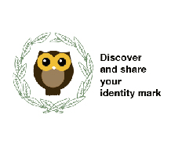

5th-12th November 2018 eTwinning training. Minutes
Participants: School Staff
Matter:
The Elexalde School Staff has been trained in the use of eTwinning by the eTwinning ambassador Amaia Alonso. There have been two sessions of two hours. In the first session the teachers who belong to the Pedagogical team and more teachers from the School Staff have attended it.
In the second session the rest of the School Staff have followed it.
The training has been about the eTwinning platform. Amaia Alonso has explained the number of teachers, countries and projects which are inside eTwinning. She has also described the different parts of the platform and how to create a project in this platform, the design of a profile and the way of joining the platform. There has also been an approach to eTwinning. She has also shown us her project in eTwinning, its partners, the different tools used for all the activities and the assessment of it.
The teachers have been assessed by a kahoot.
At the end of the session, how to find the project “Discover and share your identity mark” on eTwinning platform has been brought to the School Staff they have also been invited to take part in it

The minutes signed by the teachers is kept by the Secretary of Elexalde School

