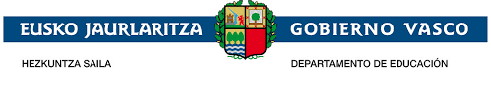

I.E.S Elexalde

6th September 2018

ORGANISATION OF THE PROJECT GROUP

Our project is a curricula project. The English department organises it and two teachers will work with the students but teachers from other departments also participate.
Art, Basque, Physical Education, Music and Spanish Language departments are also part of it.
All students of 3 DBH will work the units related to the project planned by the teachers of those fields.
As we pointed out in our project, a group of 22 students will carry out the project. Although the rest of students of 3 DBH will also work some aspects of it and participate in it. Their effort and implication will be important.
The criteria we agreed to select the group was: academic criteria, level of English, personal aspect, their abilities to integrate, to face new situations, to solve problems, work team, own initiative with illusions and entrepreneurs, creativity, hard work
Students who will be willing to work hard and whose results will be improved with the project.
Seriousness, punctuality and commitment will be assessed positively.
Economic obstacles and academic difficulties (6 students)
This is the criteria we explained in the project and we have taken into account to choose the group.
It must be highlighted we didn't know whether our project had been accepted until the middle of August and considering in June the groups must have been organised.
When we arrived in September, looking at the groups organised we decided that the group which better fulfilled the criteria mentioned before was the group is working the project.

