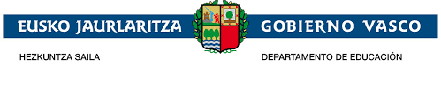
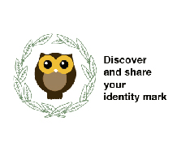

DIDACTIC UNIT ONE
Subject: ENGLIH
Issue: Students should guess what “Discover and share your identity mark" means. Work group. Once they have agreed which objectives and competences are. The work will be presented with posters hung on the wall.
Level: 3 DBH
Justification of the proposal:
As we are dealing with a two years long project, it is very important that students learn the meaning of the project, its context, objectives, and competences. This will help them with the development of the project in an effective way.
Problem situation:
Context:
"Discover and share your identity mark" will be the project on which students will be working during two years. The knowledge of its context, aims, and competences is important to elaborate the adequate tasks to obtain satisfactory results.
Problem:
Will students be able to work on the project and design different tasks according to the information given?
Purpose: design different activities including the aims learnt and learn different ways of learning and working.
Task:
Hang posters about the project on the wall.
Basic competences:
Competence in linguistic and literary competence ( communication skills)
Technological Competence ( technological skills)
Social and civic Competence ( team work)
Art Competence.
Transversal competences:

Communication competence: The English language will be used as the communication vehicle
ICT competence: Use of the Internet and all type of on line resources to carry out the project.
Artistic competence:
Develop a good aesthetic sense to elaborate the posters and make them catchy.
Didactic objectives:
- Guess what the project "Discover and share your identity mark" means
-Understand the purpose of it
-Learn the aims of the project.
-Be aware of the competences implied.
-Reflect on the different tasks which could be designed according to it.
- Be able to use the ICT tools as a way of elaborating and disseminating the project.
- Agree on the different roles each student has in the work team .
- Know the methodology used.
Contents:
Power point with all the useful information related to the project.
Vocabulary related to the project
Task sequence:
Initial stage:
Write the title “Discover and share your identity mark " on the smartboard and do a brainstorming
Share all the different students' ideas.
Present a power point with all the information related to the project.
Development stage:
Elaborate posters and hang them on the wall.
Self-assessment activity
Questionaire
Assesment:
This unit will be assessed during the two years through the activities created by the students during the development of the project. Students will bear them in mind to focus all their tasks.

