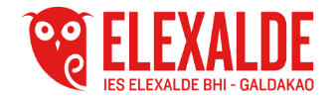
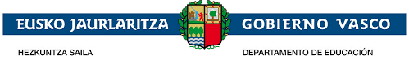
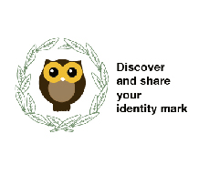

DIDACTIC UNIT ONE

TASK:
-Personalise letters for a big mural.
-Video explaining what each letter means.
Subject: ENGLISH
Issue:
Students are going to create personalised letters in order to be placed them in a big mural and to be used in different places.
They will look up the information on the project and match this information with the letter.
They will make oral presentations related to each letters.
Group work:
In groups they will choose different subjects related to the project to use in the personalised letters.
Individual work:
Each student will present the letter.
Justification of the proposal:
As the project "Discover and share your identity mark” is a project between Elexalde School in the Basque Country and Katerini School in Greek the personalised letters link both cultures.
Problem situation:
Context:
The volunteers will share their personalised letters in a mural to show the activities done in the project by both schools.
They will also present their letters with the information the letter has.
Problem:
Will letters link volunteers with the project as they have to look up information about it and present it?
Create personalised letters to organise the different murals of the school.
Present the personalised letters
Competences:
Basic competences:
Competence in linguistic and literary competence (communication skills)
Technological Competence
Art Competence.
Transversal competences:
Communication competence: The English language will be used as the communication vehicle
ICT competence: Use of you tube to create the presentations
Didactic objectives:
-Grow students' interest and motivate them to strengthen links with the Greek students through the personalised letters.
-Make them participate and with a simple activity get to know their heritage and the Greek one.
- Students will take their own decisions about the type of subjects to choose to create the letters.
-Awake their artistic competence in the creation of the letter.
-Promote the spirit of collaboration.
-Grow their enthusiasm taking into account they are doing in their break.
- Create their autonomy as they organise the type of letters used, the information contained the colours chosen, the drawing.
- Build bridges between both schools through the creation of personalised letters.
- Interaction between schools through the personalised letters
Contents:
Information related to the project.
S-'Bilbao paviment ties
T-Anphora.
I- Basque and Greek dancers.
C-Lamiak
Z- Zeus
R-Greek and Basque flag
V-Laburu
M-Greek Greek columns
A-Gorbea -Mount Olympus
H-Txistu tamboril
D-Greek harp
Y-Mari Jaia
U-Laurel wreath
O-Puppy
E- Erasmus +
N-
Assessment
A questionnaire

