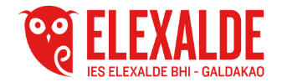
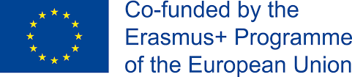

Date: 29th October 2018
Participants: All the School Board
SCHOOL BOARD MINUTES
The coordinator of the programme Erasmus + K229 Mrs Gemma Gutiérrez has exposed the project "Discover and share your identity mark" to the School board.
She has given them details about the presentation of the project, the budge granted and the project assessment.
Then, with the support of a PowerPoint, the project has been described as well as the reason to be presented and the choice of the subject heritage. She has pointed out the project objectives, development and schedule.
She has also introduced to the School Board the partners, Katerini School, the town and the students who will participate in it.
Another issue has been the dissemination and the activities the Pedagogical Departments will carry out.
At the same time, she has showed them how to follow the project through the blog, eTwinning and Instagram and have been animated to participate in it

This School Board meeting minutes is also kept by the Secretary of the School with the signatures of the teachers who attended

