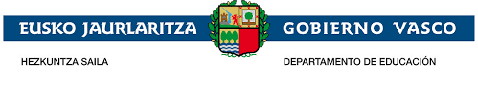
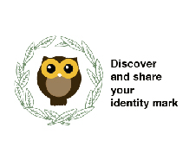
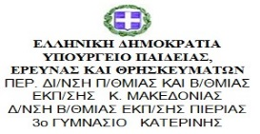

DIDACTIC UNIT FOUR

Swap Christmas cards
Design Christmas cards
Subject: ENGLISH
Issue:
Students are going to design Christmas cards related to the project. Each one decides a subject from the project a mythological character, a place which will be worked in the project related to the heritage, a typical food, a Christmas tradition.
Send them by post before Christmas holidays.
Receive Xmas cards from Greek students wishing Merry Christmas
Individual work:
The different subjects have been distributed to the students and give them time to look up information about the issue they have to use in their Christmas cards.
They have also been asked to follow a pattern so that all the Christmas cards include the logo of the project and the information asked. They could have been drawn by themselves or with the computer
Then, they have prepared a sketch and saw to the teacher to check all the instructions have been followed
Justification of the proposal:
As the project "Discover and share your identity mark " is a project between Elexalde school in the Basque Country and Katerini school in Greece , the exchange of Christmas cards is a way to strengthen links through the spirit of Christmas and improve the intercommunication between both schools for the project's benefit.
Problem situation
Context:
The students of Elexalde and Katerini School will need to communicate themselves so that their interest in the project will increase and their level of English will improve through their interaction and at the same time their relations will get closer.
Problem:
Will both schools' students be able to design Christmas cards included subjects of the subject to establish a close relation?
Create and swap Christmas cards to establish a close relation between both school students so that their motivation will make them work harder and with more interest in the project and the results of it will be higher quality.
Competences
Basic competences:
Competence in linguistic and literary competence (communication skills)
Technological Competence.
Art Competence.
Transversal competences:
Communication competence: The English language will be used as the communication vehicle.
ICT competence: Use of you tube to create the presentations.
Didactic objectives:
-Grow students' interest and motivate them to strengthen links with the Greek students through Christmas spirit.
-Make them aware of the importance of discover their Christmas traditions, share them with the Greek students and discover the Greek ones.
-Make students participate in their own decisions about the type of subjects of the project and Christmas traditions to be included
- Create their autonomy as they have to look up the information needed through flipped classroom methodology
-Use of English in order to write the texts.
-Work on the synthetic use of information to include in their Christmas cards.
- Develop their artistic skills through the design chosen for the creation of them.
-Awake their interest and motivation when receiving Greek Christmas cards.
- Make them aware of the differences or similar cultural customs related to Christmas.
- Build bridges between both schools through Christmas
- Interaction between schools through the creation of Christmas cards.
Contents:
All the subjects are connected with the project. Students have worked or will work on them. Students create their Christmas cards according to them.
- Basque mythological characters.
Tartalo,Olentzero,Galtxagorri, Mari Domingui, Lamiak, Maritxu, Basahaun
- Places with heritage
Gughemhein, Town Hall Galdakao, City Hall Bilbao, San Juan De Gaztelugatxe, Andra Mari Galdakao.
- Christmas traditions.
The Three Wise Men, The Three Wise Men round cake.
- Basque sports.
Inaxio Perurena stone lifter, Basque pilota.

Task sequence:
Initial stage
-Explain the task in detail describing the objectives of it and the importance of being aware of transmitting their Christmas traditions and discovering the Greek ones.
-Brainstorming possible subjects of the project and Christmas traditions to be included.
-Distribute those possible subjects to be used in their Christmas cards.
-Discuss the options and agree who will choose what.
Middle Stage
- Look up information at home about the subjects related to the project.
- Write the information in English in a synthetic way and clearly.
-Think about the design of the postcard and the tools used for its creation.
Final Stage
-Create the postcard drawing or on the internet
-Decorate the Christmas cards
-Open the envelope where they have received the Katerini Christmas cards.
-Discuss the differences and similarities with our Christmas traditions. -Learn through them parts of the project which have not been worked yet.
- Enjoy with them and place them on the mural prepared for them so that the rest of students can participate with them.

Methodology:

Flipped classroom. Students will look up the information needed in order to create their Christmas cards.
Once the information has been selected, they will bring to the teacher to organise it and start working on it

Assessment:

A questionnaire of satisfaction about what their experience about writing and receiving postcards has been and what they thought about the Greek ones.

