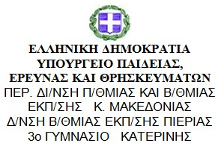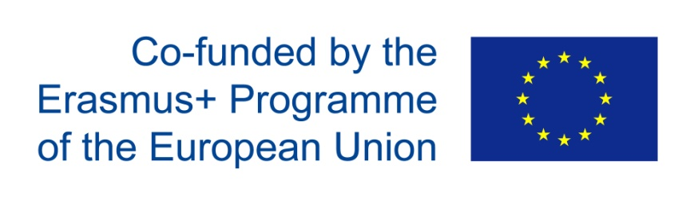

Date: 1st October 2018
Participants: the members of the pedagogical team
Meeting with the pedagogical team (P41 / minutes)
The pedagogical team’s sitting took place on the 1st of October. The teachers were introduced to the concept of the project as well as the details of its implementation. There was an allocation of duties so that it will be clear who is responsible for what. The reasoning was for every teacher to be given a topic of interest according to the subject he teaches.
Thus, the Language and Literature teachers are responsible for the Language part of the project in November. They are going to work together with the English teachers to produce a tri- lingual dictionary in Basque, Greek and English. The sports teacher will be responsible for the sports in December as well as the dances and traditional games in January. The music teacher, who has already chosen three songs to be dressed in Basque verses and sent them to the Basque teacher of music, will prepare the musical part of the project dealing with ancient instruments and ancient Greek music in January. The teachers of Technology and Home Economics are responsible for the part which has to do with Greek cuisine and the Mediterranean diet as well as the Master Chef Competition in February. The History teachers will deal with Mythology and the local history in March and April. The Science teacher together with the Chemistry teacher with the Maritime heritage in May and Natural heritage (Olympus) next year. The archaeologist with the archaeological sites.
The whole project will be worked out in extracurricular meetings as the students of the group have been chosen with certain criteria from grade B’. Thus, it wasn’t convenient to incorporate it in the Curriculum. The pedagogical team agreed to choose the students having in mind their responsibility, the degree of their involvement, if they speak English well enough and their ability to work as a team. Also, we included in the team some students with financial problems who could hardly have the opportunity to travel or study abroad and meet another culture. As for the final screening, which ones will finally travel to Spain, there will be a point system based on the above criteria and a screening board.

