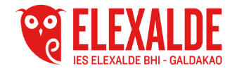
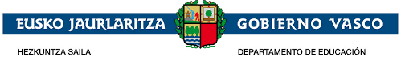
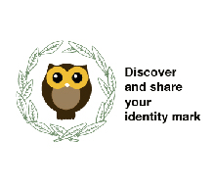

Date: 29th October 2018
Participants: All the School Staff
SCHOOL STAFF MINUTES
he coordinator of the project Erasmus + K229
Mrs Gemma Gutierrez has exposed to the School Staff the project "Discover and share your identity mark". Firstly, she has explained with the support of a PowerPoint the reason to present it, why the project is about the heritage and its objectives.
The partners of the project, as well as the School Katerini, the town and above all, the students who participate in it have also been introduced.
She has continued describing the development and schedule of it.
To finish, she has explained to them the dissemination of the project and the tasks which will be carried out by the Pedagogical Team.
She has shown the School Staff the blog, eTwinning and Instagram and they have been encouraged to take part in it.

This School Staff meeting minutes is also kept by the Secretary of the School with the signatures of the teachers who attended

