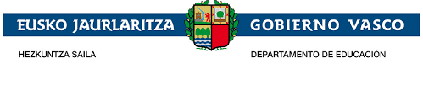
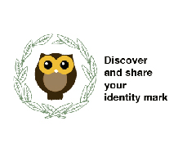

DIDACTIC UNIT THREE
What is eTwinning?
Create e Twinning accounts.
Subject: ENGLIH
Issue:
Teaches will present the students what e Twinning platform is, they will be part of it to be able to establish a communication between both schools' students
Individual work: Their eTwinning accounts will be given to get contact with Greek students.
Justification of the proposal:
As the project "Discover and share your identity mark " is a project between Elexalde school in the Basque Country and Katerini school in Greece, the knowledge of the eTwinning platform as the platform of dissemination of the project as well as the creation of accounts for all the students to establish a way of intercommunication will enrich the project.
Problem situation:
Context:
The students of Elexalde and Katerini School will need to communicate themselves so that their interest in the project will increase and their level of English will improve through their interaction and at the same time their relations will get closer.
Problem:
Will both schools' students be able to start and keep eTwinning videoconferences in order to swap interests, get involved in the project and improve their English?
Purpose:
Videoconferences and chats in eTwinning to establish a close interaction and strengthen ties.
Basic competences:
Competence in linguistic and literary competence (communication skills)
Technological Competence
Art Competence.
Transversal competences:
Communication competence: The English language will be used as the communication vehicle
ICT competence: Use of you tube to create the presentations
Didactic objectives:
- Learn about eTwinning platform.
-Understand how eTwinning platform is used in the project.
-Create profiles so that students are presented to get to know better.
-Create eTwinning accounts to establish a communication
- Improve their English through that communication.
-Increase their interest in the project through the platform
- Build bridges between both schools
- Interaction between schools.
Contents:
-What eTwinning platform is.
-The reason to use this platform in our project.
-Look at the pages, journal, polls, and discussion so that they can see the activities they are learning and the possibilities it offers.
-The journal.

Task sequence:
Initial stage:
The teacher has explained them through PowerPoint what the eTwinning platform is. She has also shown them the different parts of the eTwinning platform, pages, journal, polls, and discussion forum.
Development stage:
They have created their eTwinning accounts.

Final stage:
A videoconference.

Once every month a videoconference will take place .The first one will be to get to know each other. The other ones will deal with the subjects of the project which are being worked.
Assessment:
The task will be assessed through kahoot and through the videoconferences which will take place during the project.

