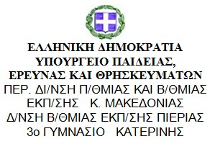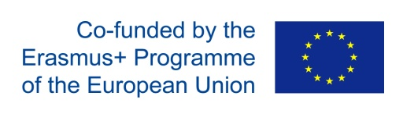

P4 (Break the ice)
School: 3rd Junior High School Katerini
Title of the activity: Break the Ice
Objective: The objective of this activity for students is to introduce themselves and present their school to their Spanish partners.
“The ice is soft so we can break it easily”
Description of the activity:
- Students were asked to say a few things about their interests, hobbies and families so as to give the opportunity to their Spanish peers to have an idea who they are and come a bit closer to them.
- Students were asked to enrich their Twinspace profiles using the information about themselves.
- Finally they presented themselves, their school and town on camera and created a video to share with their Spanish partners.

The final products are the following:
Video of our school and town
Our school from above
Students presenting themselves (group 1)
Students presenting themselves (group 2)

