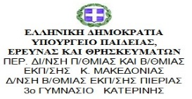
P5 GREEK SPORT (10 points)
- To whom is the Olympic Anthem directed?

- Where did Greek students practise shot put?

- The shot ball weighs
- 7,26 kg
- 7,25 kg
- 7,30 kg
- 7,24 kg

- Where should the athlete stay? Until when?

- What does Mr Damposis the Greek sport teacher demonstrate?

- Explain two rules of the game mila.

- What is the goal of the game mila?

- Give two rules of the game tzami

