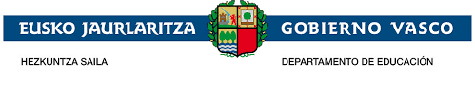
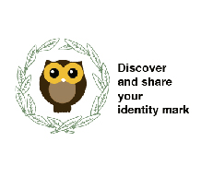

1st meeting record

Participants: I.E.S School Board
Date: 3th September 2018
Matter: The Coordinator has explained to the School Board the School project " Discover and share your identity mark”, all the information about the project, objectives, contents, participants, schedule, budget.
Although the project was explained in March last year before being presented to the national agency. It has been shown to the School Staff again, this time as a project which has been selected.
It has also been the first contact for new teachers who have incorporated to the School staff. The School staff will be informed about the development of the project in the next School board.
An eTwinning training for all The School Staff will be organised to know the platform used to disseminate the project and to participate if they would like to do it.
The project documentation as well as the project itself is in the O orokorra file to be consulted by any teacher.
The coordinator will inform the teachers about the project in detail.

