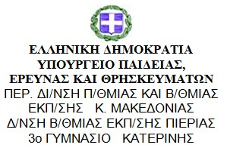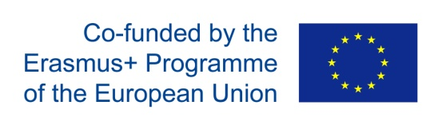

Date: 26thOctober 2018

Training in Twinspace (P3)
There were two meetings, one for the students and one for the teachers of the pedagogical team on Friday 26th of October, where all those who take part in the project created an account for eTwinning and TwinSpace and were trained on using it. All the queries were solved and all the questions were answered. Although the pedagogical team had already attended the 1st short-term joint staff training event, we considered this second meeting essential for their deeper knowledge and understanding of the platform. We also created a team in Viber to facilitate communication among all.

