MILKPIEFOR 20 PIECES – PREPERATION TIME: 30’ BAKING TIME: 45’
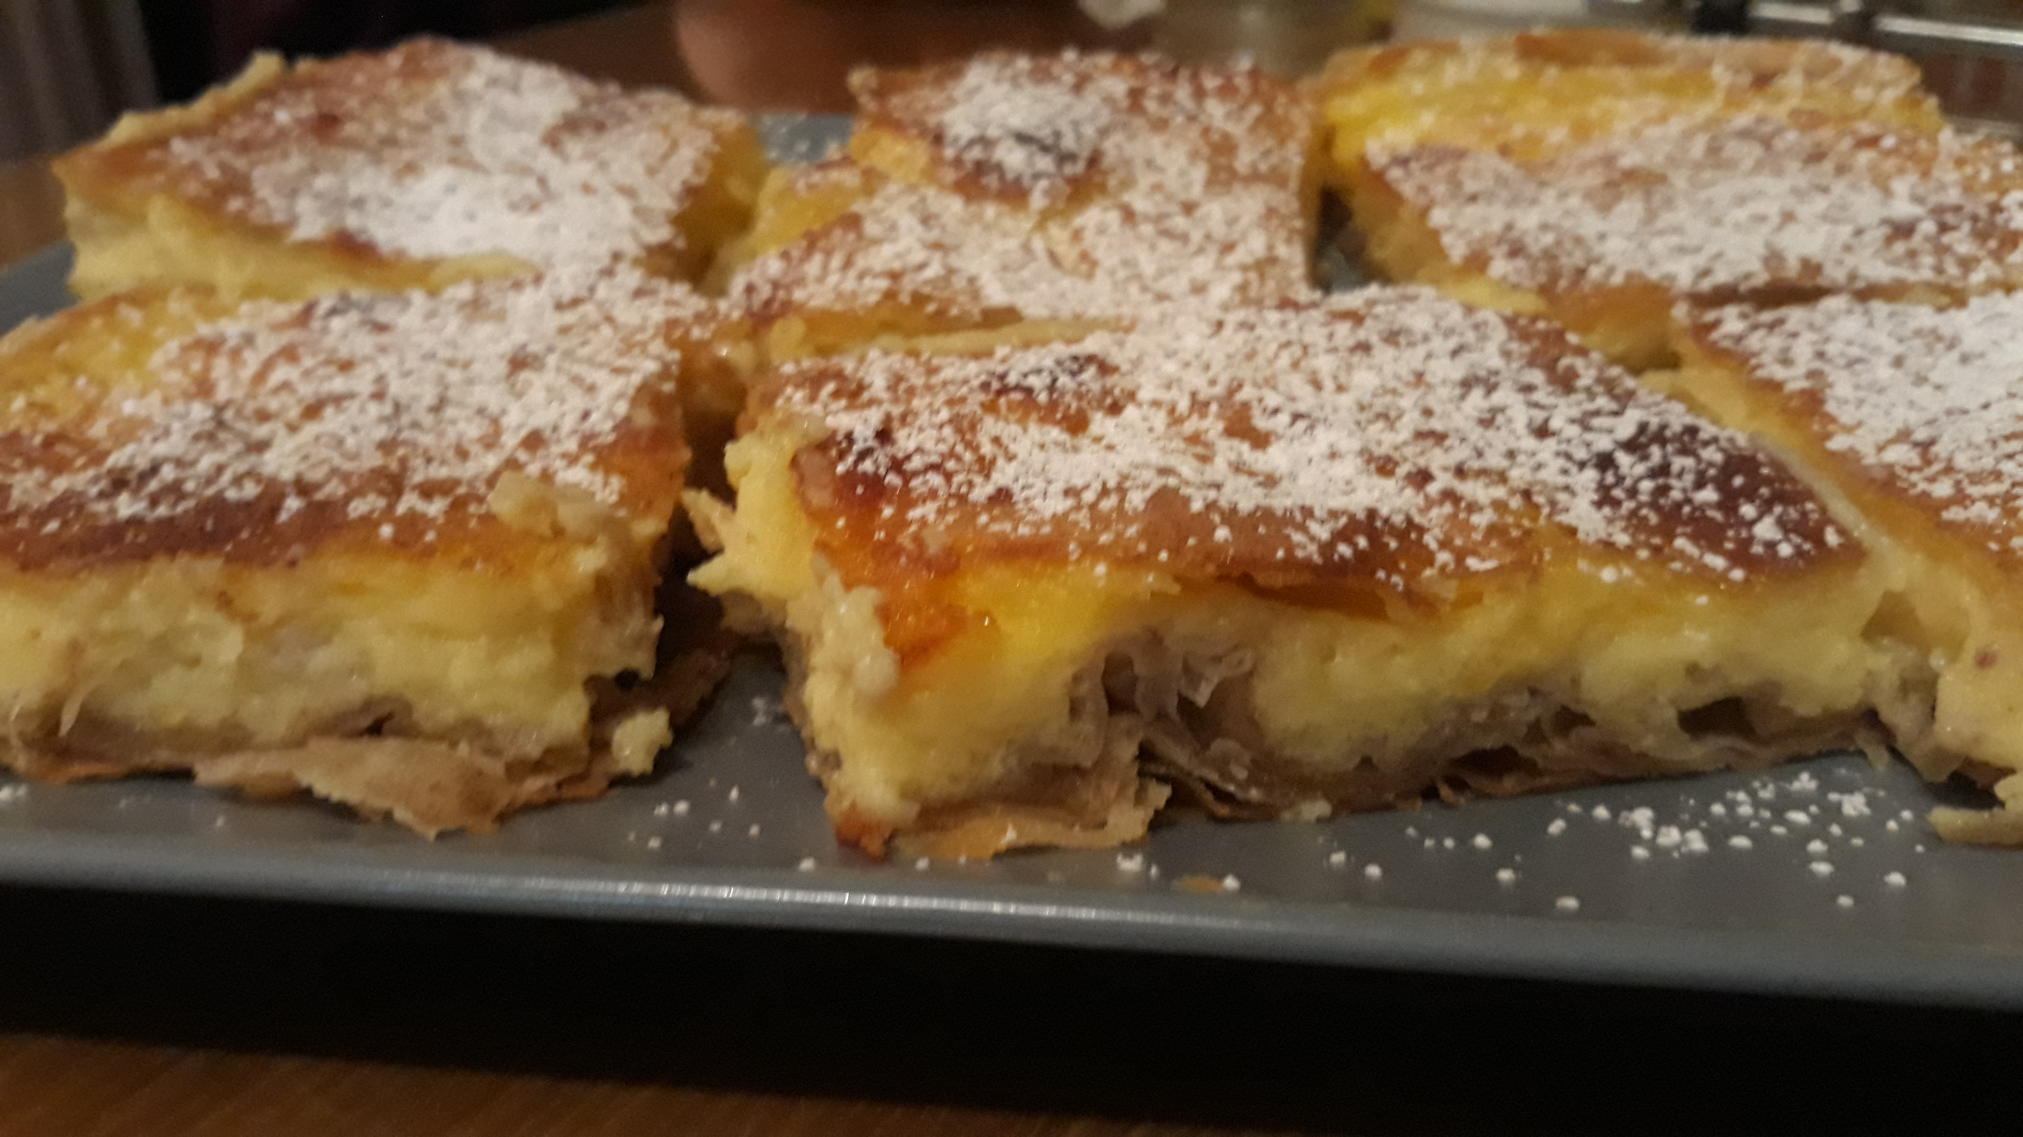

INGREDIENTS
For the home-made dough:
- 500gr flour
- 1 spoonful of vinegar
- A little salt
For the mixture to go between the pastry sheets:
- 1 teaspoon of cinnamon
- 4 spoonfuls of sugar
- 1/3 of the cup melted butter
For the cream:
- 1/3 of the cup flour
- 1/2 of the cup fine semolina
- 1 ½ of the cup sugar
- 6 cups full of warm milk
- 5 eggs lightly bitten
- 2 eggs
- 1/ 3 of the cup melted butter
- A little vanilla (powder)
- 4 spoonfuls of sugar
- A little powdered sugar
- A little cinnamon

PROCEDURE
For the dough:
Mix all the ingredients and make the dough. Separate it into small balls and, transform them into slim sheets, using a rolling pin.
For the mixture between the pastry sheets:
Mix the cinnamon with the sugar. Strew the pieces in a tile with dimensions about 30x35, smearing each of them with butter and sprinkling them with the mix of cinnamon and sugar.
For the cream:
Then mix the flour with the semolina and drop quickly the warm water. Simmer mixing it until the cream hells. Drop and mix a little of the hot cream with the beaten eggs and then mix with the other cream. Leave it aside from fire. Throw the vanilla powder and the butter and mix them with the cream. Spread the mix out on the sheets. After that, beat the two eggs with the sugar, wait for them to drown, foam and then spread the mix out on top of the cream.
Bake the pie at 175%C for about 45’ in order to have its top brownish well. Put it out and wait to cool down. Then, cut pieces and put on it powdered sugar and cinnamon. It is kept in fridge.
SERVE IT THE SAME DAY, IT IS MORE DELICIOUS!
TIP

