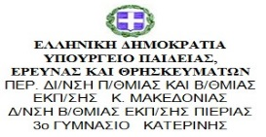

Date: 5th September 2018
Participants: Anna Persidou
Maria Dabra
Iratxe Cuñado
Gemma Gutierrez
Matter:
An introduction of ourselves and the teachers who will participate in the project, and headmasters of both schools.
The first matter was the rescheduling of the trip to Greece. Our trip was planned on 9th September but we have thought it would be better to postpone it for the 15th of October.
We have let the Greek teachers know. They have also agreed it was also better for them as the school year has started they needed time to organise our travelling to Greece.
Then we have asked them to look for our accommodation in Katerini.
We have talked about the groups which will participate in both schools, the criteria used according to what it is explained in the project.
The training of e twinning and flipped classroom we will have to carry out when we travel to Greece.
The budget which has been assigned for the trip.
The necessity of them to register in e twinning.
The coordinator has explained to them any doubt they could have about the project.
We have also talked about the necessity of didactic units and syllabus. All of us will propose a model to be discussed and modify according to the project.
We are very happy about starting our project, full of energy and enthusiasm. It has been very nice this contact.
In case we need to skype again because any problem arises, we will do it.

